Standalone Kiosk-Based Queuing Management System with Thermal Printer for Student Service Offices at Philippine Electronics and Communication Institute of Technology (PECIT)

A Capstone Project Presented to the Faculty of the
College of Computer Studies
Philippine Electronics and Communication Institute of Technology
Butuan City, Philippines

In Partial Fulfillment
Of the Requirements for the Degree
BACHELOR OF SCIENCE IN INFORMATION SYSTEM

RHEM A. SUMODLAYON
MIKE D. BEDRONA
NIÑO ANGELO M. MALICAY
OMAR O. BAYABAO
RON MATTHEW F. ARQUISOLA

SEPTEMBER 2026

DEDICATION
This capstone project is dedicated to our families. Their patience, prayers, and support carried the researchers through the long work of analysis, programming, testing, writing, and revision.
It is also dedicated to the students, parents, and walk-in clients of the Philippine Electronics and Communication Institute of Technology who wait for service at the Cashier, Registrar, and Data Management Office, and to the staff who serve them during enrollment, payment, and records periods.
The researchers further dedicate this work to the College of Computer Studies and the College of Information System, under the academic leadership of Daryll A. Cabagay, MSIT, Dean, and to the faculty who trained us in information systems. May this standalone kiosk-based queuing system with thermal printer be a modest return to the institution that formed us.

ACKNOWLEDGEMENT
The researchers express their sincere gratitude to Daryll A. Cabagay, MSIT, Dean of the College of Information System, for the academic leadership and institutional support that made this capstone project possible.
The researchers thank Josephine U. Acha, Ph.D., Research and Extension Director, for promoting a culture of inquiry at PECIT and for the research standards that guided the preparation of this manuscript.
The researchers also thank Wilson Rey Sevilla and Zoren Estrada Bajao, former and current program heads, and the rest of the College of Computer Studies and Information Systems faculty for instruction, consultation, and the reminder that a campus system must fit PECIT rather than a generic template. We likewise thank our capstone adviser and the members of the oral defense panel for their questions and comments on the problem, method, and implementation.
We are grateful to the PECIT administration and to the staff of the Cashier, Registrar, and Data Management Office. They described the manual first-come-first-served line and allowed the researchers to observe how windows, priority clients, and walk-ins are handled in daily operations.
Finally, the researchers thank their families and one another—Mike D. Bedrona, Niño Angelo M. Malicay, Omar O. Bayabao, Rhem A. Sumodlayon, and Ron Matthew F. Arquisola—for the shared work that produced this system and this manuscript.

ABSTRACT
Student service offices at the Philippine Electronics and Communication Institute of Technology (PECIT) currently process Cashier, Registrar, and Data Management Office (DMO) transactions through manual first-come-first-served lining. That physical line can produce unclear order, line cutting, weak priority handling, crowding, and no shared view of who is waiting. This capstone developed and implemented a standalone Local Area Network (LAN)–based kiosk queuing system with a 58mm thermal printer as a localized replacement for that process. One mini PC (Intel Core i5 8th Generation, 8 GB RAM) serves as both the public kiosk and the application server. The kiosk uses an ACR122U-A9 RFID/NFC reader and a SIM7600G-H GSM/LTE module. When the printer is out of paper, the staff dashboard shows a paper-out alert.
The student kiosk remains three steps: service selection, Regular or Priority, and confirmation. Confirmation requires a validated Student ID typed on the keypad or tapped on an enrolled RFID/NFC card, or an authorized walk-in ticket after the kiosk PIN is accepted. Clients who do not bring the card may still type the Student ID. Notify me by SMS is off by default and uses the mobile number stored on the student record; students do not type a number at Confirm. If no mobile is on file, the control stays off and disabled and shows that no SMS number is on file; print still proceeds. Walk-in clients may enter a number only on the PIN overlay. The printed ticket, public display, and optional local GSM SMS stay number-only. GSM SMS may notify an opted-in ticket when it is five places away in fair call order and when it is called. Staff windows that share a service, including Cashier 1 to Cashier 3, use one waiting queue and a service-wide 2 Priority → 1 Regular call order, with Hold and Call Held. Administrators manage users, the student allowlist, RFID/NFC card UID and mobile enrollment, the walk-in PIN, and reports based on completed transactions only.
Development followed the Waterfall model. Evaluation used functional tests, one technical expert review, and User Acceptance Testing aligned with ISO/IEC 25010 product-quality characteristics. User feedback was Strongly Agree (Cashier 5.00, Registrar 5.00, DMO 4.92, Student form 4.91; combined 4.96). The IT expert scored 5.00 overall. The study does not claim a measured reduction in waiting time.
Keywords: queue management, kiosk, thermal printer, LAN, Student ID, RFID/NFC, GSM SMS, priority scheduling, ISO/IEC 25010, PECIT
TABLE OF CONTENTS

TABLE OF CONTENTS
DEDICATION i
ACKNOWLEDGEMENT ii
ABSTRACT iii
TABLE OF CONTENTS v
CHAPTER 1 12
1.1 Background of the Study 12
1.2 Research Gap 16
1.3 Statement of the Problem 16
1.3.1 General Problem 16
1.3.2 Specific Problems 17
1.4 Objectives of the Study 18
1.4.1 General Objective 18
1.4.2 Specific Objectives 18
1.5 Scope and Delimitation of the Study 19
1.5.1 Scope 19
1.5.2 Delimitation 21
1.6 Significance of the Study 22
1.6.1 Educational Service Delivery 22
1.6.2 Philippine Higher Education 23
1.6.3 Philippine Electronics and Communication Institute of Technology (PECIT) 23
1.6.4 System Administrator 23
1.6.5 Administrative Staff 23
1.6.6 Students and Parents 24
1.6.7 Future Researchers 24
1.7 Definition of Terms 24
CHAPTER 2 1
2.1 Related Literature 1
2.1.1 Queue Management Systems 1
2.1.2 Self-Service Kiosk Technology 2
2.1.3 Waiting-Time Information in Queue Management 3
2.1.4 Thermal Printing Technology 4
2.1.5 Standalone and Local Area Network-Based Information Systems 4
2.1.6 Digital Technology in Educational Administration 5
2.1.7 Queue Management in Philippine Higher Education 6
2.1.8 Digital Transformation in Philippine Higher Education 6
2.1.9 Localized Information Systems for Philippine Educational Institutions 7
2.2 Related Studies 7
2.2.1 Foreign Studies 7
2.2.1.1 Digital Queueing Systems and Self-Service Kiosks 7
2.2.1.2 Digital Queueing Systems 8
2.2.1.3 Local and Offline Information Systems 8
2.2.2 Local Studies 9
2.2.2.1 Automated Enrollment Queueing System 9
2.2.2.2 Queue Management and Cashier Efficiency 9
2.2.2.3 Ticketless ID-Operated Queue Management 10
2.2.2.4 Smart Queuing and Appointment Management System 11
2.2.2.5 Localized School Information System 11
2.2.2.6 Kiosk Queue with Printed Slip and Public Display 12
2.2.2.7 Enrollment Queuing in Another Philippine College 12
2.2.2.8 Kiosk and Thermal Printer in a Service Office 13
2.3 Synthesis 13
2.4 Summary of the Review 15
CHAPTER 3 16
3.1 Conceptual Framework 16
3.1.1 Input 18
3.1.1.1 Hardware Requirements 18
3.1.1.2 Software Requirements 19
3.1.1.3 System Requirements 19
3.1.2 Process 21
3.1.2.1 Requirements Analysis 21
3.1.2.2 System Design 22
3.1.2.3 Implementation/Development 22
3.1.2.4 Testing 22
3.1.2.5 Deployment 23
3.1.3 Output 23
3.1.3.1 Standalone Kiosk-Based Queuing System 24
3.1.3.2 Printed Queue Ticket 24
3.1.3.3 Real-Time Queue Display 24
3.1.3.4 Staff Queue Management 24
3.1.3.5 Queue Records and Administrative Reporting 25
3.1.3.6 Organized and Fair Queue Management 25
3.1.4 Explanation of the IPO Framework 25
3.2 Requirements Analysis 26
3.2.1 Stakeholder Identification 26
3.2.2 Data Gathering Methods 27
3.2.3 Existing System Analysis 29
3.2.4 Requirements Gathering 32
3.3 Requirements Documentation 36
3.3.1 Functional Requirements 36
3.3.2 Non-Functional Requirements 38
3.3.3 Business Rules 40
3.3.4 Use Case Descriptions 41
3.3.4.1 Select Service 42
3.3.4.2 Select Queue Type 42
3.3.4.3 Confirm Queue Request 43
3.3.4.4 Issue Walk-in Ticket 44
3.3.4.5 Generate Queue Number 44
3.3.4.6 Print Queue Ticket 45
3.3.4.7 View Queue Display 45
3.3.4.8 Call Next Queue 46
3.3.4.9 Recall Queue 46
3.3.4.10 Complete Transaction 47
3.3.4.11 Hold Queue 47
3.3.4.12 Call Held 48
3.3.4.13 View Queue History 48
3.3.4.14 Manage Users 48
3.3.4.15 Manage Students 49
3.3.4.16 Set Kiosk PIN 49
3.3.4.17 Generate Reports 49
3.3.4.18 Estimate Waiting Time 50
3.3.4.19 Manage Multi-Counter Service Queue 50
3.4 System Analysis and Design 51
3.4.1 Business Process Analysis 51
3.4.2 System Architecture 53
3.4.3 Unified Modeling Language (UML) 55
3.4.3.1 Use case diagram 56
3.4.3.2 Activity Diagram 59
3.4.3.3 Sequence Diagram 60
3.4.4 Data Flow Diagram (DFD) 61
3.4.4.1 Level 0 – Context Diagram 61
3.4.4.2 DFD Level 1 62
3.4.5 Entity Relationship Diagram (ERD) 63
3.4.6 Database Design 64
3.4.6.1 Data base schema 64
3.4.6.2 Data Dictionary 65
3.4.7 System Flowchart 73
3.4.8 User Interface Design 74
3.5 Operational Environment 79
3.5.1 Hardware Requirements 79
3.5.2 Software Requirements 81
3.5.3 Network Requirements 82
3.5.4 User Environment 82
3.6 System-to-System Interface 83
3.7 Communication Interface 85
3.7.1 Internal Communication 85
3.7.2 External Communication 87
3.8 Development Methodology 88
3.8.1 Software Development Model 90
3.8.2 Development Approach 91
3.8.3 Development Tools 92
3.8.4 Version Control 93
3.8.5 Deployment Strategy 94
3.9 System Workflow and Operations 94
3.9.1 System Workflow 94
3.9.2 Operational Workflow 95
3.9.3 Module Interaction 96
3.9.4 Input–Process–Output Workflow 98
3.10 Project Management Plan 99
3.10.1 Gantt Chart 99
3.10.2 Budget and Resource Allocation 101
3.10.3 Risk Management Plan 103
3.11 Verification, Validation and Testing Plans 105
3.11.1 Test Planning 105
3.11.2 Unit Testing 106
3.11.3 Integration Testing 106
3.11.4 System Testing 106
3.12 Ethical Considerations 107
CHAPTER 4 109
4.1 System Overview 109
4.2 System Features 110
4.3 System Modules 111
4.3.1 Student Kiosk Module 111
4.3.2 Staff Module 111
4.3.3 Administrator Module 112
4.3.4 Queue Display Module 112
4.4 Database Implementation 112
4.5 User Interface Presentation 113
4.6 System Implementation 117
4.7 Testing Results 118
4.7.1 Functional Testing 118
4.7.2 Non-Functional Testing 118
4.7.3 User Acceptance and Expert Evaluation 119
4.7.3.1 Combined User Acceptance Results 120
4.7.3.2 Technical Expert Evaluation 121
4.7.3.3 Results by Feedback Form 122
4.7.5 Usability Evaluation 126
4.7.6 Efficiency Evaluation 126
4.7.7 Reliability and Accuracy Evaluation 127
4.7.8 User Satisfaction Evaluation 127
4.7.9 ISO/IEC 25010-Aligned Evaluation 127
4.8 Discussion of Findings 128
CHAPTER 5 130
5.1 Summary 130
5.2 Conclusions 131
5.3 Recommendations 132
5.4 Future Enhancements 133
5.5 Recommendations for Future Researchers 134

CHAPTER 1
INTRODUCTION

1.1 Background of the Study
Efficient service delivery is an important aspect of institutional operations, particularly in offices that handle a high volume of transactions within limited periods. In educational institutions, student service offices commonly manage activities such as payments, enrollment-related concerns, academic records, document requests, and verification. At PECIT, these transactions are currently handled through manual first-come-first-served lining. When clients depend only on physical arrival order, they may experience long lines, uncertainty about service order, overcrowded waiting areas, line cutting, and difficulty determining when their turn will be served [12]. Administrative personnel may likewise experience challenges in coordinating clients, serving priority cases, and monitoring the movement of transactions across several windows.
The development of digital technologies has encouraged organizations and educational institutions to adopt computerized systems that improve the organization and delivery of services. In the Philippine higher education sector, digital transformation has become increasingly relevant to institutional support services. The Commission on Higher Education Regional Office XI [5] has implemented and promoted digital transformation initiatives involving higher education institutions, including automated frontline services and a queueing system with online appointment and automated printing capabilities. These developments demonstrate the growing relevance of technology-assisted processes in improving administrative service delivery.
Self-service kiosk technology provides another approach for organizing the initial stage of service transactions. Kiosks allow clients to interact directly with a computerized interface to select a service and initiate a transaction. In campus service settings, digitized queue entry has been used to standardize how clients join a line, obtain a queue reference, and reduce dependence on informal physical lining [12]. In a student service environment, a kiosk can provide a structured process for selecting a service, choosing a queue type, confirming the request, and receiving a printed queue ticket.
Automated queueing has also been applied specifically in Philippine higher education institutions. Espinosa et al. [7] developed an automated enrollment queueing system for a university to address problems related to student waiting lines, overcrowding, and employee workload. Their study reported that an automated queueing approach could provide a more organized and controlled enrollment process and improve the experience of students and guardians. Pantonial et al. [16] examined queue management and cashier efficiency in a private higher education institution and highlighted the relationship between queue conditions, student payment behavior, and cashier productivity. Ramoga [17] also examined a queue management system for the Registrar and Cashier offices of Jose Rizal Memorial State University–Dipolog Campus, addressing manual queuing problems such as long waiting times, crowded service areas, and communication gaps. These studies establish that queue management remains a relevant concern in Philippine higher education service environments.
Despite these developments, existing queue management implementations differ in their architecture, scope, and combination of functions. Some systems focus on enrollment or specific office processes, while others use online, appointment-based, ticketless, or hybrid approaches [7], [17]. This indicates a continuing need for queue management solutions that are designed around the particular operational conditions of an institution. UNESCO [22] emphasizes that educational technology should be selected according to relevance, institutional context, and sustainability rather than adopted merely because it is available. For PECIT, such a solution needs to coordinate multiple student service offices and service windows while providing a clear process for queue generation, priority handling, ticket issuance, queue monitoring, staff control, and administrative reporting.
A standalone, Local Area Network (LAN)-based architecture is appropriate for an institutional environment where continuous internet connectivity is not required for essential queue operations [22], [9]. In the developed system, the kiosk, staff workstations, public display, administrator computer, and local database communicate within the institution's local network. The system is built using Laravel 12, Blade, Vite/Tailwind, and MySQL/MariaDB and is intended for local deployment through the institution's available computing and network resources.
The proposed system is specifically designed for the student service offices of the Philippine Electronics and Communication Institute of Technology (PECIT). Through the touchscreen kiosk, clients select a service, choose either Regular or Priority, and proceed to a confirmation stage. During confirmation the Student ID is typed on the keypad or read from an enrolled RFID/NFC student ID card at the kiosk reader, then validated before a queue ticket is generated. Clients who do not bring the physical ID may still type the Student ID. Clients who cannot use a Student ID may request a walk-in ticket at the same kiosk after entering the designated kiosk PIN. When sufficient historical and current queue information is available, the confirmation stage may also provide an estimated waiting time. A Notify me by SMS control is off by default. Students do not type a mobile number at the kiosk; notices use the mobile number stored with the Student ID and RFID/NFC card serial in the student list. Walk-in clients have no student record and may enter a mobile number only on the PIN overlay. The student kiosk flow remains a three-step process of service selection, priority selection, and confirmation before ticket generation.
The staff component supports coordinated queue management across service windows. Multiple windows assigned to the same service can share one waiting queue. In the Cashier service, for example, Cashier 1, Cashier 2, and Cashier 3 share a common Cashier waiting queue while maintaining independent active transactions and service timers. The system applies a service-wide 2 Priority → 1 Regular scheduling rule and provides authorized staff with functions to call the next queue, recall a queue, place a transaction on hold, resume a held transaction, and complete a transaction. While serving, staff may view the student name associated with a validated Student ID or the walk-in reason for an authorized walk-in ticket.
The system also provides a public queue display showing current serving numbers and waiting queues without exposing student names publicly. Queue and service activities are recorded in the local database, enabling administrators to manage authorized users and student records, set the kiosk walk-in PIN, monitor queue activities, review transaction history, and generate reports containing waiting-time and service-time information from completed transactions only.
Although automated queueing systems have already been implemented in different educational and service environments, there remains a need for a localized and integrated solution specifically tailored to PECIT's student service operations [9]. The distinct contribution of the present study is therefore not simply the use of a standalone queueing system, but the integration of a standalone, LAN-based kiosk, thermal ticket printing, Student ID validation by keypad or RFID/NFC tap, authorized kiosk-PIN walk-in issuance, local GSM SMS notices, priority queue scheduling, multi-counter queue management, real-time public display, staff queue controls, transaction recording, and administrative reporting within a single system designed around the operational requirements of PECIT. Through this approach, the study seeks to provide a practical, organized, transparent, and institution-specific queue management solution for PECIT's student service offices.

1.2 Research Gap
Kiosks, public displays, Student ID entry, SMS notices, and online appointments have already been used in queue studies. This study does not treat those tools as new inventions.
What is still missing is a standalone LAN design for PECIT. Some Philippine systems depend on the web or online appointments [7], [17]. Others drop the paper ticket and rely on SMS. PECIT’s Cashier, Registrar, and DMO still use a manual first-come-first-served line with no ticket, and daily queue work must continue when the internet is down [22].
Prior work also tends to cover one office or one function—enrollment lines or cashier behavior—rather than Cashier, Registrar, and DMO in one platform. Few systems combine kiosk confirmation (type or RFID/NFC tap), PIN walk-in, 58mm number-only print, local GSM SMS, 2 Priority → 1 Regular across shared windows, Hold and Call Held, and done-only reports on a campus LAN.
The gap this study fills is integration and localization: a PECIT-specific kiosk queue that replaces the physical line, not a claim that any single device is original.

1.3 Statement of the Problem

1.3.1 General Problem
The Philippine Electronics and Communication Institute of Technology (PECIT) currently handles Cashier, Registrar, and Data Management Office (DMO) transactions through manual first-come-first-served lining. Clients wait in a physical line and do not receive a queue ticket. Service order depends only on who arrived first. This process can produce unclear service order, line cutting, difficulty serving priority clients, and weak coordination when several windows work at once. These conditions indicate the need for a more organized and technology-supported queue management process.
Thus, the general problem of this study is:
How can a standalone kiosk-based queuing management system be developed and implemented to replace PECIT’s current first-come-first-served lining, which uses no queue ticket, with an organized, monitored, and coordinated queue process?

1.3.2 Specific Problems
Specifically, this study seeks to answer the following questions:
- How can student transactions at the Cashier, Registrar, and DMO be organized when clients currently wait in a manual first-come-first-served line that uses no queue ticket and is subject to line cutting?
- How can a client’s request be checked and confirmed—through Student ID validation by keypad or RFID/NFC tap, or authorized walk-in issuance—before a queue number is given, instead of relying only on physical arrival?
- How can clients have a clear queue reference when the current process issues no ticket, and how can priority clients be served fairly while several windows share one service queue, instead of depending only on a first-come-first-served physical line?
- How can clients and service windows track who is being served and who is waiting when the current process has no real-time queue display, and how can a student who opts in to SMS—or a walk-in who gives a mobile number—be notified when their ticket is near and when it is called?
- How can the developed system be evaluated in terms of functionality, usability, efficiency, reliability and accuracy, and user satisfaction through system testing, expert evaluation, and User Acceptance Testing (UAT)?

1.4 Objectives of the Study

1.4.1 General Objective
The general objective of this study is to design, develop, and implement a Standalone Kiosk-Based Queuing Management System with Thermal Printer for the student service offices of the Philippine Electronics and Communication Institute of Technology (PECIT) to automate queue processing, organize service transactions, improve queue monitoring and coordination, and support efficient service delivery.

1.4.2 Specific Objectives
Specifically, this study aims to:
- Develop a standalone kiosk-based queuing management system that automates and organizes student transactions for the selected PECIT student service offices, particularly the Cashier, Registrar, and Data Management Office (DMO).
- Implement a confirmation-based transaction process that allows clients to select a service, choose Regular or Priority queue status, type or tap and validate their Student ID or complete authorized kiosk-PIN walk-in issuance, and confirm the request before a queue number is generated.
- Integrate a 58mm USB thermal printer that automatically produces a physical queue ticket containing the necessary queue information after a confirmed transaction, and incorporate a priority queue mechanism that follows the 2 Priority → 1 Regular scheduling rule while supporting multiple service windows assigned to the same service.
- Implement a real-time queue display and monitoring feature that allows clients and authorized staff to view current queue information, supports coordination among service windows, and sends optional local GSM SMS notices when a ticket is five places away in fair call order and when the number is called. Students opt in with an SMS toggle that is off by default and uses the mobile number stored on their student record. Walk-in clients may enter a number only on the PIN overlay.
- Evaluate the developed system in terms of functionality, usability, efficiency, reliability and accuracy, and user satisfaction through system testing, expert evaluation, and User Acceptance Testing (UAT), using quality characteristics aligned with ISO/IEC 25010 [10].

1.5 Scope and Delimitation of the Study

1.5.1 Scope
This study focuses on the design, development, and implementation of a Standalone Kiosk-Based Queuing Management System with Thermal Printer for selected student service offices of the Philippine Electronics and Communication Institute of Technology (PECIT), particularly the Cashier, Registrar, and Data Management Office (DMO).
The system provides a touchscreen-based kiosk that allows clients to:
- select the required student service;
- choose between Regular and Priority queue status;
- type their Student ID or tap an enrolled RFID/NFC student ID card during the confirmation stage, or issue a walk-in ticket after entering the kiosk PIN when a Student ID is not available;
- review and confirm the selected service and queue type;
- optionally turn on Notify me by SMS (off by default) if a mobile number is already stored on the student record; students do not type a number on Confirm;
- receive an automatically generated 58mm thermal queue ticket; and
view estimated waiting time when sufficient historical and current queue information is available.
- The system also includes staff-controlled queue management functions. Authorized staff can:
- view the waiting queue assigned to their service window;
- call the next queue;
- recall a previously called queue;
- place an active transaction on hold;
- resume a held transaction;
- complete an active transaction; and
monitor an independent service timer for the assigned service window.
For services with multiple windows, the system supports a shared waiting queue across windows. The queue scheduler follows the 2 Priority → 1 Regular service order across windows sharing the same service.
The system further includes a real-time public queue display that shows current serving numbers and waiting queues. Student names and held tickets are not displayed publicly. A student who turns on SMS after a successful lookup may receive a GSM SMS at the mobile number stored on the student record when the ticket is about five waiting tickets away in the same fair call order used by Call Next, with an estimated wait when history is sufficient, and a second SMS when the number is called or recalled. If no mobile is on file, the SMS control stays off and disabled and shows that no SMS number is on file; print still proceeds. Walk-in clients may enter a mobile number only on the PIN overlay. Queue operations continue if the GSM module is unavailable. Queue and service activities are recorded in the local database for monitoring, history, and administrative reporting. The administrator can manage authorized users and student records, enroll RFID/NFC card serials (UID) and mobile numbers against Student IDs, set the kiosk walk-in PIN, monitor queue activities, review records, and access waiting-time and service-time reports based on completed transactions.
The system operates within the institution's Local Area Network (LAN) and does not require continuous internet connectivity for normal queue operations [22]. It uses Laravel 12, Blade, Vite/Tailwind, and MySQL/MariaDB on one mini PC that serves as both kiosk and application server (Intel Core i5 8th Generation, 8 GB RAM). The mini PC hosts the kiosk touchscreen, the 58mm XP-Q90EC printer, the ACR122U-A9 RFID/NFC reader, and the SIM7600G-H GSM/LTE module. When the printer is out of paper, the staff dashboard shows a paper-out alert.

1.5.2 Delimitation
The study is limited to the selected student service offices of PECIT, specifically the Cashier, Registrar, and Data Management Office (DMO), and does not cover all institutional offices or departments.
The system is limited to local, LAN-based operation and does not include continuous cloud-based synchronization or remote internet-based administration as part of its current implementation.
The system does not include:
- online queue reservation;
- mobile application integration;
- a public cloud SMS or email gateway (notices use a local GSM/LTE module);
- cloud-based queue synchronization; and
- remote queue management through the internet.
RFID/NFC at the kiosk is used only to identify an enrolled student card at confirmation. It is not used for payment, attendance, or door access. Forgetting the physical ID is not a walk-in; the client may still type the Student ID. Students do not type a mobile number on Confirm. SMS uses the stored student mobile only when the SMS control is turned on. The kiosk does not show the full number; at most the last four digits may appear. SMS text contains the ticket number, service or window, and an estimate when available. Names are not sent by SMS.
Student tickets require a valid Student ID during the kiosk confirmation process, and only one open student ticket is allowed per Student ID per day. Walk-in tickets do not use a Student ID; they are issued at the kiosk after the walk-in PIN is accepted, or by an administrator, and more than one walk-in ticket may be open at the same time. The Guard role is used only as the kiosk issuer record and cannot log in. The student's name may be displayed during confirmation for verification and to authorized staff while serving, but it is not printed on the queue ticket, is not displayed on the public queue monitor, and is not included in SMS.
The evaluation of the system is limited to the selected participants involved in the study, including the intended users and one expert evaluator. Therefore, the findings represent the evaluation of the developed system within the study's selected environment and participants and should not be generalized to all educational institutions or queue management environments.

1.6 Significance of the Study
The significance of the study is presented from macro to micro: from technology in education, to Philippine higher education, to PECIT, then to the administrator, staff, students and parents, and future researchers.

1.6.1 Educational Service Delivery
UNESCO states that technology in education should match the actual setting in which it will be used, and that it should be judged by relevance, equity, scalability, and sustainability [22]. The present study follows that principle. It applies a standalone, LAN-based queue design rather than a cloud-only model, so student-service work can continue when the internet is down.

1.6.2 Philippine Higher Education
Queueing is a known concern in Philippine higher education during enrollment, payment, and document-request periods [5], [7], [16]. This study adds a localized campus-office model that other institutions may compare with web-based, appointment-based, or ticketless designs.

1.6.3 Philippine Electronics and Communication Institute of Technology (PECIT)
The study provides PECIT with a queue management solution tailored to its Cashier, Registrar, and DMO. Its standalone LAN-based design allows essential queue operations to function on the local network without continuous internet connectivity. The kiosk, staff workstations, public display, administrator functions, and local database operate as one institutional environment.

1.6.4 System Administrator
The system gives the administrator centralized functions for monitoring queue activities, managing authorized users and student records, enrolling RFID/NFC card serials (UID) and mobile numbers against Student IDs, setting the kiosk walk-in PIN, reviewing transaction records, and generating reports. Recorded queue and service information can support the monitoring of waiting time, service time, completed transactions, and service-window performance. Reports are based on done tickets only.

1.6.5 Administrative Staff
The system assists Cashier, Registrar, and DMO personnel through a structured queue process. Authorized staff can Call Next, Recall, Hold, Call Held, and Complete. Staff can see the student name while serving a validated student ticket, or the walk-in reason for an authorized walk-in ticket. For services with multiple windows, the system supports a shared waiting queue while keeping independent active transactions and service timers. The service-wide 2 Priority → 1 Regular rule provides a consistent method for managing queue order.

1.6.6 Students and Parents
The system provides students and parents with a more organized and transparent way of joining and monitoring queues. Through the kiosk, they can select the service, choose Regular or Priority, type or tap and validate their Student ID or complete authorized walk-in issuance, optionally turn on SMS (off by default), confirm the request, and receive a printed number-only ticket. Students do not type a phone number; SMS uses the number stored with the Student ID. Walk-in clients may enter a number only after the kiosk PIN is accepted. The public display allows them to monitor queue progress without remaining in a physical line. The system may show an estimated waiting time when data are sufficient, and may send GSM SMS notices when the ticket is near and when it is called.

1.6.7 Future Researchers
The study may serve as a reference for future researchers developing queue management systems, self-service kiosks, and localized information systems for educational institutions [9]. It provides a basis for further work on additional offices, alternative scheduling, mobile or online queueing, advanced analytics, and other extensions of the current system.

1.7 Definition of Terms
To ensure clarity and consistency, the following terms are defined conceptually and operationally based on their use in the study and the developed system.
- Administrative Staff – Refers to authorized personnel assigned to the Cashier, Registrar, and Data Management Office (DMO) who process student transactions and use the staff interface to manage queues.
- Call Held – Refers to the staff function used to resume a previously held queue ticket at a service window. A held ticket can be resumed without following the normal 2 Priority → 1 Regular calling sequence.
- Cashier – Refers to the PECIT student service office responsible for processing payment-related and other financial transactions.
- Data Management Office (DMO) – Refers to the PECIT office responsible for handling student data-related services, including record verification and other related transactions.
- Estimated Waiting Time – Refers to the calculated approximate time a client may wait before being served, based on available current queue information and sufficient historical service data.
- GSM SMS Notice – Refers to an optional number-only text sent through a SIM7600G-H GSM/LTE USB module on the mini PC that also hosts the kiosk and application server. A student turns on Notify me by SMS at confirmation (off by default). The notice uses the mobile number stored on the student record, not a number typed at the kiosk. If no mobile is on file, the control stays off and print still proceeds. A walk-in ticket may use a number entered only on the PIN overlay. A ticket that opted in may receive one notice when it is about five waiting tickets away in fair call order (with an estimated wait when history is sufficient) and another notice when the number is called or recalled. Queue operations do not depend on the modem.
- Interview – Refers to the oral data-gathering method used only with Cashier, Registrar, and DMO staff during requirements analysis. Students and parents were not interviewed.
- Kiosk PIN – Refers to the walk-in access code stored in the system settings and edited by the administrator. Every use of the kiosk walk-in control requires this PIN. The PIN is checked on the server, and the Guard role cannot log in to the system.
- Local Area Network (LAN) – Refers to the local network used by the mini PC (kiosk and server), staff workstations, public display, administrator computer, and database to communicate within the PECIT environment without requiring continuous internet connectivity.
- Mini PC – Refers to the Intel Core i5 8th Generation computer with 8 GB RAM that serves as both the public kiosk host and the application server.
- Multi-Counter Queue – Refers to a service configuration in which multiple service windows share a common waiting queue while each window maintains its own active transaction and service timer. This is applied to the Cashier service in the current system.
- Notify me by SMS – Refers to the confirmation-step control that is off by default. Students do not type a phone number. If a mobile number is stored with the Student ID, turning the control on copies that number to the ticket for GSM notices. The kiosk does not show the full number; at most the last four digits may appear after the control is on. If no mobile is on file, the control stays off and disabled and shows No SMS number on file. Confirm and print still proceed.
- Paper-Out Alert – Refers to the notice shown on the staff dashboard when the 58mm thermal printer has no paper. Stored tickets remain valid and can be reprinted after paper is loaded.
- Priority Queue – Refers to the queue category assigned to qualified priority clients and processed according to the system's 2 Priority → 1 Regular scheduling rule.
- Public Queue Display – Refers to the display component that shows the current serving queue numbers and waiting queue information to clients without displaying student names.
- Queue Management System (QMS) – Refers to the integrated hardware and software system developed to generate, organize, monitor, and manage student service queues at PECIT.
- Queue Number – Refers to the identifier automatically generated by the system for a confirmed service request and used to determine the client's position in the appropriate service queue.
- Questionnaire (Needs-Assessment Survey) – Refers to the student-and-parent form used before the system was built. Part I collected profile data. Part II used a five-point Likert scale (quantitative). Part III used checklist items with an optional Other line. Part IV collected open suggestions (qualitative). Those results belong in Chapter 3 and are not mixed with Chapter 4 evaluation scores.
- Recall – Refers to the staff function used to re-announce a previously called queue number when necessary.
- Registrar – Refers to the PECIT student service office responsible for academic records, enrollment-related documents, certifications, clearances, and other registrar services.
- Regular Queue – Refers to the standard queue category for clients who are not classified under the system's Priority category.
- RFID/NFC Confirmation – Refers to tapping an enrolled ISO 14443A / MIFARE student ID card on the ACR122U-A9 kiosk reader during the third kiosk step. The card serial is mapped to a Student ID. Service and Regular or Priority are still selected before confirm. Typing the Student ID remains available when the card is not presented.
- Service Window – Refers to a designated staff workstation or counter assigned to a particular service and used to process queue transactions.
- Standalone System – Refers to the queue management system designed to perform its essential operations within the institution's local computing and network environment without requiring continuous internet connectivity.
- Student ID – Refers to the identification number typed by the client during the kiosk confirmation stage, or resolved from an enrolled RFID/NFC card serial, and validated against the authorized student list before a student queue ticket is generated. Walk-in tickets do not use a Student ID.
- Thermal Printer – Refers to the 58mm USB XP-58 (XP-Q90EC) printer connected to the mini PC and used to automatically produce the client's physical queue ticket after confirmation. Paper-out is reported to the staff dashboard.
- User Acceptance Testing (UAT) – Refers to the evaluation conducted after the system was implemented, using the Cashier, Registrar, DMO, and Student System Feedback Forms, to determine whether the developed queue management system satisfies functionality, usability, efficiency, reliability and accuracy, and satisfaction requirements, using quality characteristics aligned with ISO/IEC 25010 [10]. UAT results belong in Chapter 4 and are separate from the Chapter 3 needs-assessment questionnaire.
- Walk-in Ticket – Refers to a queue ticket issued without a Student ID after the kiosk walk-in PIN is accepted, or by an administrator. Walk-in tickets may be open at the same time, are printed as numbers only, and appear to staff as Walk-in followed by the recorded reason. The walk-in overlay may accept an optional mobile number for SMS because there is no student record.
- References

CHAPTER 2
REVIEW OF RELATED LITERATURE AND STUDIES
This chapter presents the review of related literature and studies relevant to the development of the Standalone Kiosk-Based Queuing Management System with Thermal Printer for Student Service Offices at the Philippine Electronics and Communication Institute of Technology (PECIT). The review covers queue management systems, self-service kiosk technology, waiting-time information, thermal ticket printing, standalone and Local Area Network (LAN)-based information systems, and the application of digital technologies in educational institutions. Foreign and local studies published from 2021 to 2026 are reviewed to establish the basis of the proposed system and to support the research gap stated in Chapter 1.
The reviewed literature and studies establish that technology can support more organized service processes, improve access to queue information, and assist personnel in managing service transactions. However, existing systems differ in their architecture, service coverage, queueing mechanisms, ticketing methods, and integration of kiosk, staff, display, and administrative functions. These differences provide a basis for developing a localized system that responds to PECIT's present process of manual first-come-first-served lining in the Cashier, Registrar, and Data Management Office (DMO).

2.1 Related Literature

2.1.1 Queue Management Systems
Queue management systems are designed to organize the order in which clients receive services and to provide information about queue progress. In traditional service environments, clients commonly wait in physical lines and depend on verbal announcements or other manual methods to determine their turn. Such arrangements become difficult to manage when the number of clients increases, particularly when several service points operate at the same time [12].
Tesa et al. [21] reviewed digital queueing systems and reported that online queues, self-service kiosks, and reservation systems can reduce waiting time and improve the client experience. They also noted that the effectiveness of digital queueing depends on local infrastructure and users’ ability to use the technology. This finding is relevant to PECIT because the present process is still a manual first-come-first-served line. A computerized queue can provide a clearer alternative, but it must still match the institution’s local setting.
This literature supports the present study because PECIT’s student service offices are physical service environments in which clients wait to be served. The proposed system applies computerized queue generation, queue monitoring, and public queue information as a structured alternative to manually managed first-come-first-served lining.

2.1.2 Self-Service Kiosk Technology
Self-service kiosks allow clients to complete the first steps of a service transaction through a technological interface [21]. They are useful where many users select a service or start a transaction in the same way [21], [12]. A kiosk can move routine entry work away from staff while keeping a standard process for joining the queue [12].
For the present study, the kiosk is the main client entry point. The PECIT kiosk allows a client to select a service, choose Regular or Priority, type or tap and validate a Student ID, confirm the request, and obtain a printed queue ticket. Clients who cannot use a Student ID may request a walk-in ticket at the same kiosk after entering the designated kiosk PIN. The student flow remains three steps: service selection, priority selection, and confirmation. Recent campus systems likewise use RFID or NFC at a reader so a student can tap instead of typing an ID [1], [3].

2.1.3 Waiting-Time Information in Queue Management
Waiting time is an important concern in service systems because clients need information not only about their queue number but also about how long they may wait. Tesa et al. [21] reported that digital queue systems can reduce waiting-related problems, but only when the supporting data and infrastructure are adequate. Pantonial et al. [16] likewise found that queue conditions and monitoring are closely related to cashier efficiency in a Philippine higher education setting. The present study records wait and service times from completed tickets for reports and estimates; it does not claim a measured cut in waiting time.
This concept is relevant because the PECIT system may show an estimated waiting time during confirmation. The estimate is shown only when enough completed-service history and current waiting and serving information are available. The system therefore treats estimated waiting time as supporting information, not as a guaranteed prediction.

2.1.4 Thermal Printing Technology
A physical queue ticket gives the client a clear reference that can be kept while waiting, instead of depending only on a place in a first-come-first-served line [12], [8]. Queue tickets usually contain limited information such as the queue number, service, and date or time.
Other Philippine systems have used a ticketless Student ID approach with SMS and voice announcement [17]. The present study takes a different route. After confirmation, the PECIT kiosk sends ticket information to a connected 58mm USB thermal printer. The printed ticket shows the queue number and may include an estimated waiting time when enough history exists. The student’s name is not printed.

2.1.5 Standalone and Local Area Network-Based Information Systems
Information systems should match the technical setting in which they will be used. Where continuous internet access is not required for daily work, a local system can be more suitable than a cloud-dependent platform [22], [11].
A Local Area Network (LAN) allows computers and devices within a limited area to exchange information. For an institutional queue management system, a local network can connect the kiosk, staff workstations, public display, administrator computer, and database.
UNESCO [22] emphasizes that technology in education should be judged by relevance, equity, scalability, and sustainability, and that it should respond to actual institutional needs. This principle supports PECIT’s standalone, LAN-based design. The system uses Laravel 12, Blade, Vite/Tailwind, and MySQL/MariaDB, and its essential queue operations do not require continuous internet connectivity.

2.1.6 Digital Technology in Educational Administration
Educational institutions increasingly use information systems to support administrative processes, data management, and student services. UNESCO [22] identifies system management as one area in which digital technology can help, provided the technology is appropriate to the institution’s context.
This principle applies to student service offices because these offices handle repeated transactions for many students and other clients. A queue management system is a focused use of information technology for queue entry, service order, monitoring, and transaction records.

2.1.7 Queue Management in Philippine Higher Education
Queueing concerns are especially relevant in Philippine higher education because administrative offices may face high volume during enrollment, payment periods, document requests, and related services.
Pantonial et al. [16] investigated student payment behaviors, queue management, and cashier efficiency at Liceo de Cagayan University, using surveys and observations of 761 students. Their study shows that queue conditions affect cashier operations and the student transaction experience. Maala et al. [12] likewise described manual campus queueing as a source of delay, unclear order, and extra work for staff.
These studies are relevant because the Cashier is one of PECIT’s target offices, and the present process is still manual first-come-first-served lining. The present study goes further by developing an integrated system that generates tickets, coordinates staff windows, and records completed transactions.

2.1.8 Digital Transformation in Philippine Higher Education
Digital transformation is also part of administrative improvement in Philippine higher education. CHED Regional Office XI [5] documented digital-transformation work that includes student services and a queueing system with online appointment and automated printing.
This context shows that queue-related digital services are already recognized in Philippine higher education. It also shows that institutions adopt different models according to their processes and infrastructure. The present study therefore develops a solution for PECIT’s on-site, LAN-based offices rather than copying an online appointment model.

2.1.9 Localized Information Systems for Philippine Educational Institutions
Grepon et al. [9] designed and implemented an e-School system for a community college in Northern Mindanao. The study addressed admissions, data processing, storage, retrieval, and reporting, and it emphasized systems built around the actual requirements of a Philippine educational institution.
The study does not focus on queue management, but it supports the principle of localized information-system development. The present study applies that principle to student service queues at PECIT.

2.2 Related Studies

2.2.1 Foreign Studies

2.2.1.1 Digital Queueing Systems and Self-Service Kiosks
Tesa et al. [21] conducted a systematic literature review of digital queueing systems in Indonesian banking services. The review examined online queues, self-service kiosks, and reservation systems. The authors reported that digital queue systems can improve the customer experience and reduce waiting-related problems, but that results depend on infrastructure and users’ ability to use the technology.
The study is relevant because it supports kiosk-based and digital entry into a physical service process. Its setting, however, is banking, and many of the reviewed systems rely on online or reservation features. PECIT’s system is designed as a local, standalone LAN-based platform for student service offices, with a printed thermal ticket rather than an internet-dependent reservation.

2.2.1.2 Digital Queueing Systems
Tesa et al. [21] conducted a systematic literature review of digital queueing systems in Indonesian banking services. The review examined digital queueing technologies, including online queues, self-service kiosks, and reservation systems, and reported that digital queue systems can contribute to improvements in customer experience and waiting-related service problems. The study also emphasized that the effectiveness of digital queueing can depend on infrastructure and users' ability to interact with the technology.
The study is relevant because it demonstrates the variety of digital approaches to queue management. However, banking environments and online queue systems differ from the physical student service environment addressed in the present study. PECIT's system is designed as a local, standalone LAN-based system rather than an internet-dependent queueing platform.

2.2.1.3 Local and Offline Information Systems
Linhalis and Silva [11] reviewed ICT solutions used in settings with low or unstable internet connectivity and noted that some systems operate through a local network rather than continuous online access. Although their review focused on education platforms, the same design idea applies to institutional service systems that must keep running inside a campus LAN.
The study supports PECIT’s standalone architecture. It does not address thermal tickets, Student ID confirmation, or multi-counter priority scheduling, which remain part of the present system’s localized design.

2.2.2 Local Studies

2.2.2.1 Automated Enrollment Queueing System
Espinosa et al. [7] developed an automated enrollment queueing system to address student waiting lines, overcrowding, and staff workload. The authors reported that an automated queue could provide a more controlled process for students and guardians and reduce the need for loud manual announcements.
The study is closely related because both projects address queueing in a Philippine higher education institution. It focuses mainly on enrollment, whereas the PECIT system covers the Cashier, Registrar, and DMO. The PECIT system also differs through LAN-based operation, 58mm thermal printing, Student ID validation, kiosk-PIN walk-in issuance, priority scheduling, and multi-counter support.

2.2.2.2 Queue Management and Cashier Efficiency
Pantonial et al. [16] examined student payment behaviors, queue management, and cashier efficiency at Liceo de Cagayan University. Using surveys and observations of 761 students, they found that queue strategies and monitoring were related to cashier performance.
The study supports the relevance of queue management to Cashier operations. It investigated relationships among behavior, queues, and efficiency rather than building a complete queue platform. The present study addresses that implementation gap by generating tickets, coordinating several cashier windows, and recording completed service.

2.2.2.3 Ticketless ID-Operated Queue Management
Ramoga [17] developed a ticketless, Student ID–operated queue management system with SMS notification and voice-over for the Registrar and Cashier offices of Jose Rizal Memorial State University–Dipolog Campus. The study addressed long waiting times, crowded service areas, and communication gaps in a manual process.
The main difference is the queueing approach. Ramoga’s system is ticketless and uses SMS and voice announcement. The PECIT system issues a physical 58mm thermal ticket, keeps names off the ticket, public display, and SMS, and operates within a standalone LAN. SMS in the present study is optional and local (GSM/LTE module): a five-tickets-away estimate and a now-serving notice. Students opt in with Notify me by SMS (off by default); the notice uses the mobile number stored on the student record rather than a number typed at the kiosk. Walk-in clients who have no Student ID are handled through a kiosk PIN and may enter a mobile number only on that overlay. It is not a cloud SMS gateway and does not replace the printed ticket.

2.2.2.4 Smart Queuing and Appointment Management System
Concepcion et al. [6] developed a Smart Queuing and Appointment Management System for client services at Bulacan State University–Bustos Campus. The web-based system combined walk-in queueing and online appointment scheduling with real-time monitoring. It was built with HTML, CSS, JavaScript, PHP, and MySQL and was evaluated using the Technology Acceptance Model and ISO/IEC 25010:2023, with a general weighted mean of 4.59.
The study is highly relevant because it addresses client-service queue management in another Philippine higher education institution. Its web-based and appointment-oriented design differs from the PECIT system, which emphasizes standalone LAN operation, physical thermal tickets, Student ID confirmation, kiosk-PIN walk-in issuance, 2 Priority → 1 Regular scheduling, shared multi-counter queues, and staff Hold and Call Held functions. Concepcion et al. evaluated acceptance with the Technology Acceptance Model and ISO/IEC 25010 [6], [10]. The present study uses ISO/IEC 25010-aligned UAT rather than TAM scales.

2.2.2.5 Localized School Information System
Grepon et al. [9] developed an e-School information system for a community college in Northern Mindanao. The study showed how a localized information system can support institutional processing, storage, retrieval, and reporting.
Although it does not address queue management, it supports institution-specific system development in a Philippine educational setting. The present study applies that localized approach to student service queues.

2.2.2.6 Kiosk Queue with Printed Slip and Public Display
Mallari et al. [13] developed CLIQUE for the Office of the University Registrar at Angeles University Foundation. Clients used a kiosk-like touchscreen, received a printed queue slip, and could follow the queue on a display. The system was web-based (ASP.NET, C#, and MySQL) and also allowed browser tracking.
The study is relevant because it combines a kiosk, a printed slip, a public display, and staff monitoring in a Philippine registrar office. PECIT's system is standalone on a LAN, uses 58mm thermal printing, confirms Student ID or a kiosk-PIN walk-in, and applies 2 Priority to 1 Regular across shared windows rather than a registrar-only web kiosk.

2.2.2.7 Enrollment Queuing in Another Philippine College
Caranza et al. [4] described a smart enrollment queuing system for St. Clare College of Caloocan. Manual enrollment queues for requirements, cashier payment, and records checking produced delay and crowding. The proposed system aimed to help staff manage queues and give students a clearer process.
The study supports the need to organize campus service lines. It is enrollment-focused. The PECIT system covers Cashier, Registrar, and DMO with Student ID confirmation, walk-in PIN issuance, thermal tickets, and shared multi-window scheduling.

2.2.2.8 Kiosk and Thermal Printer in a Service Office
Falcon et al. [8] implemented a three-tier queue for land-transportation clients: a touchscreen kiosk with a thermal printer, a personnel workstation, and a public display. They chose thermal printing for speed and low maintenance and cleared kiosk data for privacy.
The hardware pattern is close to PECIT's kiosk, 58mm printer, staff panel, and display. The setting is a government transport office, not a campus LAN with Student ID confirmation, walk-in PIN, and 2 Priority to 1 Regular shared cashier windows.

2.3 Synthesis
The reviewed literature and studies provide a consistent foundation for the proposed queue management system.
First, digital queueing research shows that technology can structure physical waiting and give clients a clearer way to enter and monitor a queue [21], [12]. This is directly relevant to PECIT’s current first-come-first-served lines.
Second, self-service kiosks can standardize the first steps of a transaction. The PECIT kiosk applies this through service selection, Regular or Priority selection, Student ID validation by keypad or RFID/NFC tap or kiosk-PIN walk-in issuance, confirmation, and ticket generation.
Third, waiting-time information can help clients, but only when the supporting data are sufficient [21], [16]. The PECIT system therefore shows an estimate only when enough completed history is available.
Fourth, a printed ticket provides a physical queue reference. The present study uses a 58mm USB thermal printer and does not print the student’s name, in contrast to ticketless ID-and-SMS designs [17]. Optional GSM SMS in the PECIT system supplements the ticket; it does not replace it.
Fifth, Philippine studies establish that queue management matters in higher education. Espinosa et al. [7] addressed enrollment queues, Pantonial et al. [16] examined cashier queues, Ramoga [17] addressed Registrar and Cashier offices, Concepcion et al. [6] combined walk-in and online appointment queueing, Mallari et al. [13] used a registrar kiosk with a printed slip and display, Caranza et al. [4] addressed enrollment queues, Maala et al. [12] digitized campus queue monitoring, Barbado et al. [3] used RFID and thermal printing at a campus kiosk, Sumalinog and Mahusay [20] proposed a paperless cashier and records queue, and Panganiban and Becenia [15] combined registrar and cashier appointments on the web.
Sixth, those systems use different architectures. Some are web-based and appointment-oriented, some are paperless or ticketless, and others use SMS. The present study uses physical thermal tickets, a standalone LAN, RFID/NFC confirmation as an optional input on the third kiosk step [1], [3], and local GSM SMS rather than a public cloud messaging API.
Finally, technology should match institutional requirements and infrastructure [22], [11], [9]. This supports a localized PECIT design.
The proposed system therefore combines a touchscreen kiosk, Student ID validation by keypad or RFID/NFC tap, authorized kiosk-PIN walk-in issuance, Regular and Priority queueing, confirmation before ticket generation, 58mm thermal printing, estimated waiting time when data are sufficient, optional local GSM SMS after Notify me by SMS is turned on (stored student mobile; walk-in overlay number only), service-wide 2 Priority → 1 Regular scheduling, shared multi-counter queues, Hold and Call Held staff controls, a number-only public display, local database storage, and administrative reports based on completed transactions only.

2.4 Summary of the Review
The literature in this chapter supports the research gap already stated in Chapter 1. That gap is not restated here.

CHAPTER 3
RESEARCH METHODOLOGY
This chapter presents the methods and procedures used in the development of the Standalone Kiosk-Based Queuing Management System with Thermal Printer for the student service offices of the Philippine Electronics and Communication Institute of Technology (PECIT). It discusses the conceptual framework, requirements analysis, requirements documentation, system analysis and design, operational environment, system-to-system interface, communication interface, development methodology, system workflow and operations, project management plan, verification, validation, and testing plans, and ethical considerations. The methodology was structured so that the developed system would address the identified problems and satisfy the requirements of its intended users. The current PECIT process is manual first-come-first-served lining at the Cashier, Registrar, and Data Management Office (DMO). The methods in this chapter were therefore directed toward replacing that physical line with a standalone, LAN-based kiosk process that confirms a Student ID or authorized walk-in request, prints a 58mm thermal ticket, applies fair multi-window scheduling, and provides real-time monitoring and administrative reports.

3.1 Conceptual Framework
The study adopts the Input–Process–Output (IPO) Framework to illustrate the relationship among the requirements, development process, and resulting output of the Standalone Kiosk-Based Queuing Management System with Thermal Printer for the student service offices of the Philippine Electronics and Communication Institute of Technology (PECIT). The framework presents how the identified hardware, software, and system requirements are processed through the Waterfall Software Development Model to produce the completed queue management system.
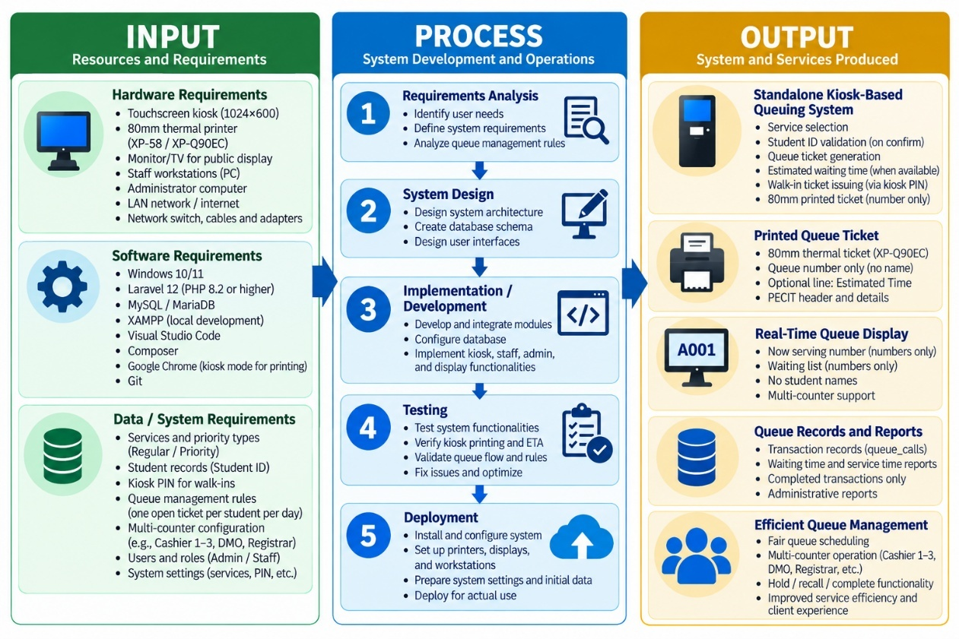
Figure 3.1 Input–Process–Output (IPO) Framework
The IPO framework consists of three major components: Input, Process, and Output. The Input represents the resources and requirements necessary for the development and operation of the proposed system. The Process represents the development activities performed using the Waterfall Software Development Model. The Output represents the completed queue management system and its implemented functions.

3.1.1 Input
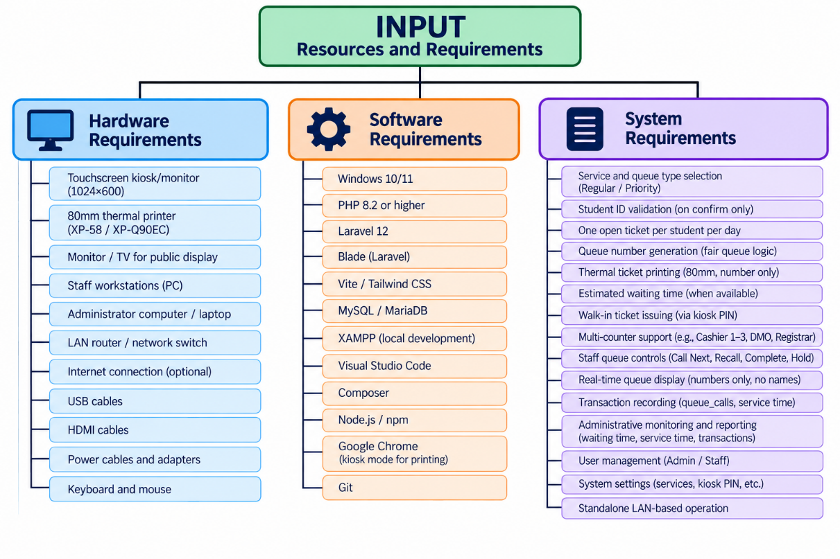
Figure 3.2 Input
The input stage consists only of the hardware requirements, software requirements, and system requirements needed to develop and operate the proposed system.

3.1.1.1 Hardware Requirements
The hardware requirements include one mini PC that serves as both the public kiosk host and the application server (Intel Core i5 8th Generation, 8 GB RAM), a touchscreen monitor, a 58mm USB thermal printer (XP-58 / XP-Q90EC), a USB RFID/NFC reader (ACR122U-A9, ISO 14443A / MIFARE), a GSM/LTE USB module (SIM7600G-H) on the same mini PC, a public HDMI display, an AVR HDMI box, staff workstations, an administrator computer, keyboard and mouse, a LAN router or network switch, and the USB, HDMI, AVR, Ethernet, and power cables required for local deployment at PECIT.
These components support kiosk interaction, queue ticket printing, public queue display, staff queue management, administrative functions, and communication among the connected system components. The operational environment of the system uses these hardware components for local deployment at PECIT.

3.1.1.2 Software Requirements
The software requirements include Windows 10/11, PHP 8.2 or higher, Laravel 12, Blade, Vite, Tailwind CSS, MySQL/MariaDB, XAMPP, Visual Studio Code, Composer, Node.js/npm, Google Chrome or Microsoft Edge, and Git.
Laravel serves as the primary application framework, while Blade and Vite with Tailwind CSS support the system interfaces. MySQL/MariaDB provides local database storage, and XAMPP provides the local server environment. Visual Studio Code is used for source-code development, Composer and Node.js/npm support dependency and frontend package management, while Google Chrome and Microsoft Edge are used for system access and testing. Git is used for version control and source-code management. Essential queue operations do not require continuous internet connectivity [11].

3.1.1.3 System Requirements
The system requirements specify the functional and operational capabilities of the proposed system. These include service selection, Regular and Priority queue selection, confirmation before ticket generation, Student ID validation by keypad or RFID/NFC tap or authorized kiosk-PIN walk-in issuance, one-open-ticket-per-student-per-day control, queue-number generation, 58mm thermal ticket printing, estimated waiting-time information when sufficient data are available, optional local GSM SMS when a student turns on Notify me by SMS (off by default; stored student mobile) or when a walk-in enters a number on the PIN overlay, shared service queues, 2 Priority to 1 Regular scheduling, multi-counter support, staff queue controls, real-time queue display, transaction recording, administrative monitoring and reporting, authentication, and standalone LAN-based operation.
The kiosk follows the sequence of service selection, queue type selection, and confirmation. During confirmation, the user types a Student ID or taps an enrolled RFID/NFC card, which is validated against the authorized student list before a queue ticket is generated. After lookup, Notify me by SMS is off by default and uses the stored student mobile; students do not type a number. The system also checks whether the student already has an open ticket for the day.
For services with multiple windows, the system supports a shared waiting queue. Cashier 1, Cashier 2, and Cashier 3 operate from one Cashier waiting queue while maintaining independent active transactions and service timers. The system applies the 2 Priority → 1 Regular scheduling rule across windows sharing the same service. Staff operations include Call Next, Recall, Complete, Hold, and Call Held.

3.1.2 Process
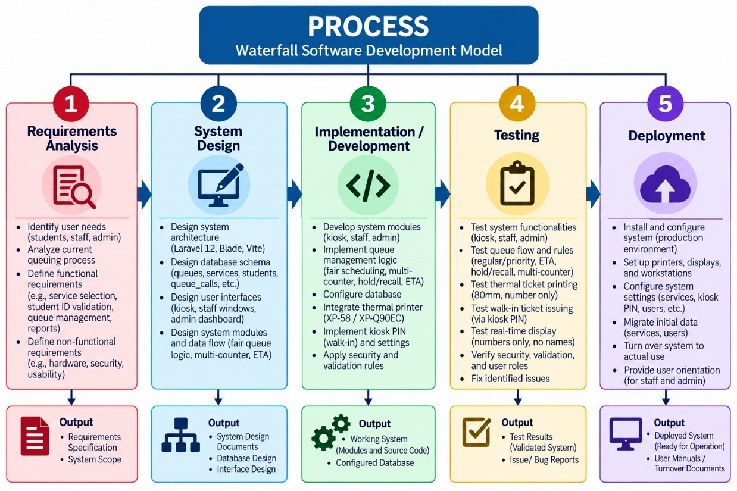Figure 3.3 Waterfall Software Development Model Used in the Study
The process stage transforms the identified inputs into the completed system through the Waterfall Software Development Model. The development process consists of five sequential phases: Requirements Analysis, System Design, Implementation/Development, Testing, and Deployment [19].

3.1.2.1 Requirements Analysis
The Requirements Analysis phase identifies the problems associated with the existing manual queuing process and determines the functional, non-functional, and operational requirements of the intended users and selected PECIT service offices. The researchers used questionnaires, interviews, observation, and document review to gather information about the existing process and the requirements of the proposed system. The results of the requirements analysis served as the basis for the subsequent design and development activities.

3.1.2.2 System Design
The System Design phase converts the identified requirements into the system architecture, process models, database structure, system workflow, and user-interface designs. The design defines the interaction among the touchscreen kiosk, application server, local database, 58mm thermal printer, staff panels, public queue display, and administrator dashboard. It also incorporates the required queue scheduling, multi-counter, privacy, and transaction-management rules.

3.1.2.3 Implementation/Development
The Implementation/Development phase translates the approved system design into a working application. The researchers developed and integrated the Student Kiosk Module, Staff Module, Administrator Module, Queue Display Module, local database, and thermal printer. The implementation includes Student ID validation, queue generation, thermal ticket printing, shared queue processing, priority scheduling, staff queue controls, and transaction recording.

3.1.2.4 Testing
The Testing phase verifies whether the developed system performs according to the documented requirements. Testing covers the kiosk, Student ID validation, one-open-ticket-per-student-per-day rule, queue generation, 58mm thermal ticket printing, fair queue scheduling, staff functions, public queue display, multi-counter behavior, database transactions, and access controls.
Integration testing also verifies the communication and data exchange among the kiosk, database, thermal printer, Staff Module, Queue Display Module, and Administrator Module.

3.1.2.5 Deployment
The Deployment phase involves installing and configuring the completed system within the designated PECIT student service environment. The touchscreen kiosk, 58mm USB thermal printer, public display monitor, staff workstations, administrator computer, local database, and LAN components are configured and verified.
The system is then prepared for operation within the selected student service offices using the institution's local computing and network environment. The system is designed to perform its essential queue operations without requiring continuous internet connectivity.

3.1.3 Output
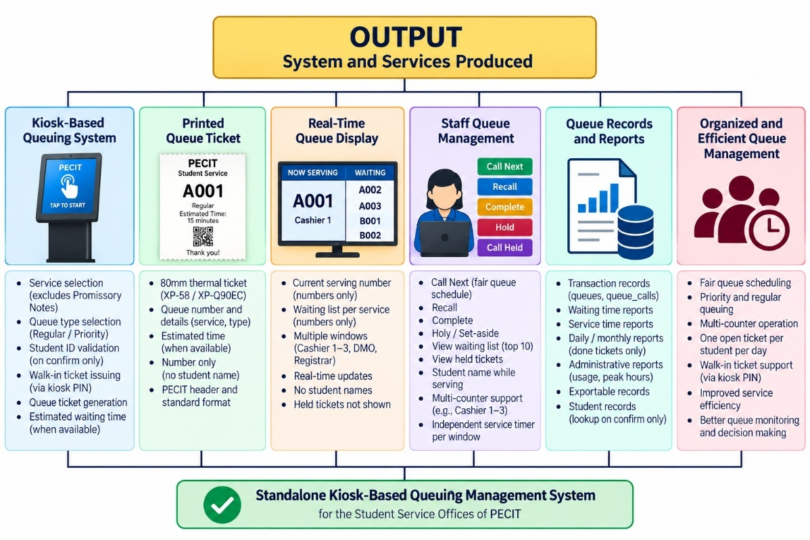
Figure 3.4 Output System and Services Produced
The output of the IPO framework is the completed Standalone Kiosk-Based Queuing Management System with Thermal Printer for the selected student service offices of PECIT.
The developed system produces the following major outputs:

3.1.3.1 Standalone Kiosk-Based Queuing System
The kiosk serves as the primary client interface. It allows users to select a service, choose Regular or Priority, enter and validate their Student ID, confirm their request, and obtain a queue number. The kiosk follows the sequence of service selection, queue-type selection, and confirmation before ticket generation.

3.1.3.2 Printed Queue Ticket
Following successful validation and confirmation, the system automatically generates an 58mm thermal queue ticket containing the queue number and necessary queue information. When sufficient historical service data are available, estimated waiting-time information may also be included. The student's name is not printed on the queue ticket.

3.1.3.3 Real-Time Queue Display
The public queue display presents the current serving number and waiting queue information to clients. The display provides queue information in real time while omitting student names and held tickets from public presentation.

3.1.3.4 Staff Queue Management
The Staff Module enables authorized personnel to manage queue transactions through their assigned service windows. Staff members can perform Call Next, Recall, Complete, Hold, and Call Held operations. Multiple service windows assigned to the same service can share one waiting queue while maintaining independent active transactions and service timers.

3.1.3.5 Queue Records and Administrative Reporting
The system stores queue transactions, student associations, services, service windows, queue calls, and completion information in the local database. Authorized administrators can manage users and student records, monitor queue activities, review transaction history, and generate reports containing waiting-time and service-time information based on completed transactions.

3.1.3.6 Organized and Fair Queue Management
The developed system provides an organized queue process through automated queue generation, 2 Priority → 1 Regular scheduling, shared service queues, multi-counter coordination, real-time queue monitoring, staff controls, transaction recording, and public queue information. The Cashier service supports multiple counters using a shared waiting queue while maintaining independent active transactions and service timers.

3.1.4 Explanation of the IPO Framework
The IPO Framework illustrates how the hardware requirements, software requirements, and system requirements serve as the inputs for the development of the proposed queue management system. These inputs are transformed through the five Waterfall phases: Requirements Analysis, System Design, Implementation/Development, Testing, and Deployment [9], [19].
The process results in a completed standalone, LAN-based queue management system specifically designed for the selected student service offices of PECIT. The system integrates the touchscreen kiosk, Student ID validation, 58mm thermal ticket printing, estimated waiting-time information when sufficient data are available, Regular and Priority queueing, 2 Priority → 1 Regular scheduling, shared multi-counter service queues, staff queue controls, real-time public display, transaction recording, and administrative reporting.
The framework therefore establishes the relationship between the identified system requirements, the development methodology, and the completed system. It reflects the actual operational structure of the developed PECIT system and provides the basis for the succeeding requirements documentation, system analysis and design, implementation, and testing activities.

3.2 Requirements Analysis
The Requirements Analysis phase was conducted to identify the problems encountered in the existing queuing process and determine the requirements of the proposed Standalone Kiosk-Based Queuing System with Thermal Printer. The researchers gathered information from students and parents through a questionnaire and from personnel of the Cashier, Registrar, and Data Management Office (DMO) through interviews. Observation and document review were also used to understand the existing process and identify the operational requirements of the selected offices.
The findings from the requirements analysis served as the basis for determining the features of the proposed system, including service selection, Regular and Priority queue selection, Student ID validation during confirmation, one-open-ticket-per-student-per-day control, automatic 58mm thermal ticket printing, real-time queue display, fair queue scheduling, staff queue management, Hold and Call Held functions, and administrative monitoring and reporting.

3.2.1 Stakeholder Identification
The stakeholders identified in the study were students and parents, personnel from the Cashier, Registrar, and Data Management Office (DMO), and the system administrator.
Students and parents were identified as the primary clients because they directly experience the existing queuing process and would interact with the kiosk and queue display. The questionnaire itself identifies Student and Parent as respondent roles and specifically focuses on their experiences with the Cashier, Registrar, and DMO.
Personnel from the Cashier, Registrar, and DMO were identified as operational stakeholders because they manage and process client transactions. Their input was necessary to identify the difficulties encountered in the manual process and the functions required for queue management.
The System Administrator was identified as the stakeholder responsible for authorized administrative functions such as user management, student records, the kiosk walk-in PIN, queue monitoring, and report generation. The Guard role exists only as the kiosk issuer record and cannot log in. This is consistent with the actual system, which provides administrative dashboard and reporting functions.

3.2.2 Data Gathering Methods
The researchers employed questionnaires, interviews, observation, and document review to gather the information required for the development of the system.
Questionnaire
A questionnaire entitled “Data Gathering for the Proposed Standalone Kiosk-Based Queuing System with Thermal Printer for Service Management at PECIT” was administered to students and parents. The stated purpose of the questionnaire was to collect information regarding users' experiences with the current queuing system at the Cashier, Registrar, and Data Management Office (DMO) for academic purposes.
The questionnaire contained four parts. Fifty respondents completed the form: 40 students (80 percent) and 10 parents (20 percent). Part I collected basic respondent information (quantitative profile). Part II used a five-point Likert scale (quantitative). Part III used checklist items with an optional Other line. Part IV collected open suggestions (qualitative). The printed form labels Part III as a Student Interview Guide, but students and parents were not interviewed. Those items were answered on the same questionnaire. Interview was used only with Cashier, Registrar, and DMO staff. These questionnaire results belong in Chapter 3. They are not evaluation scores of the finished system.
Survey results belong in Chapter 3 (Tables 3.1 through 3.3). Evaluation results belong in Chapter 4. Staff interviews were gathered before development. Functional tests, the Technical Expert System Evaluation Form, and the Cashier, Registrar, DMO, and Student System Feedback Forms were gathered after implementation. Those two sets of scores are not combined.
The quantitative items used a five-point Likert scale:
Rating | Interpretation
5 | Strongly Agree
4 | Agree
3 | Neutral
2 | Disagree
1 | Strongly Disagree
The questionnaire assessed the following Current Queuing Experience indicators: organization of the current system, reasonableness of waiting time, confusion during queuing, whether the system meets user needs, and the need for improvement.
The Proposed System section assessed respondents' perceptions regarding an automated kiosk, printed queue tickets, real-time display, service selection, priority queues, confirmation before ticket generation, and willingness to use the system.
Interview
Interviews were conducted with personnel from the Cashier, Registrar, and Data Management Office (DMO). The interviews focused on existing queue procedures, operational difficulties, queue monitoring, and the system functions needed to improve the current process.
Observation
The researchers observed the existing queuing process to understand the actual movement of clients, queue formation, waiting, and staff operations.
Document Review
Existing procedures, forms, records, and related documents were reviewed to understand the service process and the information required in the proposed system.

3.2.3 Existing System Analysis
The existing system analysis was based on the responses to the Current Queuing Experience portion of the questionnaire and the information gathered through interviews and observation.
The five-point Likert-scale results were analyzed using the weighted mean formula:
$$\boxed{WM=\frac{\sum{f}x}{N}}$$
Where:
WM = Weighted Mean
Σfx = Sum of the products of frequency and corresponding rating
N = Total number of responses (50)
The questionnaire results were interpreted using the following scale:
Weighted Mean Range | Interpretation
4.21–5.00 | Strongly Agree
3.41–4.20 | Agree
2.61–3.40 | Neutral
1.81–2.60 | Disagree
1.00–1.80 | Strongly Disagree

Questionnaire Statement | Weighted Mean | Interpretation
1. The current queuing system is well organized. | 2.43 | Disagree
2. The waiting time before being served is reasonable. | 2.30 | Disagree
3. I experience confusion during the queuing process. | 4.17 | Agree
4. The current queuing system meets my needs as a student. | 2.47 | Disagree
5. The current queuing process needs improvement. | 4.40 | Strongly Agree
Overall Mean | 3.15 | Neutral
Table 3.1 Current Queuing Experience
These five statements correspond directly to Part II-A of the questionnaire.
Computation of Overall Mean $\text{Overall Mean}=\frac{2.43+2.30+4.17+2.47+4.40}{5}$$$=\frac{15.77}{5} \\ \boxed{3.15}$$
The computed overall mean of 3.15 falls within the Neutral range based on the stated interpretation scale. However, the individual indicators reveal specific problems in the current process. The statement that the current queuing process needs improvement received the highest weighted mean of 4.40, interpreted as Strongly Agree. The statement concerning confusion during the queuing process received a weighted mean of 4.17, interpreted as Agree. Conversely, respondents disagreed that the current system was well organized, that waiting time was reasonable, and that the system met their needs.
These results indicate that the existing process has specific weaknesses in queue organization, waiting-time experience, and clarity of the queuing process.
Part III of the student-and-parent questionnaire (checklist items, not an interview) was summarized by the most checked box on each item.  Item |  | Most checked response
 | 1. Experience in line | The lines are usually long, especially during peak hours such as enrollment and payment.
 | 2. Problems encountered | Some people cut in line or do not follow proper order.
 | 3. How a kiosk could help | It can organize the queue and prevent people from cutting in line.
 | 4. Printed ticket or display | Yes, because I can monitor my turn through the display screen.
 | 5. Recommended improvement | Installation of a kiosk for automatic queue number generation.
Table 3.2 Most Checked Responses from the Student and Parent Questionnaire (Part III)
These most-checked answers match the problem and the proposed system: the current first-come-first-served line is long, uses no ticket, and is subject to line cutting, and respondents want a numbered kiosk queue with a public display

3.2.4 Requirements Gathering
The requirements of the proposed system were determined from the problems identified in the current process and the respondents' assessment of the proposed kiosk-based system.
The questionnaire's proposed-system section contained seven statements addressing the usefulness and acceptance of the proposed features.

Questionnaire Statement | Weighted Mean | Interpretation
1. A kiosk-based automated queuing system would improve service efficiency. | 4.53 | Strongly Agree
2. A printed queue ticket would help me track my turn easily. | 4.60 | Strongly Agree
3. A real-time queue display would make the system more organized. | 4.57 | Strongly Agree
4. Selecting services (Cashier, Registrar, DMO) through a kiosk would be convenient. | 4.50 | Strongly Agree
5. A priority queue option (regular/priority) would improve service flexibility. | 4.37 | Strongly Agree
6. A confirmation step before ticket generation would help reduce errors. | 4.43 | Strongly Agree
7. I am willing to use a kiosk-based queuing system. | 4.63 | Strongly Agree
Overall Mean | 4.52 | Strongly Agree
Table 3.3 Perception of the Proposed Kiosk-Based Queuing System
These seven statements are taken directly from Part II-B of the questionnaire.
Computation of Overall Mean
Based on the seven displayed weighted means:
$$\text{Overall Mean}=\frac{4.53+4.60+4.57+4.50+4.37+4.43+4.63}{7} \\ =\frac{31.63}{7} \\ \boxed{4.52}$$
The computed mean of 4.52 is interpreted as Strongly Agree. These ratings support the kiosk features built into the system.
Part IV suggestions matched those features: install a kiosk that issues a queue number; print a ticket as a clear queue reference so clients need not remain in a physical line; show Now Serving and waiting numbers on a public display; let clients select Cashier, Registrar, or DMO at the kiosk; provide Regular and Priority; and confirm the request before the ticket is printed. Suggestions beyond this build, such as SMS alerts or extra counters only at peak hours, remain later work and were not implemented in the current LAN system.
Requirements Identified from the Data
Based on the questionnaire and interview findings, the researchers identified the following user-centered requirements:
Finding from Questionnaire/Interview | Corresponding System Requirement
Need for better queue organization | Automated queue management
Waiting-time concerns | Organized queue flow and queue monitoring
Confusion during queuing | Automatic queue numbering and clear queue information
Long lines and overcrowding | Kiosk-based queue issuance
Users want a clear queue reference | Printed queue ticket
Need to monitor the queue while waiting | Real-time queue display
Need for service selection | Cashier, Registrar, and DMO service selection
Need for priority handling | Regular/Priority queue selection
Concern about incorrect selections | Confirmation before ticket generation
Staff need better queue control | Call Next, Recall, and Complete functions
Need for transaction monitoring | Queue records and reports
Need to be notified while waiting | Optional local GSM SMS after Notify me by SMS at five tickets away and when called
The questionnaire itself explicitly asks about the kiosk, printed tickets, real-time display, service selection, priority selection, and confirmation step.
the implemented system
The results of the requirements analysis therefore provided sufficient basis for proceeding to the Requirements Documentation and System Analysis and Design phases.

3.3 Requirements Documentation
The documented requirements were derived from the findings obtained through interviews, questionnaires, observation, document review, and the technical requirements of the implemented system.
The requirements cover the system's functions, quality attributes, operational rules, and user interactions.

3.3.1 Functional Requirements
Functional requirements describe the specific functions that the proposed system shall perform.
The system shall:
- Allow clients to select an available public service through the touchscreen kiosk. Promissory Notes is hidden from the public kiosk list.
- Allow clients to select either Regular or Priority queue type.
- Display a confirmation page before a queue ticket is generated.
- Require a valid Student ID during student confirmation, reject a second open student ticket for the same Student ID on the same day, and allow authorized walk-in issuance at the kiosk after the walk-in PIN is accepted, or by an administrator, without a Student ID.
- Generate a unique queue number based on the selected service and operating day.
- Store the generated queue record in the local database.
- Automatically print the queue ticket using the connected 58mm USB thermal printer.
- Display the estimated waiting time when sufficient historical service data are available.
- Require a valid Student ID during kiosk confirmation and validate it against the authorized student list before generating a queue ticket.
- Place newly generated tickets in the appropriate service queue.
- Apply the 2 Priority → 1 Regular queue scheduling rule when calling tickets.
- Allow multiple service windows assigned to the same service to share one waiting queue.
- Allow authorized staff to view the waiting queue assigned to their service window.
- Allow staff to call the next queue ticket.
- Allow staff to recall a previously called ticket.
- Allow staff to complete an active transaction and record its completion time.
- Maintain an independent service timer for each service window.
- Update queue status and queue information in real time.
- Display the current serving number and waiting queue on the public display.
- Group service windows according to their configured service group.
- Record queue calls and completion times in the database.
- Provide queue history for authorized users.
- Allow administrators to manage authorized user accounts, student records, and the kiosk walk-in PIN.
- Maintain the authorized Student ID list
- Provide an administrator dashboard for queue monitoring.
- Generate reports containing queue and service information, including waiting-time and service-time information where available.
- Operate through the institution's Local Area Network (LAN) without requiring continuous internet connectivity.
- Restrict staff and administrator functions to authenticated and authorized users.
The functions above include Student ID validation, kiosk-PIN walk-in issuance, one open student ticket per day, fair scheduling, multi-counter operation, Hold and Call Held, public display privacy, and done-only administrative reporting.

3.3.2 Non-Functional Requirements
Non-functional requirements define the quality characteristics and operating conditions expected from the proposed system.

Performance
The system shall process queue requests, generate queue numbers, update queue information, and communicate with connected components within an acceptable response time during normal operation.
Reliability
The system shall consistently perform queue generation, printing, calling, hold and resume, completion, recording, and display updating during normal operation.
Usability
The system shall provide clear and understandable interfaces for clients, staff, and administrators. The kiosk shall use a simple sequence of service selection, queue-type selection, and confirmation.
Security
Only authenticated staff and administrators shall access protected functions. One staff user is assigned to a window. The walk-in PIN is checked on the server. The Guard role cannot log in.
Availability
The system shall remain available during the intended operating hours of the participating service offices.
Maintainability
The system shall support software correction, database maintenance, system updates, and future enhancement.
Scalability
The system shall support additional service windows and service configurations without requiring fundamental changes to the queue management structure.
Compatibility
The system shall operate with the supported Windows environment, web browser, touchscreen kiosk, 58mm USB thermal printer, HDMI display, local database, and LAN infrastructure.
Privacy
The student name may appear during confirmation and to staff while serving. It shall not be printed on the ticket or shown on the public display.
Local operation
The system shall support normal queue operations within the local network without requiring continuous internet connectivity. Local application assets shall be used for normal interface operation.
Evaluation quality. System testing, expert evaluation, and User Acceptance Testing shall use quality characteristics aligned with ISO/IEC 25010 [10]. Essential queue operations do not require continuous internet connectivity [11].

3.3.3 Business Rules
Business rules define the policies and conditions that govern the operation of the proposed queuing system.
- Student ID shall be entered only during the kiosk confirmation step and validated against the authorized student list before a ticket is generated.
- The kiosk shall allow only two queue types: Regular and Priority.
- The client must confirm the selected service, queue type, and valid Student ID before a ticket is generated.
- Each confirmed request shall generate one queue ticket.
- Queue numbers shall be generated according to the selected service and operating day.
- The queue sequence shall be maintained separately for each service and date.
- Every generated queue record shall be stored in the local database.
- Every generated ticket shall be printed using the configured 58mm thermal printer.
- Queue calling shall follow the 2 Priority → 1 Regular scheduling rule for a service.
- Service windows assigned to the same service shall access a shared waiting queue.
- Each service window shall maintain its own active queue call and service timer.
- Staff shall only manage queue operations permitted for their assigned service window.
- Staff shall be authorized to Call Next, Recall, Complete, Hold, and Call Held queue transactions.
Hold shall temporarily set an active queue to held, free the current service window, and exclude the held ticket from public Now Serving and waiting lists until authorized staff resume it through Call Held.
- Queue status changes shall be reflected on the public display.
- The public waiting list shall follow the same fair queue order used by the queue-calling function.
- Completed transactions shall be retained as historical records, while held tickets remain excluded from served reports until completed.
- Estimated waiting time shall be shown only when sufficient historical completion data are available.
- Staff and administrator functions shall require authenticated access.
- One staff user shall be assigned to a service window according to the system's service-window restriction.
- The system shall operate within the institution's LAN without requiring continuous internet connectivity.
- Student names shall not be printed on tickets or shown on the public display. One open ticket per student per day shall be enforced across waiting, serving, and held statuses.

3.3.4 Use Case Descriptions
The Use Case Descriptions present the major interactions between the system and its actors. The primary actors are the Client, Staff, and Administrator, while the system performs automated processing such as Student ID validation, queue generation, ticket printing, scheduling, display updating, hold/resume handling, and reporting.

3.3.4.1 Select Service
Item | Description
Actor | Client
Objective | Select the required service
Precondition | Kiosk is available
Normal Flow | 1. Client accesses the kiosk. 2. System displays available public services. 3. Client selects the required service.
Alternative Flow | If no valid service is selected, the system does not proceed.
Postcondition | Selected service is recorded for the next step.
The public kiosk service list is filtered so that Promissory Notes is not shown on the kiosk, although the service may remain available for staff/display functions.

3.3.4.2 Select Queue Type
Item | Description
Actor | Client
Objective | Select Regular or Priority
Precondition | Service has been selected
Normal Flow | 1. System displays Regular and Priority options. 2. Client selects a queue type.
Alternative Flow | If no valid queue type is selected, the system does not proceed.
Postcondition | Queue type is recorded.

3.3.4.3 Confirm Queue Request
Item | Description
Actor | Client
Objective | Confirm the selected service and queue type
Precondition | Service and queue type have been selected
Normal Flow | 1. Client enters Student ID on the keypad. 2. System looks up the ID. 3. Name may appear for verification. 4. Waiting counts and ETA may appear. 5. Confirm remains disabled until lookup succeeds. 6. Client confirms.
Alternative Flow | Unknown ID or an already-open ticket today is rejected. The client may return to a previous step. Walk-in clients use the kiosk PIN path instead of Student ID.
Postcondition | Confirmed request is submitted for processing.
The confirmation stage validates the entered Student ID against the authorized student list, may show the matched student name for on-screen verification, and may show live waiting counts and estimated waiting time when sufficient data are available.

3.3.4.4 Issue Walk-in Ticket
Item | Description
Actor | Client / authorized issuer
Objective | Issue a ticket without a Student ID
Precondition | The kiosk walk-in control is used, or an administrator issues a walk-in ticket
Normal Flow | 1. Client or staff uses the kiosk corner control. 2. System asks for the walk-in PIN every time. 3. Server checks the PIN in settings. 4. Authorized user selects service, priority, and reason. 5. System issues the ticket.
Alternative Flow | Wrong PIN is rejected. After print or cancel, the next corner click asks for the PIN again.
Postcondition | A walk-in ticket is stored with issued_by and issue_reason. Print and display remain number-only.

3.3.4.5 Generate Queue Number
Item | Description
Actor | System
Objective | Generate a unique queue number
Precondition | Student confirmation or authorized walk-in is valid
Normal Flow | 1. System validates the request. 2. System obtains the current daily queue counter. 3. System increments the counter. 4. System generates the queue number. 5. System saves the queue record.
Alternative Flow | If validation fails, no queue number is generated.
Postcondition | Queue number and queue record are created.
The system maintains daily queue counters for each service.

3.3.4.6 Print Queue Ticket
Item | Description
Actor | System
Objective | Produce the physical queue ticket
Precondition | Queue number has been successfully generated
Normal Flow | 1. System prepares ticket information. 2. System sends the print request. 3. The 58mm thermal printer prints the ticket.
Alternative Flow | If printing fails, the queue record remains stored while the printer problem is addressed.
Postcondition | Client receives the queue ticket.
The current system uses a 58mm XP-58(XP-Q90EC) printing configuration. The student's name is not printed on the ticket.

3.3.4.7 View Queue Display
Item | Description
Actor | Client
Objective | Monitor queue progress
Precondition | Public display is operating
Normal Flow | 1. Client views the public display. 2. System shows current serving numbers and waiting tickets. 3. System updates the information as queue status changes.
Postcondition | Client receives current queue information.
The waiting list follows the same fair ordering used by the queue-calling process.

3.3.4.8 Call Next Queue
Item | Description
Actor | Staff
Objective | Call the next appropriate queue
Precondition | Staff is authenticated and assigned to a service window
Normal Flow | 1. Staff selects Call Next. 2. System determines the appropriate ticket according to the fair queue order. 3. System assigns the ticket to the staff window. 4. System updates queue status. 5. Service timer begins.
Alternative Flow | If no waiting ticket is available, the system indicates that no queue is available.
Postcondition | Ticket becomes the active transaction for the staff window.
The queue scheduler applies 2 Priority → 1 Regular across windows sharing the same service and protects against duplicate assignment during concurrent calls.

3.3.4.9 Recall Queue
Item | Description
Actor | Staff
Objective | Re-announce a previously called queue
Precondition | A previously called queue is available for recall
Normal Flow | 1. Staff selects Recall. 2. System retrieves the applicable queue call. 3. System updates the announcement information. 4. The queue is re-announced.
Postcondition | The queue is re-announced to waiting clients.

3.3.4.10 Complete Transaction
Item | Description
Actor | Staff
Objective | Complete the active client transaction
Precondition | Staff has an active queue call
Normal Flow | 1. Staff selects Complete. 2. System records the completion time. 3. Queue status is updated. 4. Display information is updated. 5. Transaction becomes part of the history.
Alternative Flow | The system prevents a staff window from completing another window's active call.
Postcondition | Transaction is recorded as completed.
The actual system keeps Call Next, Complete, Hold, and Call Held window-scoped to maintain independent counters and timers.

3.3.4.11 Hold Queue
Item | Description
Actor | Staff
Objective | Set aside the open ticket and free the window
Precondition | The window has an open serving ticket
Normal Flow | 1. Staff selects Hold. 2. The open call is finished. 3. Status becomes held. 4. The number leaves Now Serving and waiting lists.
Alternative Flow | Hold is not Complete. The ticket is not counted as a served transaction.
Postcondition | The window is free. The ticket remains held until Call Held.

3.3.4.12 Call Held
Item | Description
Actor | Staff
Objective | Resume a held ticket at this window
Precondition | The window has no open serving ticket, and a held ticket is selected
Normal Flow | 1. Staff selects Call on a held row. 2. The system assigns the ticket to this window. 3. Status becomes serving. 4. The window timer starts.
Alternative Flow | Call Held does not use 2 Priority to 1 Regular.
Postcondition | The held ticket is again the active transaction at this window.

3.3.4.13 View Queue History
Item | Description
Actor | Staff / Administrator
Objective | Review processed queue transactions
Precondition | User is authenticated
Normal Flow | 1. User opens history. 2. System retrieves authorized records. 3. System displays the records.
Postcondition | Authorized user can review queue history.

3.3.4.14 Manage Users
Item | Description
Actor | Administrator
Objective | Manage authorized accounts
Precondition | Administrator is authenticated
Normal Flow | 1. Administrator opens user management. 2. System displays user records. 3. Administrator creates or updates authorized accounts. 4. System saves valid changes.
Postcondition | User records are updated.

3.3.4.15 Manage Students
Item | Description
Actor | Administrator
Objective | Maintain the authorized Student ID list
Precondition | Administrator is authenticated
Normal Flow | 1. Administrator opens Students. 2. System displays authorized Student IDs. 3. Administrator adds, deletes, or imports records. 4. System saves valid changes used by kiosk lookup.
Postcondition | The authorized student list is updated.

3.3.4.16 Set Kiosk PIN
Item | Description
Actor | Administrator
Objective | Set the walk-in PIN stored in settings
Precondition | Administrator is authenticated
Normal Flow | Administrator updates the walk-in PIN. The PIN is not stored in the public kiosk page.
Postcondition | Later kiosk walk-in unlocks use the new PIN.

3.3.4.17 Generate Reports
Item | Description
Actor | Administrator
Objective | Monitor queue and service performance
Precondition | Administrator is authenticated and transaction records are available
Normal Flow | 1. Administrator opens reports. 2. System retrieves queue-call records. 3. System calculates available waiting and service statistics. 4. System displays the results.
Postcondition | Administrator receives queue and service reports.
The actual administrator reporting functions include overall and per-window average waiting and service times based on done tickets; hold sessions are excluded from served reports.

3.3.4.18 Estimate Waiting Time
Item | Description
Actor | System
Objective | Estimate the client's expected waiting time
Precondition | Sufficient historical and current queue/service data are available
Normal Flow | 1. System retrieves waiting and serving information. 2. System uses available service history. 3. System calculates the estimated wait. 4. System displays the estimate during confirmation when available.
Alternative Flow | If insufficient historical completion data are available, the estimate is omitted.
Postcondition | Client receives an estimated waiting time when available.
The WaitTimeEstimator uses historical, waiting, and serving information for multi-counter ETA calculations.

3.3.4.19 Manage Multi-Counter Service Queue
Item | Description
Actor | Staff / System
Objective | Allow multiple windows to serve one shared queue
Precondition | Multiple windows are assigned to the same service
Normal Flow | 1. Clients enter the service queue. 2. Multiple staff windows access the shared waiting queue. 3. Each window calls an available ticket according to the fair scheduling rule. 4. Each window maintains its own active call and timer.
Alternative Flow | If no waiting ticket is available, the window remains ready for the next request.
Postcondition | Multiple counters can serve the shared queue without duplicate ticket assignment.
The actual system supports Cashier 1–3 sharing one Cashier waiting queue, with independent active calls and timers. Held tickets may be resumed at the assigned window without following the normal 2 Priority → 1 Regular call order.

3.4 System Analysis and Design
This section presents the overall design of the proposed Standalone Kiosk-Based Queuing System with Thermal Printer. It describes the business process, system architecture, Unified Modeling Language (UML) diagrams, data flow, database structure, system workflow, and user interface design. These models provide a visual representation of the system's structure, functionality, and interactions, serving as the blueprint for the development and implementation of the proposed system.

3.4.1 Business Process Analysis
The Business Process Analysis describes the existing manual queuing process and the proposed automated process for the selected student service offices at PECIT.
Existing Business Process
In the existing process, students and other clients proceed directly to the Cashier, Registrar, or Data Management Office (DMO) and wait in a manual first-come-first-served line. Personnel watch the physical line and call the next person by arrival order. This process can become difficult to manage during periods of high transaction volume and may result in unclear order, line cutting, confusion, overcrowding, and difficulty monitoring queue progress.
Proposed Business Process
In the proposed process, the client begins at the touchscreen kiosk by selecting the appropriate service and Regular or Priority, then confirms with a Student ID or an authorized walk-in PIN path. The system stores the ticket and prints a 58mm number-only ticket. The queue record is stored in the local database and the queue ticket is printed through the connected 58mm USB thermal printer.
The generated ticket enters the appropriate service queue. When multiple windows serve the same service, they share the service's waiting queue. The system applies the 2 Priority → 1 Regular fair scheduling rule when staff call the next ticket. Each staff window maintains its own active service call and timer. The queue display is updated in real time, allowing clients to monitor the current serving and waiting queue.

3.4.2 System Architecture
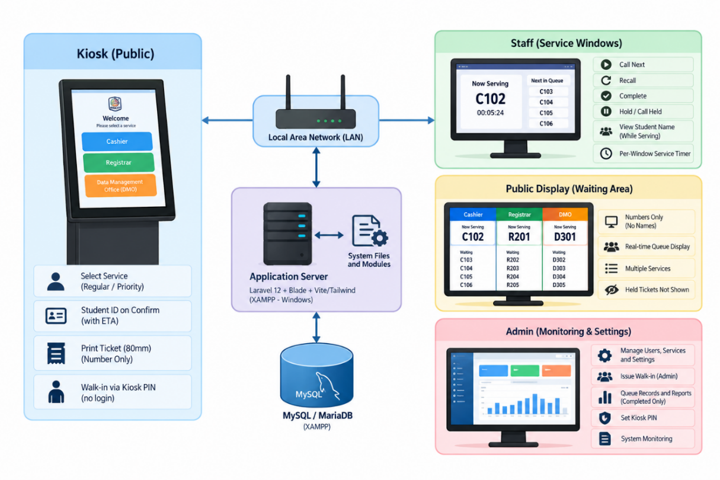
Figure 3.5 LAN architecture of the implemented queuing system
The proposed system follows a standalone LAN-based architecture in which the major hardware and software components communicate within a local network. The system is designed to operate without continuous internet connectivity for its normal queueing operations.
The architecture consists of the following major components:
Touchscreen Kiosk
Serves as the public interface where clients select a service, choose either Regular or Priority status, confirm the transaction using their Student ID, view the estimated waiting time when sufficient service data are available, and generate a queue ticket. The kiosk also supports PIN-based walk-in ticket issuance without requiring a system login.
58mm USB Thermal Printer
Produces a physical queue ticket after a valid queue request is successfully processed. The printed ticket displays the queue number and may include the estimated waiting time when available. Student names are not printed on the ticket.
Local Area Network (LAN)
Connects the kiosk, application server, staff service windows, public queue display, administrator workstation, and other authorized devices within the local network. This allows the system components to exchange queue information and operate as a standalone system.
Application Server and System Logic
Processes system requests and coordinates the different components of the queueing system. The application server handles Student ID validation, queue generation, walk-in ticket processing, queue scheduling, ticket issuance, staff queue operations, real-time display updates, administrative functions, and transaction recording. The system is implemented using Laravel with Blade, Vite, and Tailwind CSS in a Windows/XAMPP environment.
MySQL/MariaDB Database
Stores the system's operational data, including queue records, services, service windows, users, students, settings, daily queue counters, and queue-call information. The database also maintains transaction records used for queue monitoring and reporting.
Staff Service Windows
Allow authorized staff members to manage queue transactions through functions such as Call Next, Recall, Complete, Hold, and Call Held. Multiple staff windows may share the same service queue while maintaining independent active calls and service timers. Staff members may also view the client's name while actively serving a valid student or identify authorized walk-in transactions.
Public Queue Display
Provides real-time queue information for clients in the waiting area. The display shows currently serving queue numbers and waiting queue information based on the system's queue order. Student names and held tickets are not shown on the public display.
Administrator Dashboard
Provides authorized administrators with system monitoring and management functions. These include user management, student management, service and queue monitoring, walk-in ticket issuance, kiosk PIN settings, transaction history, reports, and other administrative functions.
The actual system also contains specialized queue-processing services that support the core queueing operations. The FairQueueScheduler manages the shared 2 Priority → 1 Regular queue order across service windows that handle the same service. The WaitTimeEstimator calculates estimated waiting time using available completed-service history, waiting queues, currently serving transactions, and the number of active service windows. These components support the system's objective of providing an organized, automated, and efficient standalone queue management process for the selected student service offices of PECIT.

3.4.3 Unified Modeling Language (UML)
Unified Modeling Language (UML) is used to represent the behavior and structure of the proposed system. The UML diagrams illustrate the system actors, activities, sequence of interactions, and relationships among system components.

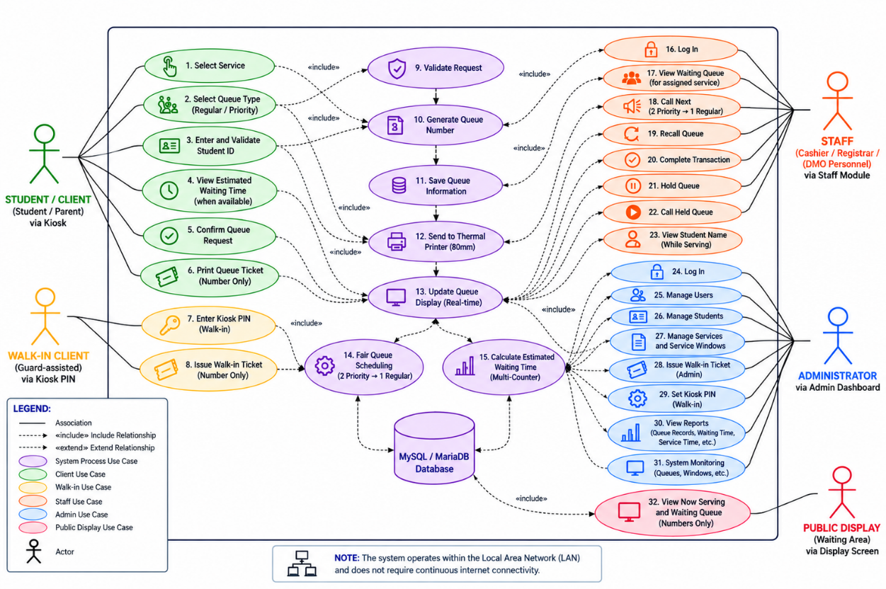
3.4.3.1 Use case diagram
Figure 3.6 Use case diagram
The Use Case Diagram presents the major interactions between the The Use Case Diagram illustrates the interactions between the different users and the Standalone Kiosk-Based Queuing Management System with Thermal Printer. The major actors and their corresponding functions are presented below:
Student/Client
- Select Service
- Select Queue Type (Regular / Priority)
- Enter and Validate Student ID
- View Estimated Waiting Time (when available)
- Confirm Queue Request
- Print Queue Ticket (Number Only)
Walk-in Client
- Enter Kiosk PIN
- Issue Walk-in Ticket (Number Only)
System Processes
- Validate Request
- Generate Queue Number
- Save Queue Information
- Send Ticket to Thermal Printer (58mm)
- Update Queue Display in Real Time
- Manage Fair Queue Scheduling (2 Priority → 1 Regular)
- Calculate Estimated Waiting Time (Multi-Counter)
Staff
- Log In
- View Waiting Queue for Assigned Service
- Call Next Queue (2 Priority → 1 Regular)
- Recall Queue
- Complete Transaction
- Hold Queue
- Call Held Queue
- View Student Name While Serving
Administrator
- Log In
- Manage Users
- Manage Students
- Manage Students and Set Kiosk PIN
- Issue Walk-in Ticket
- Set Kiosk PIN
- View Reports
- System Monitoring
Public Display
- View Now Serving and Waiting Queue
- Display Queue Numbers Only
Database
- Store and manage queue records
- Store service information
- Store service windows and users
- Store student records
- Store system settings and kiosk PIN
- Store daily queue counters
- Store queue-call and transaction records
The diagram also shows that the system operates within a Local Area Network (LAN) and does not require continuous internet connectivity for normal queueing operations. The FairQueueScheduler manages the shared 2 Priority → 1 Regular queue order, while the WaitTimeEstimator calculates estimated waiting time based on available queue and service information.

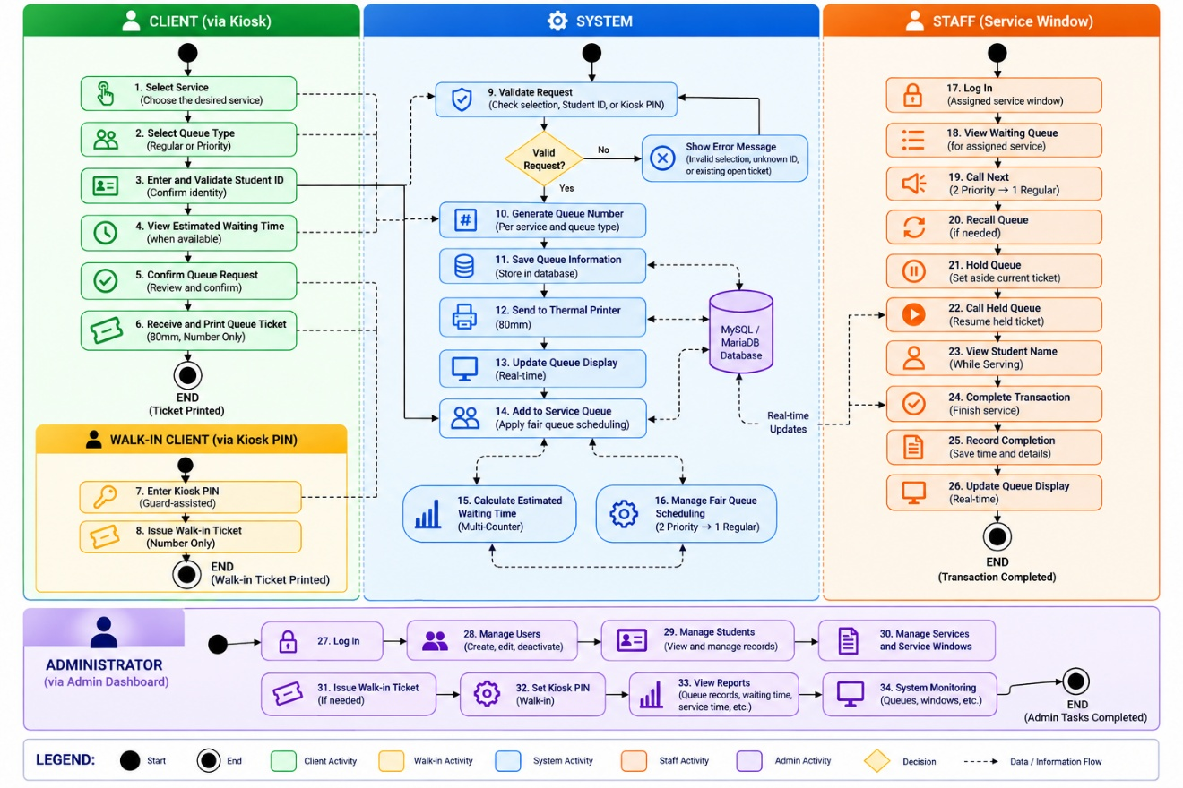
3.4.3.2 Activity Diagram
Figure 3.7 Activity Diagram
The Activity Diagram illustrates the sequence of activities from the client's queue request to transaction completion.
The process begins when the Student/Client selects a service, chooses Regular or Priority, enters and validates a Student ID, and confirms the queue request. The system validates the request, generates a queue number, stores the queue information, prints the 58mm queue ticket, and updates the public queue display.
For Walk-in Clients, a queue ticket can be issued through the kiosk after entering the designated kiosk PIN.
The ticket enters the appropriate service queue. Staff call the next ticket according to the fair queue schedule of 2 Priority → 1 Regular, serve the client, and may recall, hold, or resume a held ticket before completing the transaction. The system then records the transaction and updates the public queue display in real time.

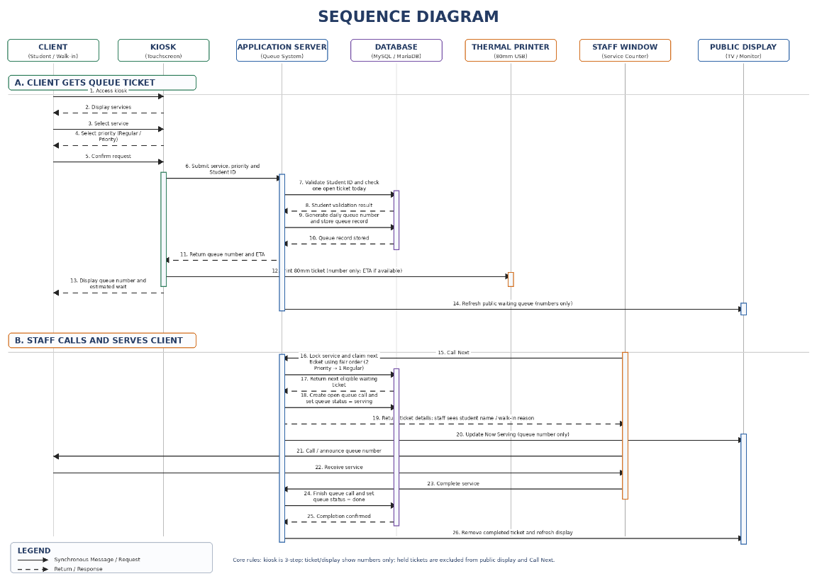
3.4.3.3 Sequence Diagram
Figure 3.8 Sequence Diagram
The Sequence Diagram presents the chronological interaction among the client, kiosk, application, database, thermal printer, staff window, and public display.
The sequence begins with the client's service and queue-type selection. After confirmation, the application validates the request, generates the queue number, stores the record, and sends ticket information to the thermal printer. The queue information is then made available to the staff window and public display.
When staff call, recall, or complete a transaction, the application updates the queue status and the corresponding display information.

3.4.4 Data Flow Diagram (DFD)
The Data Flow Diagram (DFD) illustrates how data moves between the users, system processes, and data storage of the proposed Standalone Kiosk-Based Queuing System with Thermal Printer. It shows how queue requests are received, processed, stored, and delivered to the appropriate system components.

3.4.4.1 Level 0 – Context Diagram
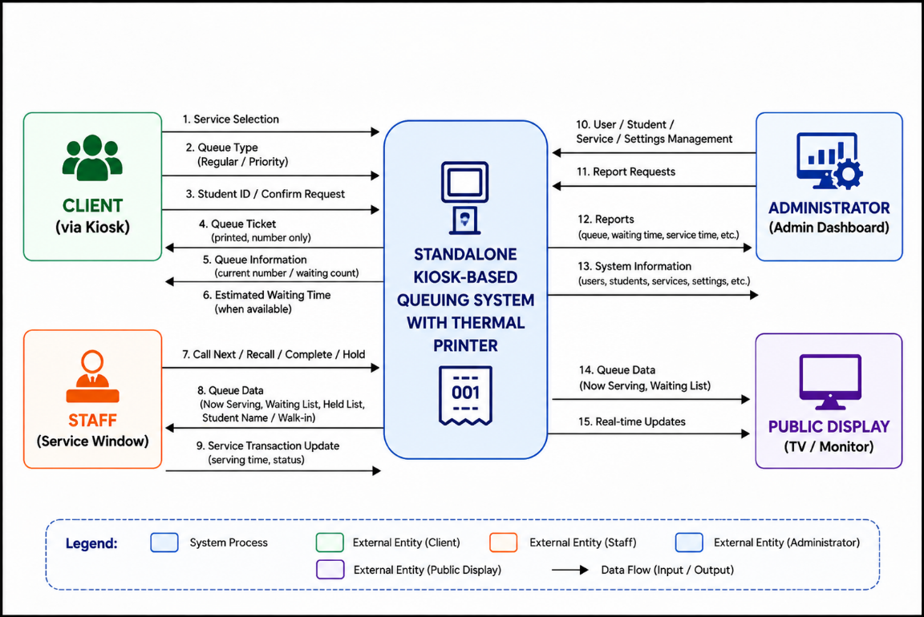
Figure 3.9 Level 0 – Context Diagram
The Level 0 DFD presents the proposed system as a single process interacting with the primary external entities:
Client to System: service, priority, Student ID or walk-in PIN and reason
Staff to System: Call Next, Recall, Complete, Hold, and Call Held
Administrator to System: user, student, kiosk PIN, and report requests
System → Client
Queue ticket and queue information
System → Staff
Waiting queue and transaction status
System → Administrator
Queue records and reports

3.4.4.2 DFD Level 1
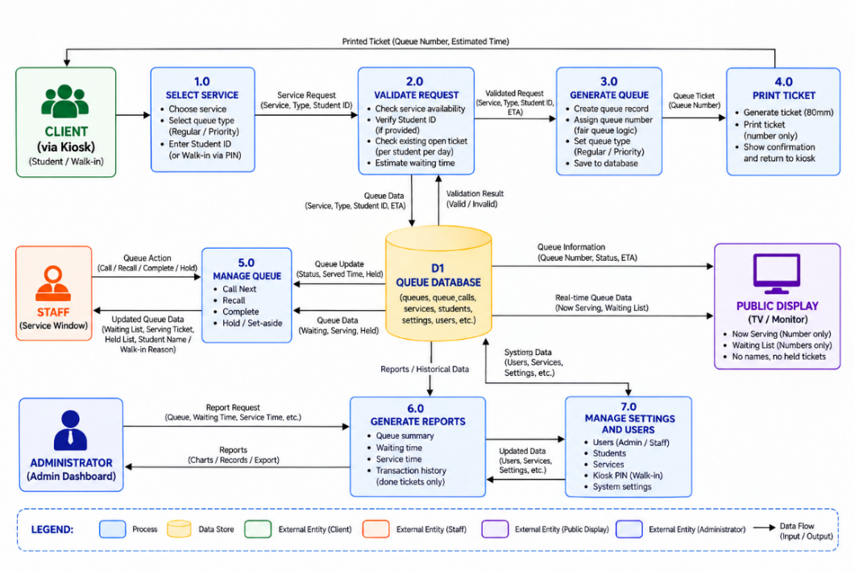
Figure 3.10 DFD Level 1
The Level 1 Data Flow Diagram (DFD) provides a more detailed view of how data moves within the proposed Standalone Kiosk-Based Queuing System with Thermal Printer. It shows how client requests are processed from service selection and queue confirmation to queue number generation, database storage, ticket printing, queue display, staff queue management, and administrative reporting. The diagram also shows the interaction of the system with the main data stores and connected system components.

3.4.5 Entity Relationship Diagram (ERD)
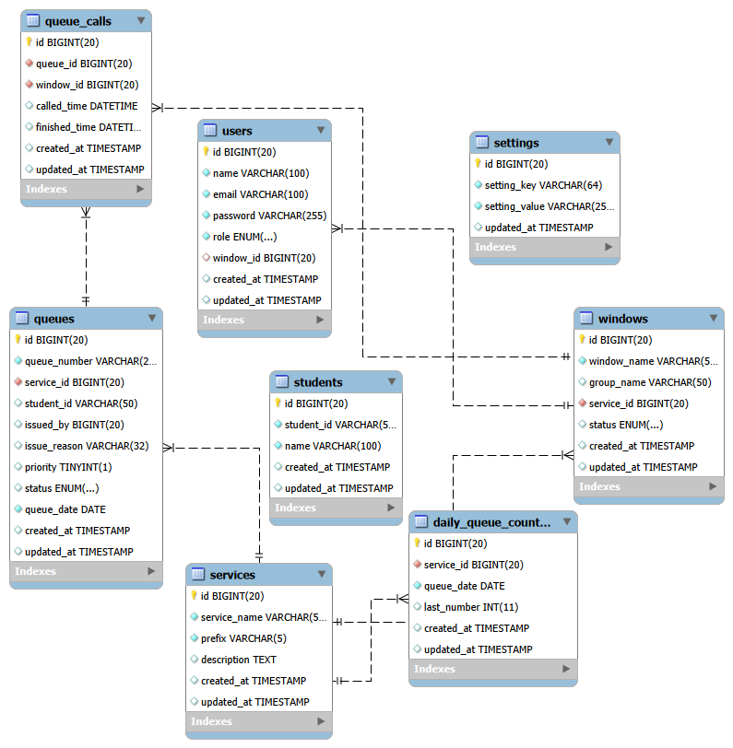
Figure 3.11 Entity Relationship Diagram (ERD)
The Entity Relationship Diagram represents the relationships among the main database entities used by the system.
The principal entities are Services, Windows, Users, Students, Settings, Daily Queue Counters, Queues, and Queue Calls.
- Services
- Windows
- Users
- Students
- Settings
- Daily Queue Counters
- Queues
- Queue Calls
The services entity is related to queues, windows, and daily_queue_counters. The students entity stores the authorized Student IDs and corresponding names used for kiosk validation. The queues entity references the selected service and validated student association when used; it is related to queue_calls, while queue_calls are associated with service windows. Users are associated with their assigned service windows. The database structure supports queue generation, student validation, shared service queues, fair scheduling, service-window management, transaction recording, and reporting.

3.4.6 Database Design
The database contains the Services, Windows, Users, Students, Settings, Daily Queue Counters, Queues, and Queue Calls tables.

3.4.6.1 Data base schema
The domain structure includes services, windows, users, students, settings, daily_queue_counters, queues, and queue_calls. The Laravel migrations table, if present, is not a queue-domain table.
The users table stores authorized administrator and staff accounts. The Guard role is stored as the kiosk issuer record and cannot log in. The settings table stores the kiosk walk-in PIN.
The daily_queue_counters table maintains the queue-number sequence for each service and operating date. The queues table stores the generated queue number, service, priority value, queue status, queue date, and timestamp information. The queue_calls table records the association between queue tickets and service windows, including the time the ticket was called and the time the transaction was completed.
The relationships among these tables allow the system to generate queue numbers by service and date, associate queues with their corresponding services, assign service windows, record queue calls and completions, and support the waiting-time and service-time information used in administrative reports. The database therefore provides the data foundation for queue generation, queue management, transaction monitoring, and reporting.

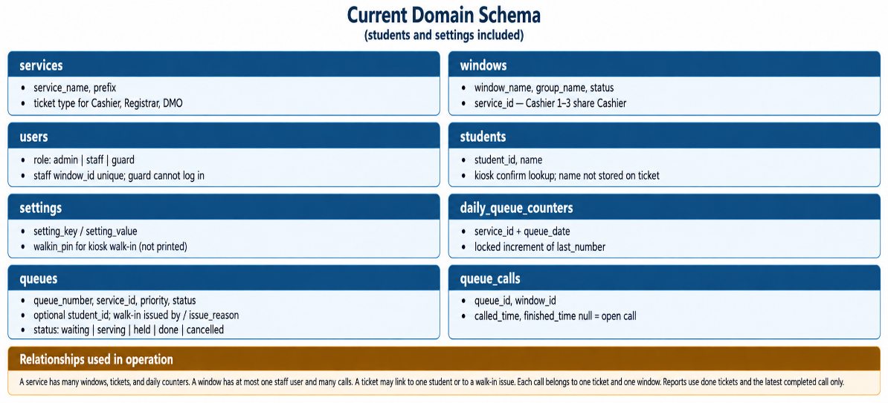
Figure 3.12 Current database schema, including students and settings

3.4.6.2 Data Dictionary
The dictionary corresponds to the actual system structure, including services, windows, users, students, settings, daily queue counters, queues, and queue calls.
Field Name | Data Type | Key | Description
id | BIGINT(20) | PK | Unique identifier of the service
service_name | VARCHAR(255) | — | Name of the service
prefix | VARCHAR(10) | — | Prefix used for queue numbering
description | TEXT | — | Description of the service
created_at | TIMESTAMP | — | Date and time the record was created
updated_at | TIMESTAMP | — | Date and time the record was last updated
Table 3.4 Data Dictionary - Services
The Services table contains the service categories available in the system and the information needed to identify and generate queue numbers for each service. The actual system uses service records and ticket prefixes as part of queue generation.
Field Name | Data Type | Key | Description
id | BIGINT(20) | PK | Unique identifier of the service window
window_name | VARCHAR(255) | — | Name or number of the service window
group_name | VARCHAR(50) | — | Group assigned to the service window
service_id | BIGINT(20) | FK | Identifies the service assigned to the window
status | ENUM | — | Indicates the current status of the window
created_at | TIMESTAMP | — | Date and time the record was created
updated_at | TIMESTAMP | — | Date and time the record was last updated
Table 3.5 Data Dictionary - Windows
The Windows table stores the service counters or windows used by staff. Each window is associated with a service, and multiple windows can share the same service queue, such as the Cashier counters.
Field Name | Data Type | Key | Description
id | BIGINT(20) | PK | Unique identifier of the user
name | VARCHAR(100) | — | Name of the authorized user
email | VARCHAR(100) | — | Email or login identifier
password | VARCHAR(255) | — | User authentication password
role | ENUM | — | Defines whether the user is an administrator, staff, or guard
window_id | BIGINT(20) | FK | Identifies the service window assigned to a staff user
created_at | TIMESTAMP | — | Date and time the record was created
updated_at | TIMESTAMP | — | Date and time the record was last updated
Table 3.6 Data Dictionary - Users
The Users table stores authorized accounts. Roles are admin, staff, and guard. Staff users may be assigned to one window. The Guard role cannot log in and is used only as the kiosk walk-in issuer record.
Field Name | Data Type | Key | Description
student_id | VARCHAR | PK | Authorized Student ID used for kiosk validation. The students table also has a numeric id primary key; student_id is unique.
name | VARCHAR | — | Student name associated with the authorized Student ID
card_uid | VARCHAR(32) | Unique, nullable | Enrolled RFID/NFC serial for tap confirm
mobile | VARCHAR(20) | - | Stored number for GSM SMS; not typed at student Confirm
Table 3.7 Data Dictionary - Students
The Students table stores the authorized Student ID allowlist and the matching name used on confirmation and by staff while serving. The table has a numeric id primary key. student_id is unique. The student name is never stored on the ticket row.
Field Name | Data Type | Key | Description
id | BIGINT | PK | Setting identifier
setting_key | VARCHAR(64) | Unique | Setting name (walkin_pin)
setting_value | VARCHAR(255) | - | Stored value
updated_at | TIMESTAMP | - | Last update
Table 3.8 Data Dictionary - Settings
The Settings table stores the kiosk walk-in PIN as setting_key walkin_pin and setting_value. The PIN is edited by the administrator and checked on the server. Every kiosk corner-button use asks for this PIN. The PIN value is not published in this manuscript.
Field Name | Data Type | Key | Description
id | BIGINT(20) | PK | Unique identifier of the daily queue counter
service_id | BIGINT(20) | FK | Identifies the service associated with the counter
queue_date | DATE | — | Date for which the queue counter is maintained
last_number | INT(11) | — | Stores the latest queue number generated
created_at | TIMESTAMP | — | Date and time the record was created
updated_at | TIMESTAMP | — | Date and time the record was last updated
Table 3.9 Data Dictionary - Daily Queue Counters
The Daily Queue Counters table maintains the latest queue number for each service and operating date.
Field Name | Data Type | Key | Description
id | BIGINT(20) | PK | Unique identifier of the queue record
queue_number | VARCHAR(20) | — | Generated queue number
service_id | BIGINT(20) | FK | Identifies the selected service
student_id | VARCHAR(50) | FK | Student ticket only; nullable. Walk-in tickets leave this field empty.
priority | TINYINT(1) | — | Indicates Regular or Priority queue type
status | ENUM | — | Current status of the queue
queue_date | DATE | — | Date the queue ticket was generated
created_at | TIMESTAMP | — | Date and time the queue was created
updated_at | TIMESTAMP | — | Date and time the queue record was updated
notify_mobile | VARCHAR(20) | - | Copied from students.mobile when SMS is on, or walk-in overlay
sms_near_sent | TINYINT | - | 1 after the five-tickets-away SMS
Table 3.10 Data Dictionary - Queues
The Queues table stores the queue tickets generated by the kiosk. It records the service, queue number, priority value, validated student association, status, queue date, and timestamps required for queue management and waiting-time calculations. The actual system uses priority values of 0 for Regular and 1 for Priority, with statuses including waiting, serving, done, cancelled, and held.
Walk-in tickets leave student_id empty and store issued_by and issue_reason. The student name is never stored on the ticket row. Staff see Walk-in followed by the reason while serving.
Queues also store issued_by (nullable foreign key to the issuer user) and issue_reason (walk-in reason). Reports use the latest completed call of a done ticket. Hold sessions are excluded from served counts.
Field Name | Data Type | Key | Description
id | BIGINT(20) | PK | Unique identifier of the queue-call record
queue_id | BIGINT(20) | FK | Identifies the queue ticket being served
window_id | BIGINT(20) | FK | Identifies the service window handling the queue
called_time | DATETIME | — | Date and time the queue was called
finished_time | DATETIME | — | Date and time the transaction was completed
created_at | TIMESTAMP | — | Date and time the call record was created
updated_at | TIMESTAMP | — | Date and time the call record was updated
Table 3.11 Data Dictionary - Queue Calls
The Queue Calls table records the service activity associated with a queue ticket. It identifies the queue and service window and records the time when the ticket was called and completed. These timestamps support service monitoring and the calculation of waiting and service times.
Laravel migrations, if present in the environment, are not a queue-domain table and are omitted from this dictionary.
The primary domain tables are services, windows, users, students, settings, daily queue counters, queues, and queue calls.
Data Dictionary Summary
Table name | Main Purpose
services | Stores available services and queue prefixes
windows | Stores service counters/windows and their assigned services
users | Stores authorized administrator and staff accounts
students | Stores authorized Student IDs, names, optional card serials (UID), and optional mobile numbers
settings | Stores the kiosk walk-in PIN; the PIN is not published in this manuscript.
daily_queue_counters | Maintains daily queue-number sequences
queues | Stores generated queue tickets and their statuses
queue_calls | Records queue calls, service windows, and completion times
migrations | Not a queue-domain table. Laravel migrations, if present, are omitted from this dictionary.
Table 3.12 Data Dictionary Summary
settings — Stores the kiosk walk-in PIN. The PIN is checked on the server and is not printed in this manuscript.

3.4.7 System Flowchart
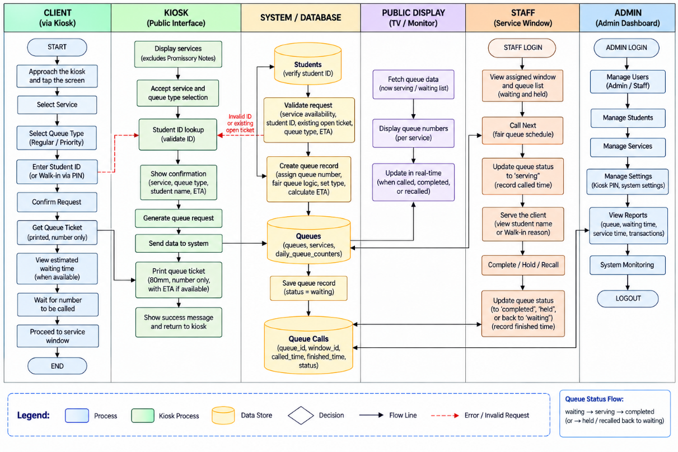Figure 3.13 System Flowchart
The System Flowchart illustrates the overall operational flow of the proposed Standalone Kiosk-Based Queuing System with Thermal Printer. It shows the sequence of activities performed by the client, kiosk, system and database, public display, staff service window, and administrator from queue creation until transaction completion.
The process begins when the client accesses the kiosk and selects Cashier, Registrar, or DMO. Promissory Notes is hidden from this list. The client selects Regular or Priority. A student then enters a Student ID on the confirmation keypad. Confirm stays disabled until lookup succeeds. A walk-in client uses the corner PIN control, then selects service, priority, and reason.
After the ticket is generated, the queue is placed in the appropriate service queue and the public display is updated with the current queue information. For services with multiple counters, the service windows share the same waiting queue, and the system applies the 2 Priority → 1 Regular fair scheduling rule. Each service window maintains its own active call and service timer.
The staff member accesses the assigned window, views the fair waiting list, and may Call Next, Recall, Complete, Hold, or Call Held. Hold is not Complete. Each window keeps its own open call and timer. An optional System Float window can stay on top on the staff PC.
The administrator accesses the dashboard to manage users and students, set the kiosk walk-in PIN, issue walk-in tickets, review history and held tickets, and generate done-only wait and service reports.
The flowchart reflects queue status progression among waiting, serving, held, and done. Hold is not Complete.

3.4.8 User Interface Design
The interfaces below are described from the implemented system. Images placed in this section are placeholders and must be replaced with screenshots of the current kiosk, staff panel, administrator dashboard, and public display. The text is the description of record.
The four implemented components are the kiosk, staff panel, administrator dashboard, and public display.
Kiosk Interface
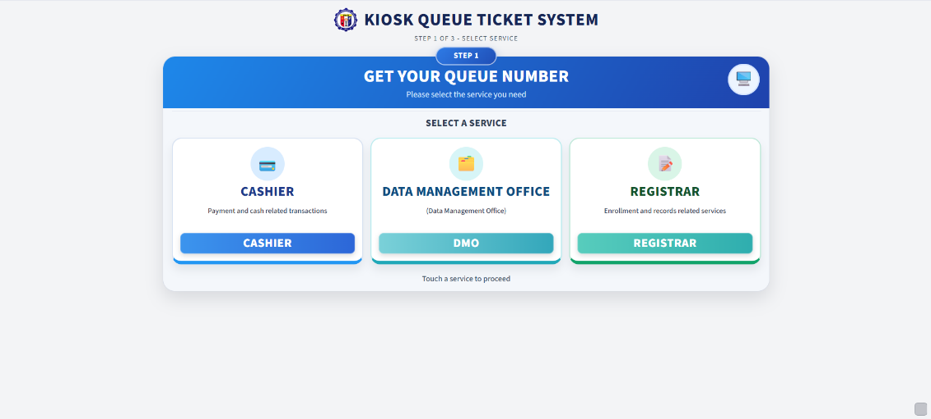
Figure 3.14 Current kiosk service selection
The public kiosk shows Cashier, Registrar, and DMO. Promissory Notes is hidden. The layout is a compact three-step flow for a 1024 by 600 screen: service, Regular or Priority, and confirmation with a summary column, Student ID keypad, and RFID/NFC reader. Confirm stays disabled until lookup succeeds. The matched name may appear for checking only. Waiting counts and estimated wait may appear when data are sufficient. Notify me by SMS is off by default and uses the stored student mobile; students do not type a number. If no mobile is on file, the control is disabled and shows No SMS number on file. The full number is not shown. A small bottom-right control opens the walk-in PIN pad on every use. After a correct PIN, the overlay issues a walk-in ticket with service, priority, reason, and an optional mobile number.
The interface follows a simplified interaction flow:
- Service selection
- Priority selection
- Confirmation screen
- Automatic ticket generation and printing
After print, a countdown returns to the first step. The student name is never printed and is never shown on the public display. Walk-in tickets also print number-only.
Large, clearly labeled buttons and a clean layout make the interface easy to understand and accessible, even for first-time users. After confirmation, the system automatically prints the ticket and displays the queue number on screen, and then automatically returns to the home screen after a set duration.
Staff Panel
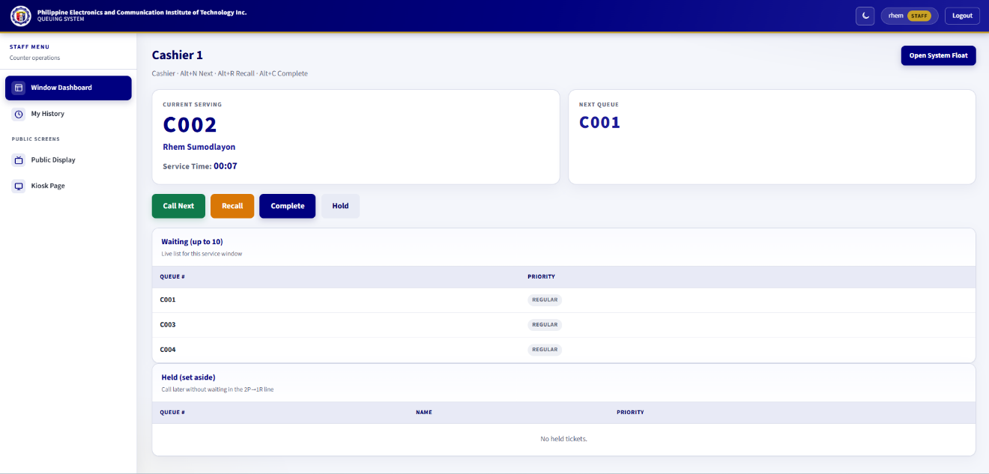
Figure 3.15 Current staff serving panel
The staff panel interface is intended for personnel assigned to service windows. It allows staff to efficiently manage the queue through the following functions:
- Call Next, Recall, Complete, Hold, and Call Held
- Recall ticket
- Complete transaction
- View waiting queue list
The panel shows the current number, the student name or Walk-in (reason), an independent window timer, a fair waiting list of up to 10, and a held list. Shortcuts are Alt+N for Call Next, Alt+R for Recall, and Alt+C for Complete. An optional System Float window can stay on top on the staff PC.
Administrator Dashboard
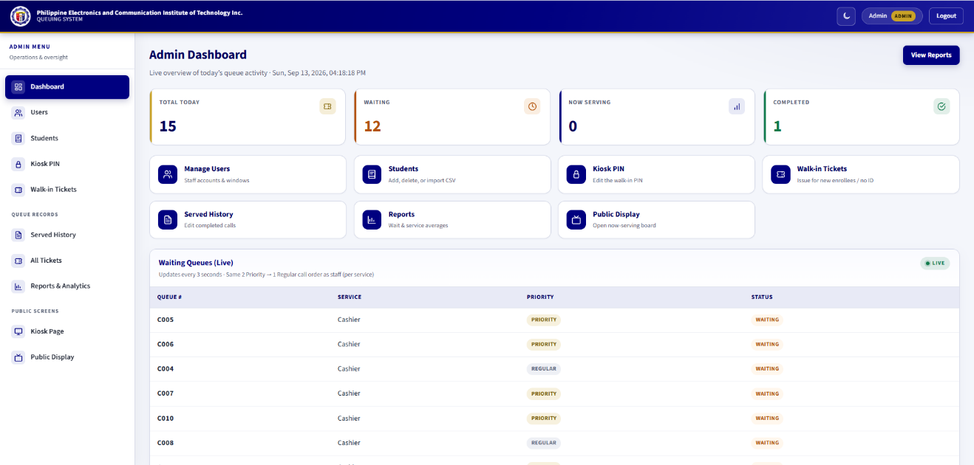
Figure 3.16 Current administrator dashboard
The admin dashboard is designed for administrators to monitor and manage the overall system. It provides:
- Real-time queue monitoring
- Access to transaction reports
- User, student, and kiosk PIN management
The interface is organized to present key system data clearly, allowing administrators to oversee system performance and make necessary adjustments. The dashboard supports efficient system management through a structured and user-friendly layout.

Public Display
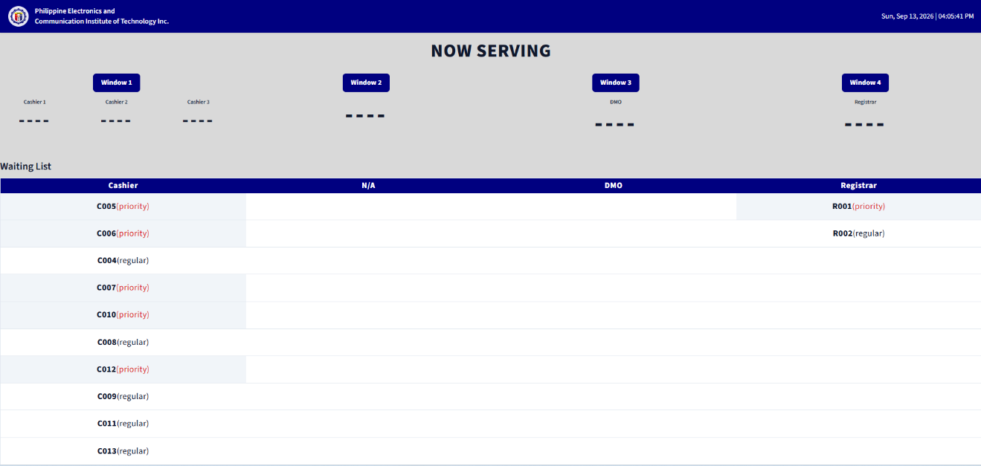
Figure 3.17 Current public display (numbers only)
The queue display page is designed to present real-time queue information to users waiting for their turn. It displays:
- Current serving numbers
- Waiting list (queue number and priority only)
- Assigned service windows
The display supports grouped service windows, such as:
- Window 1: Cashier 1, Cashier 2, Cashier 3
- Window 2: Promissory Notes. This window exists in the domain data, but Promissory Notes is hidden from the public kiosk service list.
- Window 3: Data Management Office (DMO)
- Window 4: Registrar
The interface uses a clear and highly visible layout to ensure that users can easily track queue progress. It may also include the current date and time, as well as visual or audio indicators to notify users when their number is called.

3.5 Operational Environment
The operational environment describes the hardware, software, network infrastructure, and user environment required for the successful deployment and operation of the proposed Standalone Kiosk-Based Queuing System with Thermal Printer. Since the system is designed as a standalone application operating within the campus, it requires appropriate computing resources and network configuration to ensure efficient queue management, reliable ticket printing, and real-time queue monitoring.

3.5.1 Hardware Requirements
HDMI public queue display monitor
Hardware Component | Actual/Required Configuration
Touchscreen Kiosk / Touchscreen Monitor | Primary public interface for service selection and confirmation
58mm USB Thermal Printer | XP-58 (XP-Q90EC) or equivalent compatible 58mm thermal printer
HDMI public display monitor | Public queue display
AVR HDMI Box | Display/AVR connection
Staff Workstation | Windows workstation for assigned service-window operations
Administrator Computer | Windows workstation for administrative functions
Keyboard and Mouse | Standard USB keyboard and mouse
LAN Router / Network Switch | Local network communication among system components
USB Cable | Kiosk-to-thermal-printer connection
HDMI Cable | Display connection
AVR Cable | AVR/display connection
Ethernet Cable | LAN connection
Power Cables / Adapters | Power and device connection
Mini PC (kiosk and server) | Intel Core i5 8th Generation, 8 GB RAM; hosts kiosk browser and Laravel application
USB RFID/NFC reader | ACR122U-A9, ISO 14443A / MIFARE, for tap confirm
GSM/LTE USB module | SIM7600G-H on the mini PC; local SMS, not a cloud API
Table 3.13 Hardware Requirements
The kiosk unit serves as the primary interface where users select services and obtain queue tickets. A thermal printer is connected directly to the kiosk for automatic ticket printing, while a separate display monitor presents the currently served and waiting queue numbers. Administrative staff utilize desktop computers connected through a Local Area Network (LAN) to manage queue operations.

3.5.2 Software Requirements
The proposed system utilizes open-source software technologies for application development, database management, and system deployment. Table 3.14 presents the software requirements of the proposed system.
Software | Purpose
Windows 10/11 | Operating system for local deployment and workstation use.
XAMPP | Provides the local Apache/PHP/MySQL server environment.
PHP 8.2+ | Server-side programming language.
Laravel 12 | Main application framework and backend logic.
Blade | Laravel templating engine for system interfaces.
Vite | Frontend asset development and bundling tool.
Tailwind CSS | Utility-first CSS framework used for interface styling.
MySQL/MariaDB | Local relational database management system.
Visual Studio Code | Source-code editor used during development.
Composer | PHP dependency manager.
Node.js / npm | Frontend package and dependency management.
Google Chrome / Microsoft Edge | Browsers used for local system access and testing.
Git | Version control and source-code management.
Table 3.14 Software Requirements
Laravel serves as the primary framework for application development because of its security, scalability, and support for the Model-View-Controller (MVC) architecture. MySQL manages the storage of queue transactions, while XAMPP provides the local server environment necessary for deploying the standalone application.

3.5.3 Network Requirements
The proposed system operates within the institution's Local Area Network (LAN), allowing communication between the kiosk, administrative computers, queue display monitor, and the local database server. The system does not require internet connectivity during normal operation since all data processing and storage are performed locally.
A wired Ethernet connection is recommended to ensure stable and uninterrupted communication among system components. The use of CAT5e or CAT6 LAN cables connected through a network switch enables real-time synchronization of queue information across the kiosk, staff terminals, and queue display monitor. This network configuration minimizes communication delays and ensures reliable operation of the queue management system.

3.5.4 User Environment
The proposed system accommodates three primary categories of users, each with specific roles and responsibilities.
Students and Clients
Students and other clients interact with the touchscreen kiosk to select the appropriate office, choose the queue type (Regular or Priority), confirm their request, and receive a printed queue ticket. They can also monitor the queue display to determine when their queue number is being served.
Office Personnel
Authorized personnel from the Cashier, Registrar, and Data Management Office (DMO) manage queue operations through the staff interface. They are responsible for calling the next queue number, recalling missed clients, completing transactions, and monitoring the current queue status.
System Administrator
managing student records, setting the kiosk walk-in PIN, monitoring queue records, generating reports

3.6 System-to-System Interface
The System-to-System Interface describes how the major components of the proposed Standalone Kiosk-Based Queuing System with Thermal Printer interact and exchange information to support efficient queue management. Although the system operates within a standalone local network, its components communicate seamlessly to ensure synchronized processing of queue transactions and real-time updates.
The kiosk interface serves as the entry point where students and clients initiate queue requests by selecting the desired service office and queue type. The application processes the user's request, generates a unique queue number, stores the transaction in the local database, and sends a command to the thermal printer to produce a printed queue ticket.
The local database maintains queue records, service configurations, transaction logs, and user information. The staff panel retrieves queue information from the database and updates the queue status whenever personnel call, recall, or complete a transaction. These updates are immediately reflected on the queue display monitor, allowing waiting clients to monitor queue progress in real time.
The administrator dashboard also communicates with the database to manage users, configure services, monitor queue activities, and generate transaction reports. Through these interactions, the system maintains data consistency, supports efficient queue processing, and provides reliable service operations throughout the institution.
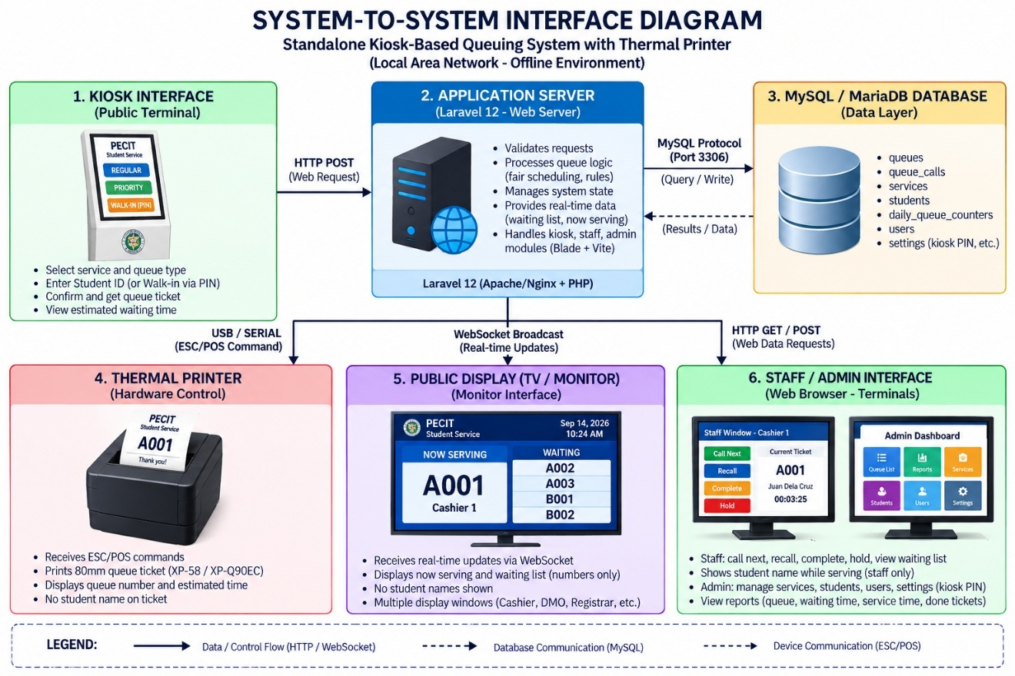Figure 3.18 System-to-System Interface

3.7 Communication Interface
Since the proposed system is implemented as a standalone application within the institution, communication occurs through the Local Area Network (LAN) and direct device connections. The LAN supports real-time exchange among the kiosk, application/database host, staff workstations, administrator computer, and queue display. The thermal printer connects directly to the kiosk workstation through USB. Continuous internet connectivity is not required for normal operation.

3.7.1 Internal Communication
Internal communication refers to the exchange of information among the software and hardware components of the proposed queuing system.
Source Component | Destination Component | Data Transmitted | Purpose
Touchscreen Kiosk | Laravel Application | Service, priority, Student ID, confirmation | Validates the request and processes queue creation.
Application Server | MySQL/MariaDB Database | Queue, student association, service, priority, status, counters | Stores and retrieves queue information.
Application Server | 58mm USB Thermal Printer | Queue number and ticket details | Prints the confirmed queue ticket without the student's name.
MySQL Database | Staff Panel | Queue calls, status changes, hold/resume actions | Enables authorized staff to manage transactions.
MySQL Database | Administrator Dashboard | Users, students, services, history, reports | Supports authorized administration and reporting.
MySQL Database | Queue Display Monitor | Serving and waiting queue numbers | Displays public queue information without student names.
Table 3.15 Internal Communication Interface

3.7.2 External Communication
External communication refers to the interaction between the proposed queuing system and its users through the available input and output devices
External Entity | Interface | information Sent
  System Response
Students and Clients | Touchscreen Kiosk | Service, priority, Student ID, confirmation | Validates Student ID and generates a queue ticket after confirmation.
Students and Clients | Queue Display Monitor | — | Displays current serving and waiting queue numbers only.
Administrative Staff | Staff Panel | Call Next, Recall, Complete, Hold, Call Held | Updates queue status and service-window operations.
System Administrator | Administrator Dashboard | User, student, kiosk PIN, and report requests | Supports authorized administration.
Table 3.16 External Communication Interface

3.8 Development Methodology
The proposed Standalone Kiosk-Based Queuing System with Thermal Printer was developed using the Waterfall Software Development Model, a linear and sequential approach where each phase is completed before proceeding to the next. The methodology consisted of five phases: Requirements Analysis, System Design, Implementation/Development, Testing, and Deployment.
During Requirements Analysis, the researchers identified existing queuing problems and gathered system requirements. System Design involved preparing the system architecture, diagrams, database, workflow, and user interfaces. Implementation/Development focused on developing the kiosk, Staff Module, Administrator Module, Queue Display Module, database, and thermal printer integration. Testing verified the system's functionality, reliability, hardware, database operations, and user acceptance. Finally, Deployment involved installing and configuring the completed system, including the kiosk, printer, database, displays, workstations, and LAN.

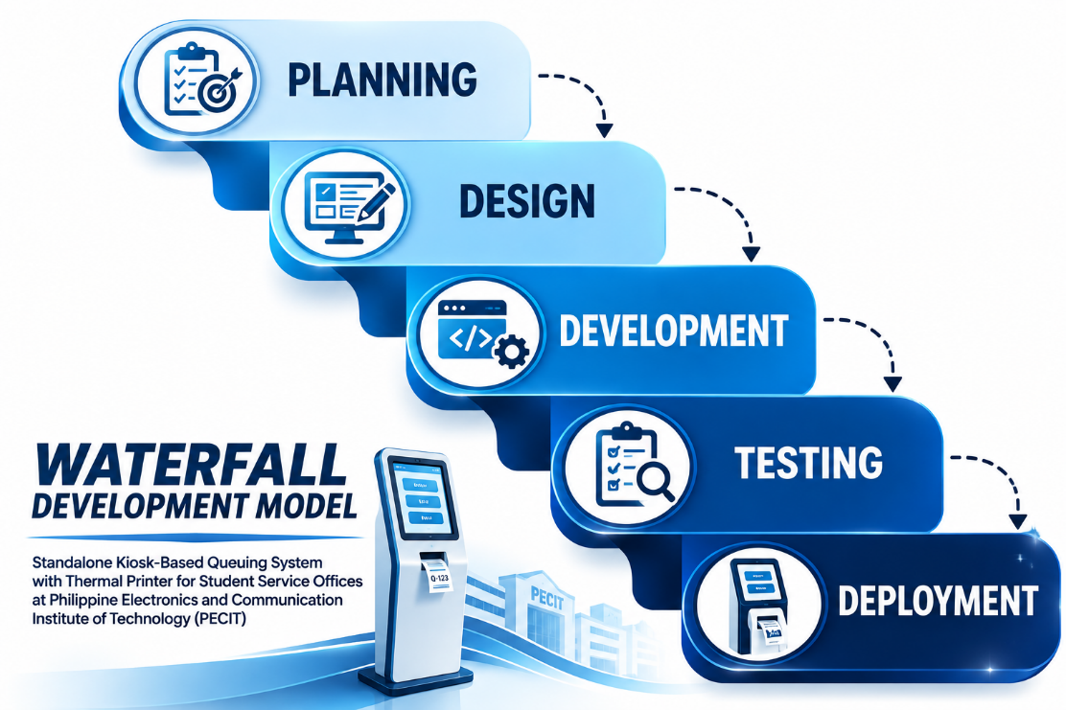
Figure 3.19 Waterfall Development Model Used in the Study
The Waterfall Software Development Methodology is a linear and sequential approach used in developing the Standalone Kiosk-Based Queuing System with Thermal Printer. The development progresses through clearly defined phases, beginning with Requirements Analysis, followed by System Design, Implementation/Development, Testing, and Deployment. Each phase is completed before proceeding to the next, ensuring that the system requirements, design, development, functionality, and deployment are systematically addressed.
Phases of the Waterfall Methodology
1. Requirements Analysis
- Identify the problems in the existing manual queuing process.
- Gather requirements from students/clients, office personnel, and administrators.
- Determine the functional and non-functional requirements of the proposed system.
2. System Design
- Develop the system architecture and workflow.
- Prepare the Use Case Diagram, DFD, flowchart, database design, and user-interface designs.
- Plan the interaction among the kiosk, database, thermal printer, staff panel, and queue display.
3. Implementation / Development
- Develop the kiosk interface, Staff Module, Administrator Module, and Queue Display Module.
- Implement the MySQL database and integrate the thermal printer.
- Connect the system components through the LAN.
4. Testing
- Conduct functional, integration, system, hardware, database, and User Acceptance Testing.
- Verify queue generation, ticket printing, real-time updates, staff operations, and database transactions.
5. Deployment
- Install and configure the system at PECIT.
- Set up the kiosk, database, printer, user accounts, and connected hardware.
- Deploy the system for actual use in the student service offices.
Five-Phase Waterfall Process:
Requirements Analysis
↓
System Design
↓
Implementation / Development
↓
Testing & Evaluation
↓
Deployment

3.8.1 Software Development Model
The proposed Standalone Kiosk-Based Queuing System with Thermal Printer was developed using the Waterfall Software Development Model. Waterfall is a linear and sequential software development methodology in which the system progresses through clearly defined phases, with each phase completed before proceeding to the next. This approach provides a structured development process that ensures the system requirements, design, implementation, testing, and deployment are systematically addressed.
For this study, the Waterfall model was implemented through five sequential phases: Requirements Analysis, System Design, Implementation/Development, Testing, and Deployment. During the Requirements Analysis phase, the researchers identified the functional and non-functional requirements through interviews, observations, and document analysis. The System Design phase involved the preparation of the system architecture, Use Case Diagram, Data Flow Diagram (DFD), system flowchart, database design, and user interface designs. During the Implementation/Development phase, the identified system modules were developed using Laravel, PHP, MySQL, and related technologies, including the kiosk interface, staff panel, administrator dashboard, and thermal printer integration. The Testing phase verified the functionality, reliability, usability, database operations, queue generation, real-time updates, and printing functions of the system. Finally, the Deployment phase involved installing and configuring the completed system, database, hardware, and user accounts within the institution for actual use.
The sequential nature of the Waterfall model [19] provided a structured and systematic approach to the development of the proposed queuing system. By completing and documenting each phase before proceeding to the succeeding phase, the researchers were able to ensure that the developed system addressed the identified requirements and operated according to its intended functions. The completed system was then evaluated and prepared for deployment as a reliable and efficient queue management solution for the student service offices at PECIT.

3.8.2 Development Approach
The development of the proposed system followed a sequential and structured approach based on the Waterfall Software Development Model. Each phase was completed before proceeding to the next, ensuring that the system requirements and functions were properly addressed.
The development process began with Requirements Analysis, followed by System Design, Implementation/Development, Testing, and Deployment. The system components included the touchscreen kiosk, Staff Module, Administrator Module, Queue Display Module, and thermal printer integration.
Throughout the development process, testing was conducted after implementation to verify that the system functions met the specified requirements before proceeding to deployment.

3.8.3 Development Tools
The proposed system was developed using modern open-source software technologies that provide stability, scalability, and efficient application development.
Tool | Purpose
Laravel Framework | Develops the backend application and manages business logic.
PHP 8.x | Server-side scripting language used for system development.
MySQL | Stores queue records, transaction logs, and system data.
XAMPP | Provides the local web server and database environment during development.
Visual Studio Code | Source code editor used for application development.
HTML5 | Develops the structure of the web-based user interfaces.
CSS3 | Designs and styles the system interfaces.
JavaScript | Implements interactive and dynamic system functions.
Tailwind CSS | Styles the user interfaces using utility classes.
Google Chrome / Microsoft Edge | Used for testing and validating the web application.
Git | Tracks source-code changes during development.
Table 3.17 Development Tools

3.8.4 Version Control
Version control was utilized during the development of the proposed system to manage source code modifications and maintain different versions of the application. The researchers used Git to record development progress, monitor code changes, and facilitate the recovery of previous versions whenever necessary.
By maintaining version history, the development process became more organized and less susceptible to accidental code loss. Version control also simplified debugging and allowed new system features and improvements to be implemented without affecting the stability of existing modules.

3.8.5 Deployment Strategy
The proposed queuing system was deployed within the institution using a standalone local area network (LAN) environment. The application was installed on a dedicated kiosk computer, while the staff panel and administrator dashboard were deployed on authorized office computers connected to the same local network. The MySQL database was hosted on the local server to ensure fast processing, secure storage, and reliable communication among all system components.
The thermal printer was directly connected to the kiosk workstation for automatic ticket generation, while the queue display monitor received real-time queue updates through the local network. Prior to actual implementation, system configuration, user account creation, database initialization, and functional testing were completed to verify that all components operated correctly.
This deployment strategy enables the proposed system to operate continuously without relying on internet connectivity, ensuring stable performance, efficient queue management, and reliable service delivery within the institution.

3.9 System Workflow and Operations

3.9.1 System Workflow
The proposed Standalone Kiosk-Based Queuing Management System follows a systematic workflow that automates queue generation, validation, queue monitoring, and transaction management. The process begins when a student or client accesses the touchscreen kiosk and selects the desired service, such as Cashier, Registrar, or Data Management Office (DMO). The user then selects Regular or Priority status and proceeds to the confirmation screen, where the Student ID is entered and validated. The matched student name may appear on the confirmation screen for verification only.
Once the request is confirmed, the application validates the Student ID and checks whether the student already has an open ticket for the day. If validation succeeds, the system generates the queue number, updates the daily queue counter, stores the transaction in the local database, and automatically prints the ticket. The ticket contains the queue number and necessary queue information but does not print the student's name.
The generated queue information is transmitted in real time to the queue display monitor and staff panel through the institution's LAN. Administrative staff manage queue operations by calling the next queue, recalling a previously called queue, completing an active transaction, or placing an active transaction on Hold. Held tickets are excluded from public waiting and Now Serving lists until authorized staff resume them through Call Held. Completed transactions are recorded for administrative history and reports.
This workflow is continuously repeated for succeeding users, enabling the proposed system to provide an organized, efficient, and transparent queue management process.

3.9.2 Operational Workflow
The operational workflow illustrates the actual sequence of activities performed during the daily operation of the proposed queuing system.
- The student or client accesses the touchscreen kiosk.
- The user selects the desired service office.
- The user selects the queue type (Regular or Priority).
- The system displays a confirmation screen.
- The user enters the Student ID and the system validates it.
- The system validates the Student ID and checks for an existing open ticket for the day.
- The system generates a unique queue number.
- The queue information is stored in the local database.
- The thermal printer automatically prints the queue ticket.
- The generated queue number is displayed on the kiosk screen.
- The queue display monitor is updated in real time.
- The student or client waits while monitoring the public queue display.
- Administrative personnel call the next queue number using the staff panel.
- The staff member provides the requested service and may Hold the transaction when necessary.
- The staff member completes the active transaction through the staff panel or resumes a held ticket through Call Held.
- The system records the completed transaction and updates the queue display.
- The process repeats for the succeeding clients.

3.9.3 Module Interaction
The proposed system is composed of several integrated modules that work together to provide automated queue management. Each module performs specific functions while communicating through the centralized database and application server.
System Module | Primary Function | Interacts With
Touchscreen Kiosk | Selects service and queue type, enters Student ID on confirmation, and requests ticket generation. | Laravel Application, MySQL/MariaDB, 58mm Thermal Printer
Application Server | Validates Student ID, checks one open ticket per student per day, generates queue numbers, and coordinates system functions. | Kiosk, Database, Staff Panel, Administrator Dashboard, Queue Display Monitor
MySQL Database | Stores students, settings, queues, services, windows, users, counters, and queue calls. | Application Server, Staff Panel, Administrator Dashboard
Thermal Printer | Prints the queue ticket after successful validation. | Application Server
Staff Panel | Allows Call Next, Recall, Complete, Hold, and Call Held. | Application Server, Database
Queue Display Monitor | Displays fair-order serving and waiting queue numbers; held tickets and student names are omitted. | Application Server, Database
Administrator Dashboard | Manages users, student records, kiosk PIN, walk-in issue, histories, and done-only reports. | Application Server, Database
Table 3.18 Module Interaction

3.9.4 Input–Process–Output Workflow
The Input–Process–Output (IPO) Workflow describes how the proposed system transforms user inputs into organized outputs through automated processing.
Input | Process | Output
User selects a service office | System validates the selected service | Valid service request
User selects queue type (Regular or Priority) | System verifies queue category | Verified queue type
Student ID entered during confirmation | System validates Student ID and checks one-open-ticket-per-day rule | Validated client request
Validated queue request | Transaction details are stored in the database | Queue record created
Queue information | Thermal printer prints queue ticket | Printed queue ticket
Queue transaction | Queue display monitor is updated | Current serving number and waiting queue displayed
Staff actions (Call, Recall, Complete, Hold, Call Held) | Queue status and call records are updated | Updated queue status, history, and timer state
Table 3.19 Input-Process-Output Workflow

3.10 Project Management Plan
The Project Management Plan outlines the activities, schedule, and milestones followed during the development of the proposed Standalone Kiosk-Based Queuing System with Thermal Printer. It served as a guide for organizing the development tasks, allocating time for each phase, and monitoring the progress of the project.
The development of the system followed the Waterfall Software Development Methodology, with activities arranged in a sequential order from requirements gathering and system analysis to design, development, testing, evaluation, documentation, and final deployment.
A Gantt Chart was used to present the sequence, duration, and schedule of the project activities. It helped the researchers monitor the progress of each phase and ensure that the major development tasks, testing, evaluation, documentation, and deployment were completed as planned.

3.10.1 Gantt Chart
The Gantt Chart presents the timeline of activities undertaken in developing the proposed Standalone Kiosk-Based Queuing System with Thermal Printer. It shows the schedule and sequence of project activities, allowing the researchers to monitor the progress and completion of each phase.
The project followed the Waterfall Development Methodology, with activities arranged sequentially from requirements gathering, system analysis and design, development, testing, evaluation, documentation, and final deployment. The timeline also included the preparation and presentation of the final capstone project.
MONTH | JANUARY |  |  |  | FEBRUARY |  |  |  | MARCH |  |  |  | APRIL |  |  |  | MAY
WEEKS | 1 | 2 | 3 | 4 | 1 | 2 | 3 | 4 | 1 | 2 | 3 | 4 | 1 | 2 | 3 | 4 | 1 | 2 | 3 | 4
Topic Identification
Title Formulation
Revision of the Title
Chapter 1
Chapter 2
Chapter 3
Table 3.20 Gantt Chart for January to May

MONTH | JUNE |  |  |  | JULY |  |  |  | AUGUST |  |  |  | SEPTEMBER
WEEKS | 1 | 2 | 3 | 4 | 1 | 2 | 3 | 4 | 1 | 2 | 3 | 4 | 1 | 2 | 3 | 4
System Analysis and Design
System Development
System Testing and Debugging
System Deployment
User Evaluation / Data Collection
Data Analysis and Interpretation
CHAPTER 4
Chapter V
Final Editing and Submission
Table 3.21 Gantt Chart for June to October

3.10.2 Budget and Resource Allocation
Resources Temporarily Provided for Testing
The following resources were temporarily provided during the development, testing, and evaluation phases of the proposed system. Since these resources were already available, they were not included in the project cost.
Item | Quantity | Estimated Cost (₱) | Remarks
Touchscreen Kiosk / Touchscreen Monitor | 1 | Actual/available | Public kiosk interface
58mm USB Thermal Printer | 1 | Actual/available | Queue ticket printing
10-inch HDMI Monitor | 1 | Actual/available | Public queue display
AVR HDMI Box | 1 | Actual/available | Display connection
Staff Workstation | 1 or more | Available | Staff queue operations
Administrator Computer | 1 | Available | Administrative operations
LAN Router / Network Switch | 1 | Available | Local network communication
USB / HDMI / AVR / Ethernet / Power Cables | As needed | Actual/available | Device and network connections
Mini PC (Intel Core i5 8th Gen, 8 GB RAM) | 1 | Actual/available | Kiosk host and application server
ACR122U-A9 RFID/NFC reader | 1 | Actual/available | Tap confirm at kiosk
SIM7600G-H GSM/LTE module | 1 | Actual/available | Optional local SMS notices
Total Estimated Cost | — | To be completed from actual receipts | Only actual implemented equipment and connection materials are included.
Table 3.22 Hardware Resources

3.10.3 Risk Management Plan
The Risk Management Plan identifies the potential risks that may affect the successful development, implementation, and operation of the proposed Standalone Kiosk-Based Queuing System with Thermal Printer. It also outlines the corresponding mitigation strategies to minimize the impact of these risks and ensure the reliability, security, and continuity of the system.
Potential risks were identified during the planning phase and categorized according to technical, operational, hardware, software, and project management concerns. Appropriate preventive measures were incorporated into the project to reduce the likelihood of system failure, delays, and service interruptions.
Potential Risk | Possible Impact | Mitigation Strategy
Hardware failure (touchscreen, thermal printer, display, or workstation) | System downtime or interruption of queue services | Inspect hardware regularly, maintain spare cables/thermal paper, and provide contingency procedures.
Power interruption | Temporary suspension of system operation and possible data loss | Enable automatic data saving and safely restart the system after power restoration.
Network communication failure | Queue display and staff panel may not synchronize | Regularly inspect LAN connections, cables, router, and switch hub before operation.
Software bugs or system errors | Incorrect queue processing or application crash | Conduct thorough testing, debugging, and software updates before deployment.
Thermal printer malfunction | Queue tickets cannot be printed | Keep spare thermal paper available, perform routine printer maintenance, and provide manual queue assistance when necessary.
Data loss or database corruption | Loss of queue records and transaction history | Perform regular database backups and implement recovery procedures.
User operational errors | Incorrect queue selection or misuse of the kiosk | Provide an easy-to-use interface with clear instructions and confirmation prompts.
Schedule delays | Delay in project completion | Establish a project timeline, monitor progress regularly, and allocate sufficient time for testing and revisions.
Student ID validation failure | Eligible client cannot generate a ticket | Maintain an accurate authorized student list, validate IDs before ticket generation, and display a clear error message.
Table 3.23 Risk Management Plan

3.11 Verification, Validation and Testing Plans
The verification, validation, and testing plans describe the procedures conducted to ensure that the proposed Standalone Kiosk-Based Queuing System with Thermal Printer was developed according to its specifications and met the required functional and non-functional requirements. The testing activities were conducted during the Testing phase of the Waterfall Software Development Model after the implementation of the system. These activities were performed to identify defects, verify system components, and validate the overall functionality, usability, reliability, and performance of the system before deployment.

3.11.1 Test Planning
The testing process covered functional testing, integration testing, system testing, User Acceptance Testing (UAT), and technical expert evaluation.
Testing Activity | Objective | Expected Outcome
Test Case Preparation | Develop test scenarios for all system modules | Complete set of test cases
Test Environment Setup | Configure hardware, software, and network | Testing environment is ready
Functional Test Planning | Verify all system functions | Functional requirements are covered
Performance Test Planning | Evaluate response time and stability | System performs efficiently
User Acceptance Preparation | Prepare evaluation procedures for end-users | Users are ready for acceptance testing
Table 3.24 Test Planning

3.11.2 Unit Testing
Unit testing was conducted to verify that each individual component of the proposed system functioned correctly according to its intended purpose. The tested components included the kiosk interface, queue number generator, database operations, thermal printer module, Staff Module, and Queue Display Module. Errors identified during testing were corrected before proceeding to system integration.

3.11.3 Integration Testing
Integration testing was conducted after the individual system components were verified. This testing focused on the communication and data exchange among the kiosk interface, database, thermal printer, Staff Module, and Queue Display Module. The researchers verified that queue information was properly stored, displayed, updated, and printed across the connected components.

3.11.4 System Testing
System testing covered the full path on the LAN at the selected PECIT offices: kiosk, printer, staff, display, and administrator. After the system was implemented, User Acceptance Testing used the Cashier, Registrar, DMO, and Student System Feedback Forms. One IT expert who tested the developed system completed the Technical Expert System Evaluation Form. Expert ratings are not combined with the UAT means. The Chapter 3 student-and-parent questionnaire is the needs-assessment survey and is not reused as the Chapter 4 evaluation.
User Acceptance Testing (UAT) was conducted with selected end-users in the student service offices to determine whether the completed system met their expected requirements and was suitable for actual use. The UAT evaluation focused on functionality, usability, efficiency, reliability and accuracy, and user satisfaction. UAT results are reported separately from the technical expert evaluation.
Technical Expert Evaluation was conducted using a separate expert form focused on Functionality, Usability, Efficiency, Reliability and Accuracy, and User Satisfaction (same five ISO/IEC 25010-based areas as the user form, five items each). Only one technical expert evaluated the system. Therefore, no average across multiple experts is computed; for each item, the item mean equals the single expert's rating, while a category mean is obtained by averaging the ratings of all items within that category.

3.12 Ethical Considerations
The development and evaluation of the proposed Standalone Kiosk-Based Queuing System with Thermal Printer were conducted in accordance with ethical principles to protect the rights, privacy, and welfare of all participants involved in the study. The researchers ensured that the system was developed and tested responsibly while maintaining the confidentiality and security of the collected information.
Prior to the system evaluation, permission was obtained from the concerned institution to conduct the study and perform system testing. Participants involved in the evaluation were informed of the purpose, objectives, and procedures of the study. Their participation was entirely voluntary, and they were free to decline or withdraw from the evaluation at any time without penalty. Collection of Student ID and related queue data followed the Data Privacy Act of 2012 and its implementing rules [18], [14].
The proposed system was designed to collect only the information necessary for queue validation and management. The Student ID is typed or tapped during kiosk confirmation and validated against the authorized student list. The corresponding student name may appear on the confirmation screen for verification and is visible to authenticated staff while serving, but the name is not printed on the queue ticket or shown on the public display. Access to student records is limited to authorized administrative functions.
To protect system data, appropriate security measures were implemented, including controlled database access, user authentication for administrative functions, and regular database backups. These measures helped ensure the integrity, confidentiality, and availability of the information stored within the system.
The researchers also adhered to the principles of honesty, transparency, and academic integrity throughout the conduct of the study. All references, software tools, and related resources used in the development of the proposed system were properly acknowledged and cited. The findings and results presented in this study accurately reflect the actual performance of the developed system without fabrication, falsification, or manipulation of data.
By observing these ethical considerations, the researchers ensured that the development, implementation, and evaluation of the proposed Standalone Kiosk-Based Queuing System with Thermal Printer were conducted responsibly, ethically, and in accordance with accepted academic and professional standards.

CHAPTER 4
SYSTEM IMPLEMENTATION, RESULTS, AND DISCUSSION
This chapter presents the implementation of the Standalone Kiosk-Based Queuing Management System with Thermal Printer, the modules and interfaces placed in operation at PECIT, the testing and evaluation results, and the discussion of those results against the five specific objectives. The implemented system replaces the manual first-come-first-served line at the Cashier, Registrar, and Data Management Office (DMO) with a standalone LAN-based kiosk process.

4.1 System Overview
The Standalone Kiosk-Based Queuing Management System with Thermal Printer was developed and implemented for the selected student service offices of the Philippine Electronics and Communication Institute of Technology (PECIT), specifically the Cashier, Registrar, and Data Management Office (DMO). The system was designed to replace major manual queueing activities with an organized and automated process for queue generation, ticket issuance, queue monitoring, and staff queue management.
A student completes three kiosk steps: service, Regular or Priority, and confirmation. During confirmation the Student ID is typed or read from an enrolled RFID/NFC card and validated against the authorized student list, and a second open ticket for the same ID on the same day is rejected. Clients who do not bring the card may still type the Student ID. Clients who cannot use a Student ID may request a walk-in ticket at the same kiosk after the walk-in PIN stored in settings is accepted. Notify me by SMS is off by default. Students do not type a mobile number; notices use the number stored on the student record. If no mobile is on file, the control stays off and disabled and shows No SMS number on file; print still proceeds. Walk-in clients may enter a number only on the PIN overlay. The printed ticket, public display, and SMS remain number-only. The student name may appear on confirmation and to staff while serving.
The public display shows serving and waiting numbers in fair call order. Staff can Call Next, Recall, Complete, Hold, and Call Held. When the printer is out of paper, the staff dashboard shows a paper-out alert. Administrators manage users and student records, enroll card serials (UID) and mobile numbers, set the kiosk walk-in PIN, may issue walk-in tickets, and generate reports from completed transactions only. The Guard role cannot log in.
The implementation therefore provides an organized connection between client transactions, queue processing, staff service windows, queue display, and transaction records.

4.2 System Features
The developed system contains the following major features:
Service Selection.
The public kiosk presents Cashier, Registrar, and DMO. Promissory Notes is hidden from the public list.
Priority Selection.
The client chooses Regular or Priority. Call Next later applies 2 Priority to 1 Regular across windows that share a service.
Transaction Confirmation.
The third kiosk step requires a valid Student ID lookup before Confirm is enabled, or an authorized walk-in path after the PIN is accepted.
Automatic Queue Number Generation.
After a valid confirmation or walk-in issue, a locked daily counter increments the number for that service and date.
Thermal Ticket Printing.
The 58mm printer issues a number-only ticket. Estimated waiting time may appear as one compact line when sufficient completed history exists. The student name is never printed.
Real-Time Queue Display.
The public monitor shows Now Serving and up to 10 waiting numbers in the same fair order used by Call Next. Names and held tickets are omitted.
Staff Queue Management.
Authenticated staff can Call Next, Recall, Complete, Hold, and Call Held at their assigned window. Each window has an independent service timer.
Transaction Recording.
Queue and service activities are recorded in the database for monitoring and administrative reporting.
Student ID Validation and Privacy.
Student ID is typed or tapped only on confirmation. Names are not printed, shown on the public display, or sent by SMS. The kiosk does not show the full student mobile number.
Authorized Walk-in Issuance.
The kiosk corner control asks for the walk-in PIN on every use. The server checks the PIN. Several walk-in tickets may be open at once. Staff see Walk-in (reason). Print and display stay number-only.

4.3 System Modules
The developed system consists of four major modules.

4.3.1 Student Kiosk Module
A student selects a service and Regular or Priority, then types a Student ID on the confirmation keypad or taps an enrolled RFID/NFC card. The system looks up the ID, may show the name for verification, may show waiting counts and estimated wait, and keeps Confirm disabled until lookup succeeds. Notify me by SMS is off by default and uses the stored student mobile; students do not type a number. After confirmation it stores the ticket and prints the 58mm number. A walk-in user uses the corner PIN control, selects service, priority, and reason, may enter a mobile number on the overlay, and receives the same number-only print.

4.3.2 Staff Module
The Staff Module is used by authorized staff assigned to service windows. Staff members can view the waiting queue in fair call order, call the next queue, recall a queue, complete an active transaction, place a transaction on Hold, and resume a held ticket through Call Held. Each window maintains an independent active call and service timer.

4.3.3 Administrator Module
The Administrator Module provides live totals, user management, student add, delete, and CSV import, kiosk PIN settings, walk-in issue, history, all tickets including held, and overall and per-window average waiting and service times. Reports count done tickets only.

4.3.4 Queue Display Module
The Queue Display Module presents current queue information to users in the waiting area. It displays queue numbers being served and the corresponding service windows, together with the waiting queue in the same fair order used by Call Next. Student names and held tickets are not shown publicly.

4.4 Database Implementation
The database supports queue numbers, windows, users, students, settings, daily counters, queues, and queue calls.
The primary tables implemented in the system are:
The implemented tables are services, windows, users, students, settings, daily_queue_counters, queues, and queue_calls. Settings stores the kiosk walk-in PIN. Users include the guard issuer record, which cannot log in.  Table | Purpose
services | Stores the services available in the system.
windows | Stores the service windows assigned to specific services.
users | Stores admin, staff, and guard accounts. Staff window assignment is unique. The Guard role cannot log in.
students | Stores authorized Student IDs and corresponding student names used for kiosk validation.
daily_queue_counters | Maintains daily queue numbering sequences.
queues | Stores the ticket number, service, optional student or issuer and reason, priority, status, and date.
queue_calls | Records queue calls, assigned windows, and service timing information.
Queue status values used in operation are waiting, serving, held, done, and cancelled. Walk-in tickets leave student_id empty and store issued_by and issue_reason. Reports count done tickets only.

4.5 User Interface Presentation
The figures in this section show the implemented kiosk steps, number-only 58mm ticket, staff serving panel, staff hold list, public display, and administrator dashboard.
The Student Kiosk Interface provides service selection, priority selection, confirmation, Student ID keypad entry/validation, and ticket generation. The Staff Interface provides queue monitoring and Call Next, Recall, Complete, Hold, and Call Held controls. The Queue Display Interface presents public queue numbers and service windows without student names. The Administrator Dashboard provides access to queue monitoring, user management, student management, kiosk PIN settings, walk-in issuance, transaction history, and done-only reports.
The staff panel shows the current ticket, name or Walk-in (reason), timer, fair waiting list, held list, and Call Next, Recall, Complete, Hold, and Call Held.
The public display shows grouped windows, Now Serving, and waiting numbers only. Held tickets and names are omitted.
The administrator dashboard shows live totals, users, students, kiosk PIN, walk-in issue, history, tickets, and done-only reports.
The interfaces were designed to minimize unnecessary steps and provide clear navigation for the intended users.
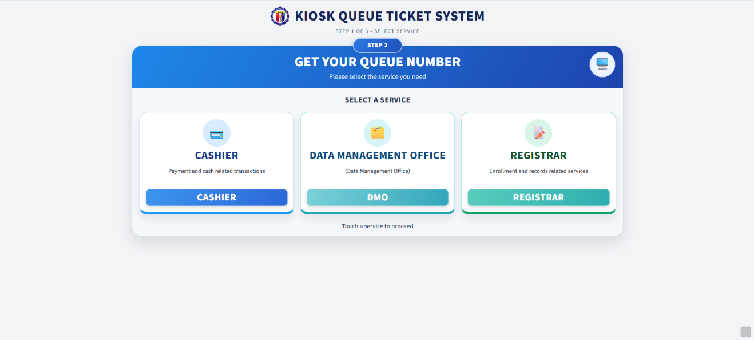
Figure 4.1 Current student kiosk service selection
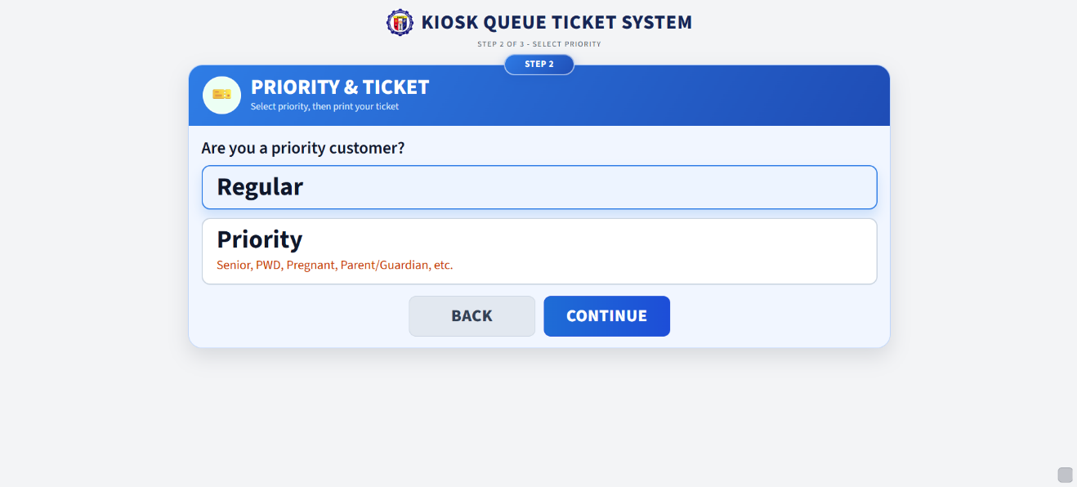
Figure 4.2 Current priority selection step

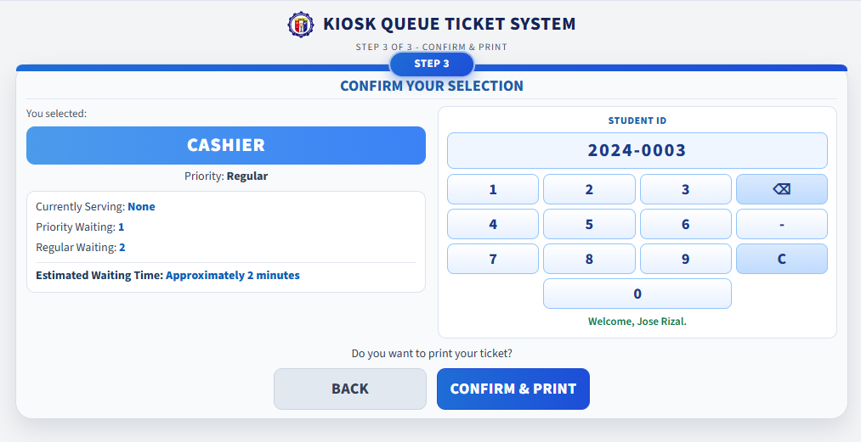
Figure 4.3 Current confirmation step with Student ID keypad
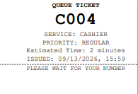
Figure 4.4 Current 58mm number-only ticket

Figure 4.5 Current staff serving panel
Figure 4.6 Current public display (numbers only)

Figure 4.7 Current administrator dashboard
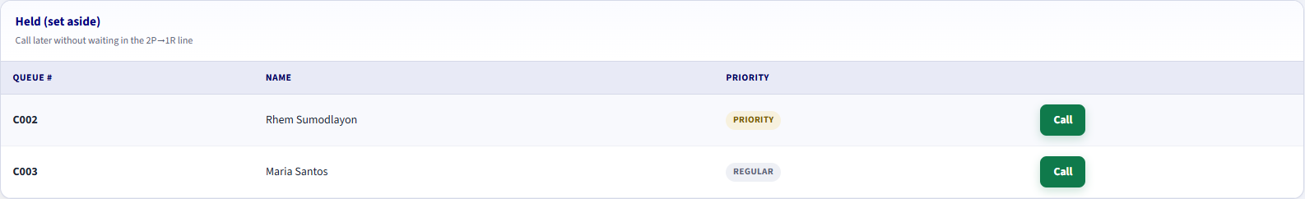
Figure 4.8 Current staff hold list

4.6 System Implementation
HDMI public display
The student path is service, priority, Student ID confirm, generate, print, wait on the display, then staff call, serve or hold, and complete. The walk-in path substitutes PIN unlock and reason for Student ID. Fair scheduling applies 2 Priority to 1 Regular on shared services. An estimate appears only when enough completed samples exist.
Staff actions update queue calls and queue status. Hold is not Complete. Administrators maintain users, students, and the walk-in PIN, and review done-only reports.
The implementation supports standalone local operation without continuous internet connectivity [11]. This localized campus deployment is consistent with campus information-system practice [9]. The public display shows queue numbers only. Authenticated staff may view the student name while serving, and administrators may access authorized student records.

4.7 Testing Results

4.7.1 Functional Testing
Functional testing was performed to determine whether the major system functions operated according to the specified requirements.
Function Tested | Expected Result | Result
Administrator Functions | Administrator can manage users, students, and the kiosk PIN, issue walk-in tickets, and view history and done-only reports. | Passed
The results show that the tested functions operated according to their intended requirements. The tested functions included service and priority selection, confirmation and Student ID validation, queue generation, 58mm thermal printing, fair scheduling, Call Next, Recall, Complete, Hold, Call Held, public display updates, database recording, and administrator functions.
Testing also verified that Promissory Notes is hidden from the public kiosk, that a wrong walk-in PIN is rejected, that two cashier windows do not claim the same ticket, that Hold removes the number from Now Serving, and that reports exclude hold sessions.

4.7.2 Non-Functional Testing
Non-functional testing assessed the system in terms of usability, efficiency, reliability and accuracy, security, compatibility, and local network operation.
The system was observed to provide responsive queue processing, stable local communication, and consistent database recording during testing. The interfaces were designed to provide straightforward interaction for clients, staff, and administrators. The system also operated within the implemented LAN environment. No percentage reduction in waiting time or fixed response-time benchmark is claimed because the study does not report a controlled before-and-after operational measurement.
The system also operated within the local network environment used for the implementation. The kiosk, thermal printer, staff workstations, administrator workstation, and queue display were integrated into the system environment.
Because the study does not provide measured numerical response-time benchmarks, specific response-time values or percentage improvements are not reported here.

4.7.3 User Acceptance and Expert Evaluation
The Chapter 3 student-and-parent questionnaire measured the current line and the proposed kiosk before development. The results in this section are evaluation results of the implemented system. They are not mixed with Tables 3.1 through 3.3.
User Acceptance Testing used Cashier, Registrar, and DMO staff feedback forms (N = 1 each) and a Student System Feedback Form administered to 20 students, 5 parents, and 5 walk-in visitors (N = 30). The Technical Expert System Evaluation Form was completed by one IT expert (N = 1). Expert ratings are kept in Table 4.4 and are not combined with the user means.
Cashier and Registrar scored 5.00 overall. DMO scored 4.92 overall. The Student System Feedback Form scored 4.91 overall. All user means are Strongly Agree. The IT expert scored 5.00 overall. The combined user mean is reported in Table 4.3.

4.7.3.1 Combined User Acceptance Results
Evaluation Area | Mean | Interpretation
Functionality | 4.93 | Strongly Agree
Usability | 4.98 | Strongly Agree
Efficiency | 4.97 | Strongly Agree
Reliability and Accuracy | 4.93 | Strongly Agree
User Satisfaction | 4.99 | Strongly Agree
Overall Mean | 4.96 | Strongly Agree
Table 4.3 User Acceptance Evaluation (office staff and student form; IT expert in Table 4.4 only)
Table 4.3 combines Cashier, Registrar, DMO, and Student System Feedback Form means. Functionality uses office Section A and student Section A; Usability uses office Section C and student Section B; Efficiency uses office Section C and student Section C; Reliability and Accuracy uses office Section D and student Section D; User Satisfaction uses office Section E and student Section E. The IT expert score is kept in Table 4.4 only. Efficiency is a perception score, not a measured cut in waiting time.

4.7.3.2 Technical Expert Evaluation
Evaluation Area | Items | Mean | Interpretation
Functionality | 5 | 5.00 | Strongly Agree
Usability | 5 | 5.00 | Strongly Agree
Efficiency | 5 | 5.00 | Strongly Agree
Reliability and Accuracy | 5 | 5.00 | Strongly Agree
User Satisfaction | 5 | 5.00 | Strongly Agree
Overall Mean | 25 | 5.00 | Strongly Agree
Table 4.4 Technical Expert System Evaluation (N = 1)
All 25 IT expert items were rated 5 (Strongly Agree), for section means of 5.00 and an overall mean of 5.00, Strongly Agree. The expert stated that the system is ready and can be deployed in PECIT, that network configuration must be set up because PECIT uses a cloud-based network, and that the UI design should be modernized. The expert score is not mixed into Table 4.3.

4.7.3.3 Results by Feedback Form
Respondent group | Instrument | Items | N | Overall mean | Interpretation
Cashier staff | Cashier System Feedback Form | 25 | 1 | 5.00 | Strongly Agree
Registrar staff | Registrar System Feedback Form | 25 | 1 | 5.00 | Strongly Agree
DMO staff | DMO System Feedback Form | 25 | 1 | 4.92 | Strongly Agree
Students, parents, and walk-in visitors | Student System Feedback Form | 27 | 30 | 4.91 | Strongly Agree
Table 4.5 Overall Means by Feedback Form
Section | Items | Mean | Interpretation
A. Functionality | 5 | 5.00 | Strongly Agree
B. Queue Management and Multi-Counter Operation | 5 | 5.00 | Strongly Agree
C. Usability and Efficiency | 5 | 5.00 | Strongly Agree
D. Reliability and Accuracy | 5 | 5.00 | Strongly Agree
E. Overall Satisfaction | 5 | 5.00 | Strongly Agree
Overall Mean | 25 | 5.00 | Strongly Agree
Table 4.6 Cashier System Feedback Form - Section Means (N = 1)
All 25 Cashier items were rated 5 (Strongly Agree). The Cashier evaluator liked that the queuing system organizes students and parents efficiently and makes the cashier process more orderly. The main difficulty noted was getting familiar with the system at first. No further improvement was suggested. Waiting-time remarks are treated as perception, not a measured cut.
Section | Items | Mean | Interpretation
A. Functionality | 5 | 5.00 | Strongly Agree
B. Queue Management | 5 | 5.00 | Strongly Agree
C. Usability and Efficiency | 5 | 5.00 | Strongly Agree
D. Reliability and Accuracy | 5 | 5.00 | Strongly Agree
E. Overall Satisfaction | 5 | 5.00 | Strongly Agree
Overall Mean | 25 | 5.00 | Strongly Agree
Table 4.7 Registrar System Feedback Form - Section Means (N = 1)
All 25 Registrar items were rated 5 (Strongly Agree). The Registrar evaluator stated that the system is very easy to use. No problems or further suggestions were reported on the form.
Section | Items | Mean | Interpretation
A. Functionality | 5 | 4.80 | Strongly Agree
B. Queue Management | 5 | 5.00 | Strongly Agree
C. Usability and Efficiency | 5 | 5.00 | Strongly Agree
D. Reliability and Accuracy | 5 | 4.80 | Strongly Agree
E. Overall Satisfaction | 5 | 5.00 | Strongly Agree
Overall Mean | 25 | 4.92 | Strongly Agree
Table 4.8 DMO System Feedback Form - Section Means (N = 1)
In Sections A and D, four items were rated Strongly Agree (5) and one item Agree (4), for a section mean of 4.80. Sections B, C, and E were all Strongly Agree (5.00). The overall mean is 4.92, Strongly Agree. The DMO evaluator liked the system, reported no problems so far, and suggested considering branding or logo placement and optional dark mode for the staff interface.

Section | Items | Mean | Interpretation
A. Functionality | 6 | 4.90 | Strongly Agree
B. Usability | 6 | 4.93 | Strongly Agree
C. Efficiency | 5 | 4.88 | Strongly Agree
D. Reliability and Accuracy | 5 | 4.90 | Strongly Agree
E. User Satisfaction | 5 | 4.95 | Strongly Agree
Overall Mean | 27 | 4.91 | Strongly Agree
Table 4.9 Student System Feedback Form - Section Means (N = 30)
All student-form section means are Strongly Agree. Functionality was 4.90, Usability 4.93, Efficiency 4.88, Reliability and Accuracy 4.90, and User Satisfaction 4.95, for an overall mean of 4.91. Respondents were 20 students, 5 parents, and 5 walk-in visitors (N = 30). Comments were positive: clients found the kiosk steps clear, the printed ticket easy to keep, and the public display helpful while waiting.
4.7.4 Functionality Evaluation
Office Functionality means were 5.00 (Cashier), 5.00 (Registrar), and 4.80 (DMO). The student Functionality mean was 4.90. The combined Functionality mean in Table 4.3 is 4.93, Strongly Agree.

4.7.5 Usability Evaluation
Office Usability and Efficiency sections were all 5.00. The student Usability mean was 4.93. The combined Usability mean in Table 4.3 is 4.98, Strongly Agree. Staff and clients found the interfaces easy to understand.

4.7.6 Efficiency Evaluation
The combined Efficiency mean in Table 4.3 is 4.97, Strongly Agree, from office Usability and Efficiency sections and the student Efficiency section (4.88). The Cashier evaluator perceived more orderly processing. Efficiency is a perception score and is not a measured reduction in waiting time.
The result represents the respondents' evaluation of the system and should not be interpreted as a measured percentage reduction in actual waiting time.

4.7.7 Reliability and Accuracy Evaluation
Office Reliability and Accuracy means were 5.00 (Cashier), 5.00 (Registrar), and 4.80 (DMO). The student mean was 4.90. The combined mean in Table 4.3 is 4.93, Strongly Agree.

4.7.8 User Satisfaction Evaluation
Office Overall Satisfaction sections were all 5.00. The student User Satisfaction mean was 4.95. The combined User Satisfaction mean in Table 4.3 is 4.99, Strongly Agree. DMO suggested branding or logo and optional dark mode; the IT expert recommended modernizing the UI and preparing network configuration for PECIT's cloud-based network.

4.7.9 ISO/IEC 25010-Aligned Evaluation
The evaluation forms used ISO/IEC 25010 product-quality characteristics as the basis for the rating items. The IT expert form and the student form used five areas: Functionality, Usability, Efficiency, Reliability and Accuracy, and User Satisfaction. The Cashier, Registrar, and DMO forms used office-specific sections, including Queue Management, and combined Usability and Efficiency.
Office and student scores are mapped to the five ISO-aligned areas in Table 4.3. The combined user overall mean is 4.96, Strongly Agree. The IT expert overall mean in Table 4.4 is 5.00, Strongly Agree, and is not mixed into Table 4.3. The study reports an ISO/IEC 25010-based evaluation form, not a certification of complete standard compliance.
The evaluation is described as an ISO/IEC 25010-based evaluation form rather than a complete ISO/IEC 25010 compliance certification. The technical expert evaluation used one evaluator; therefore, category means were calculated across the items within each category rather than across multiple expert respondents. No expert aggregate mean is presented unless the completed expert form provides those ratings.

4.8 Discussion of Findings
The findings are discussed against the five specific objectives of the study.
Objective 1. The kiosk, shared service queues, and staff windows organized Cashier, Registrar, and DMO transactions that previously depended on a physical first-come-first-served line. Objective 2. Confirmation required a validated Student ID or an authorized walk-in PIN path before a number was issued. Unknown IDs and a second open student ticket on the same day were rejected.
Objective 3. Each confirmed request produced a 58mm number-only ticket. Call Next applied 2 Priority to 1 Regular across shared windows, including Cashier 1 to 3, without assigning the same ticket twice. Objective 4. The public display and staff panel showed current serving and waiting numbers in the same fair order. Held tickets and names were omitted from the public view.
Objective 5. Functional tests passed for the implemented rules. Cashier and Registrar scored 5.00 overall, DMO scored 4.92, and the Student System Feedback Form scored 4.91 overall, all Strongly Agree. The combined user mean in Table 4.3 is 4.96, Strongly Agree. The IT expert scored 5.00 overall in Table 4.4 and recommended deployment readiness, network setup for PECIT's cloud-based network, and UI modernization.
Taken together, the implementation and evaluation show that the standalone kiosk system can replace the manual first-come-first-served line with an organized, monitored, and recorded queue process at the selected PECIT offices. The study does not claim a measured percentage reduction in waiting time.

CHAPTER 5
SUMMARY, CONCLUSIONS, AND RECOMMENDATIONS
This chapter summarizes the study, states the conclusions that answer the five specific objectives, and presents recommendations for PECIT, later system work, and future researchers.

5.1 Summary
This study designed, developed, and implemented a Standalone Kiosk-Based Queuing Management System with Thermal Printer for the Cashier, Registrar, and Data Management Office (DMO) of the Philippine Electronics and Communication Institute of Technology (PECIT). The offices previously used a manual first-come-first-served line. That process produced unclear order, line cutting, difficulty serving priority clients, crowding, and no shared view of who was waiting.
The implemented system is standalone and LAN-based [11]. One mini PC (Intel Core i5 8th Generation, 8 GB RAM) is both the public kiosk host and the application server. A student uses three kiosk steps: service, Regular or Priority, and confirmation with a validated Student ID typed on the keypad or tapped on an enrolled RFID/NFC card at the ACR122U-A9 reader. Clients who do not bring the card may still type the Student ID. Clients who cannot use a Student ID may request a walk-in ticket after the kiosk PIN stored in settings is accepted. After lookup, Notify me by SMS is off by default and uses the mobile number stored on the student record; students do not type a number. If no mobile is on file, the control stays off and disabled and shows No SMS number on file; print still proceeds. Walk-in clients may enter a number only on the PIN overlay. The system prints a 58mm number-only ticket on the XP-Q90EC printer, may send local GSM SMS through the SIM7600G-H module when an opted-in ticket is five places away and when it is called, applies 2 Priority → 1 Regular across shared windows, and shows serving and waiting numbers on a public display. When the printer is out of paper, the staff dashboard shows a paper-out alert. Staff can Call Next, Recall, Complete, Hold, and Call Held. Administrators manage users and students, enroll card serials (UID) and mobile numbers, set the walk-in PIN, may issue walk-in tickets, and generate reports from done tickets only. The Guard role cannot log in. Student names are not printed, shown on the public display, or included in SMS. The kiosk does not show the full student mobile number.
Development followed the Waterfall model: Requirements Analysis, System Design, Implementation and Development, Testing, and Deployment [19]. The four modules are the Student Kiosk Module, Staff Module, Administrator Module, and Queue Display Module.
Chapter 4 reported that the tested functions operated as intended. Cashier and Registrar scored 5.00 overall, DMO scored 4.92, and the Student System Feedback Form scored 4.91 overall, all Strongly Agree. The combined user mean in Table 4.3 is 4.96, Strongly Agree. The IT expert scored 5.00 overall in Table 4.4. The study does not claim a measured percentage reduction in waiting time.

5.2 Conclusions
Based on the development, implementation, testing, and evaluation, the researchers conclude the following:
- A standalone kiosk-based queue process can organize Cashier, Registrar, and DMO transactions that previously depended on a manual first-come-first-served line. Shared service queues and per-window timers allow several cashiers to serve one waiting list without assigning the same ticket twice.
- Confirmation before numbering is workable when the request is checked through Student ID validation by keypad or RFID/NFC tap, or authorized kiosk-PIN walk-in issuance. Unknown IDs, unknown cards, and a second open student ticket on the same day are rejected. Print, display, and SMS remain number-only.
- The 58mm thermal printer gives the client a physical queue reference after confirmation. If the printer is out of paper, the staff dashboard shows a paper-out alert and the stored ticket remains valid. 2 Priority → 1 Regular calling serves priority clients fairly while multiple windows share one service queue.
- The public display and staff panel provide a real-time view of who is being served and who is waiting. Waiting rows follow the same fair order as Call Next. Held tickets and student names are omitted from the public view. Optional local GSM SMS through the SIM7600G-H module notifies an opted-in ticket (stored student mobile, or walk-in overlay number) when the ticket is five places away in fair order and when it is called.
The system can be evaluated through functional testing, expert review, and User Acceptance Testing. User feedback was Strongly Agree (Cashier 5.00, Registrar 5.00, DMO 4.92, Student form 4.91; combined 4.96). The IT expert scored 5.00 overall under ISO/IEC 25010-aligned characteristics [10].
The developed system is therefore a practical replacement for the manual line at the selected PECIT offices. The study does not claim a measured numerical reduction in actual waiting time because no controlled before-and-after operational measurement is reported.

5.3 Recommendations
The researchers recommend the following:
- PECIT may deploy the system in the Cashier, Registrar, and DMO waiting areas using the mini PC (Intel Core i5 8th Generation, 8 GB RAM) as both kiosk and server, the 58mm XP-Q90EC printer, ACR122U-A9 RFID/NFC reader, SIM7600G-H GSM/LTE module, public display, staff PCs, and LAN already specified for standalone operation. Before go-live, network configuration should be prepared for PECIT's cloud-based network environment, as noted by the IT expert.
- Administrators and staff should receive orientation on the three-step kiosk, Student ID and card-tap errors, walk-in PIN use, GSM SMS (Notify me by SMS off by default; stored student mobile; walk-in overlay number only), paper-out alerts on the staff dashboard, Call Next, Recall, Complete, Hold, and Call Held before the offices rely on the system during peak hours.
- The mini PC, printer, RFID/NFC reader, GSM module and SIM load, display, workstations, database, and LAN should be checked regularly. Spare paper should be kept at the kiosk. The staff dashboard paper-out alert should be treated as a signal to reload the printer so stored tickets can still be reprinted.
- Administrators should keep the student allowlist, enrolled card serials (UID), and mobile numbers current, change the walk-in PIN when needed, and keep backups of the local database. The PIN should remain server-checked and should not be placed on the public kiosk page.
- Staff and administrators should review done-only reports and held tickets to see where windows need help, without treating Hold as a completed service.
- After full use, the offices should record actual waiting and service times before and after deployment if later studies need a measured efficiency comparison.

5.4 Future Enhancements
The current system is limited to the standalone LAN environment in the scope of the study. Later versions may add features that are not implemented now:
- A modernized staff and kiosk UI design, as recommended by the IT expert, while keeping the current three-step kiosk flow and number-only print, display, and SMS rules.
- A QR code on the ticket that opens number-only queue status.
- A remote reservation option that still requires Student ID validation or authorized walk-in issuance and does not replace the on-site kiosk.
- Additional campus offices, if they can share the same local rules without requiring continuous internet connectivity.
- More detailed analytics of volume, wait, and service time from done tickets only.
- Off-site backup for institutions that later accept that extra connectivity, while daily queue operations remain local [11].
- These items are future work. They are not part of the implemented PECIT kiosk system. RFID/NFC tap at confirm and local GSM SMS (five-ahead and called) are part of the current build.

5.5 Recommendations for Future Researchers
Future researchers may evaluate the system with larger user groups and longer operational periods, and they may compare 2 Priority → 1 Regular with other call orders under measured wait and service times. Studies may also examine walk-in volume versus student-ID tickets, the effect of Hold and Call Held on window use, and whether estimated wait matches later completed times.
Researchers who add a cloud SMS API, remote reservation, or cloud monitoring should keep the privacy rule used here: Student ID is for confirmation and staff serving; names are not printed, shown on the public display, or included in SMS. Localized campus information systems remain a suitable base for that work [9].
Future researchers are encouraged to keep the standalone kiosk, thermal ticket, and fair shared-window design while collecting the operational measurements this study does not claim.

REFERENCES
[1] Akila, I. S., Pratheek, P., & Poonia, A. (2023). Smart identity card for campus automation. In 2023 Innovations in Power and Advanced Computing Technologies (i-PACT) (pp. 1-5). IEEE. https://doi.org/10.1109/I-PACT58649.2023.10434674
[2] Ariningsih, P., & Muhammad, A. H. (2024). Quality evaluation of ticketing management system using ISO/IEC 25010:2023 standards and AHP method. Intechno Journal: Information Technology Journal, 6(2). https://doi.org/10.24076/intechnojournal.2024v6i2.1870
[3] Barbado, R. M. B., Peñaflorida, L. A. E., Taclibon, W., Temprosa, H. Q., & Austria, Y. D. (2025). ADUPay: A self-service payment kiosk for Adamson University's recognized student organization. In 2025 IEEE Malaysia International Conference on Communications (MICC). IEEE. https://doi.org/10.1109/MICC66164.2025.11210991
[4] Caranza, A. C. O., Cortez, C. C. G., Da, L. V., Dela Cruz, S. A. S., Rapadas, D. M., Santos, M. N. M., & Naturales, J. D. (2026). Enhancing student service efficiency through a smart enrollment queuing system for St. Clare College of Caloocan. International Journal of Research and Innovation in Applied Science, 11(5), 1493-1526. https://doi.org/10.51584/ijrias.2026.11050127
[5] Commission on Higher Education Regional Office XI. (2024, July 1). CHED RO XI awarded as government champion for digital transformation at DEVCON Mindanao Summit 2024. https://ro11.ched.gov.ph/2024/07/01/ched-ro-xi-awarded-as-government-champion-for-digital-transformation/9085/press-release/
[6] Concepcion, A. T. V., Concepcion, A. U., Guinto, C. A. A., Araza, C., Imperio, R. D. H., Regaas, B., & Perez, N. M. N. (2026). Smart queuing and appointment management system for client services in Bulacan State University Bustos Campus. International Journal of Multidisciplinary: Applied Business and Education Research, 7(1), 5-14. https://doi.org/10.11594/ijmaber.07.01.02
[7] Espinosa, G. S., Serrano, M. R., & Balmes, H. A. (2024). Automated enrollment queueing system in a university towards student experience and operational efficiency. MSEUF Research Studies, 21(1). https://www.ejournals.ph/article.php?id=24562
[8] Falcon, I. G., Dugaria, K. J. L., & Remojo, D. C. (2026). A three-tier integrated queue management system: Optimized service delivery for land transportation clients. Journal of Engineering and Technology for Industrial Applications, 12(57), 559-566. https://doi.org/10.5935/jetia.v12i57.2567
[9] Grepon, B. G. S., Baran, N. T., Gumonan, K. M. V. C., Martinez, A. L. M., & Lacsa, M. L. E. (2022). Designing and implementing e-school systems: An information systems approach to school management of a community college in Northern Mindanao, Philippines. International Journal of Computing Sciences Research, 6, 792-808. https://doi.org/10.25147/ijcsr.2017.001.1.74
[10] International Organization for Standardization. (2023). Systems and software engineering-Systems and software Quality Requirements and Evaluation (SQuaRE)-Product quality model (ISO/IEC 25010:2023). https://www.iso.org/standard/78176.html
[11] Linhalis, F., & Silva, A. C. (2023). Solutions to enable the use of ICT in education in regions with low internet connectivity: A literature review. Brazilian Journal of Education, Technology and Society, 16(4), 1185-1196. https://doi.org/10.14571/brajets.v16.n4.1185-1196
[12] Maala, R. F., Sebua, N. B., & Evangelista, K. L. L. (2023). Queuing management system in Manuel S. Enverga University Foundation Candelaria Inc. International Journal of Advanced Research in Computer Science, 14(6), 44-53. https://doi.org/10.26483/ijarcs.v14i6.7039
[13] Mallari, M. L. Z., Guintu, J. S., Magalong, Y. C., & Yap, D. S. (2022). CLIQUE: A web-based queue management system with real-time queue tracking and notification of units for Angeles University Foundation Office of the University Registrar. In Proceedings of the 12th Annual International Conference on Industrial Engineering and Operations Management. IEOM Society. https://doi.org/10.46254/an12.20220359
[14] National Privacy Commission. (2012). Implementing rules and regulations of Republic Act No. 10173. https://privacy.gov.ph/data-privacy-act/
[15] Panganiban, J. F., & Becenia, A. B. (2026). iSkulFlow: An event-driven queueing and transactional management system for registrar and financial services. International Journal of Education, Research, Innovation Perspectives. https://doi.org/10.5281/zenodo.19020670
[16] Pantonial, L., Geroy, C., & Prado, N. (2025). Student payment behaviors, queue management, and cashier efficiency in a private higher education institution. Psychology and Education: A Multidisciplinary Journal, 36(9), 1005-1010. https://doi.org/10.70838/pemj.360905
[17] Ramoga, M. R. (2025). Ticketless ID operated queue management optimization with SMS notification and voiceover feature. Current Science Research Bulletin. https://doi.org/10.5281/zenodo.16926252
[18] Republic of the Philippines. (2012). Republic Act No. 10173: Data Privacy Act of 2012. Official Gazette. https://www.officialgazette.gov.ph/2012/08/15/republic-act-no-10173/
[19] Saravanos, A., & Curinga, M. X. (2023). Simulating the software development lifecycle: The waterfall model. Applied System Innovation, 6(6), Article 108. https://doi.org/10.3390/asi6060108
[20] Sumalinog, P. S., Jr., & Mahusay, G. S. (2025). Q-Line UCLM: Enhancing student service flow through paperless. UCLM Journal of Research and Innovation, 1(1). https://doi.org/10.5281/zenodo.19181459
[21] Tesa, C. A., Haris, M. S., & Kusuma, W. T. (2025). An analysis of digital queuing systems in Indonesian banking services: A systematic literature review. International Journal of Software Engineering and Computer Science, 5(2). https://doi.org/10.35870/ijsecs.v5i2.4379
[22] UNESCO. (2023). Global education monitoring report 2023: Technology in education: A tool on whose terms? https://doi.org/10.54676/uzqv8501
CURRICULUM VITAE
RHEM A. SUMODLAYON  Bachelor of Science in Information Systems  Philippine Electronics and Communication Institute of Technology  Butuan City, Philippines  Date of Birth: September 24, 1995  Address:San Mateo Butuan City  Contact No.: +639120369311  Email: rhem1995@gmail.com | 
Personal and Academic Profile
The researcher is a candidate for the degree of Bachelor of Science in Information Systems at the Philippine Electronics and Communication Institute of Technology. In this capstone the researcher served as Lead Developer / System Architect, with primary work in backend, queue logic, staff tools, and deployment.
Educational Background
Level | School / Program | Year
Tertiary | PECIT - Bachelor of Science in Information System | 2027
Secondary | TNHS - Tungao National High School | 2014
Technical Skills
Laravel application design, fair 2 Priority to 1 Regular scheduling, wait-time estimation, staff window controls, and local Windows deployment. Implemented the kiosk, staff, display, and administrator services on the campus LAN.
Contribution to the Capstone Project
Architected and programmed the core queue services, staff Call Next / Hold / Call Held flow, walk-in PIN check, and deployment helpers used on the kiosk and staff PCs.
Seminars, Trainings, and Affiliations
MTCNA – Mikrotik Certified Network Associate
CISCO NetAcad – Networking Basics, Operating System Basics, Introduction to Data Science, Introduction to Cybersecurity (DICT)
PECIT – Summer Coding Bootcamp 2026 (Javascript, Php, Sqlite, Laravel, Github)
Character References
Available upon request from the College of Computer Studies / College of Information System, Philippine Electronics and Communication Institute of Technology.

CURRICULUM VITAE
MIKE D. BEDRONA  Bachelor of Science in Information Systems  Philippine Electronics and Communication Institute of Technology  Butuan City, Philippines  Date of Birth: January 07, 2005  Address: Purok 1 Garcia, Banza Butuan City ADN  Contact No.: 09635678292  Email: Mikebedrona07@gmail.com | 
Personal and Academic Profile
The researcher is a candidate for the degree of Bachelor of Science in Information Systems at the Philippine Electronics and Communication Institute of Technology. In this capstone the researcher served as Frontend / UI Designer, with primary work in kiosk, public display, and administrator/staff panel interface design.
Educational Background
Level | School / Program | Year
Tertiary | PECIT - Bachelor of Science in Information System | 2027
Secondary | Manat National High School | 2023
Technical Skills
User interface layout, kiosk confirm-step design, public display presentation, and PECIT panel styling. Prepared screens so students can complete service, priority, and confirmation on a compact kiosk, and so staff and administrators can work without showing names on the public display.
Contribution to the Capstone Project
Designed and refined the public kiosk, thermal-ticket presentation, public display, and panel screens used in this capstone. Kept student names off the printed ticket and the public display.
Seminars, Trainings, and Affiliations
PECIT – Summer Codeing Bootcamp 2026 (Javascript, Php, Sqlite, Laravel, Github)
Character References
Available upon request from the College of Computer Studies / College of Information System, Philippine Electronics and Communication Institute of Technology.

CURRICULUM VITAE
NIÑO ANGELO M. MALICAY  Bachelor of Science in Information Systems  Philippine Electronics and Communication Institute of Technology  Butuan City, Philippines  Date of Birth: June 22, 2002  Address: 280 LAGNADA ST., BUTUAN CITY  Contact No.: +639059463440  Email: oninmalicay722@gmail.com | 
Personal and Academic Profile
The researcher is a candidate for the degree of Bachelor of Science in Information Systems at the Philippine Electronics and Communication Institute of Technology. In this capstone the researcher served as Research / Documentation Lead, with primary work in the capstone manuscript, diagrams, and presentation.
Educational Background
Level | School / Program | Year
Tertiary | PECIT - Bachelor of Science in Information System | 2027
Secondary | Sto. Cristo Integrated School | 2019
Technical Skills
Technical writing, related literature, requirements documentation, and research presentation. Organized the five-chapter manuscript, use-case descriptions, and supporting diagrams so they match the implemented PECIT queue system.
Contribution to the Capstone Project
Led the writing and alignment of the manuscript, including the problem, method, implementation, and conclusions, and prepared diagrams and presentation materials for defense.
Seminars, Trainings, and Affiliations
PECIT – Summer Codeing Bootcamp 2026 (Javascript, Php, Sqlite, Laravel, Github)
Character References
Available upon request from the College of Computer Studies / College of Information System, Philippine Electronics and Communication Institute of Technology.

CURRICULUM VITAE
OMAR O. BAYABAO  Bachelor of Science in Information Systems  Philippine Electronics and Communication Institute of Technology  Butuan City, Philippines  Date of Birth:December 2, 1995  Address:Brgy. Zacor Butuan City  Contact No.: +639103230541  Email: marobayabao@gmail.com | 
Personal and Academic Profile
The researcher is a candidate for the degree of Bachelor of Science in Information Systems at the Philippine Electronics and Communication Institute of Technology. In this capstone the researcher served as Database / QA Specialist, with primary work in schema, testing, documentation, and validation.
Educational Background
Level | School / Program | Year
Tertiary | PECIT - Bachelor of Science in Information System | 2027
Secondary | Sto. Niño National High School | 2012
Technical Skills
Relational database design, test-case preparation, and quality checking of queue, student, settings, and call records. Verified that one open student ticket per day, walk-in issuance, Hold, and done-only reports behave as specified.
Contribution to the Capstone Project
Maintained the data model and validation work for queues, students, and settings, and supported functional testing and user-acceptance evaluation.
Seminars, Trainings, and Affiliations
PECIT – Summer Codeing Bootcamp 2026 (Javascript, Php, Sqlite, Laravel, Github)
Character References
Available upon request from the College of Computer Studies / College of Information System, Philippine Electronics and Communication Institute of Technology.

CURRICULUM VITAE
RON MATTHEW F. ARQUISOLA  Bachelor of Science in Information Systems  Philippine Electronics and Communication Institute of Technology  Butuan City, Philippines  Date of Birth: March 11, 2002  Address: Guingona Subd., Brgy. Dagohoy, Butuan City  Contact No.: +639850190377  Email: ronmattarq@gmail.com | 
Personal and Academic Profile
The researcher is a candidate for the degree of Bachelor of Science in Information Systems at the Philippine Electronics and Communication Institute of Technology. In this capstone the researcher served as Hardware / Deployment Specialist, with primary work in kiosk PC setup, the thermal printer, and public display launchers.
Educational Background
Level | School / Program | Year
Tertiary | PECIT - Bachelor of Science in Information System | 2027
Secondary | PECIT – Basic Education | 2023
Technical Skills
Hardware setup for the touchscreen kiosk, 58mm XP-58 (XP-Q90EC) thermal printer, public display, and local network cabling. Prepared launchers so the kiosk can print and the staff float can stay on top.
Contribution to the Capstone Project
Set up and tested the kiosk computer, thermal printer, public display, and LAN connections used in implementation and evaluation.
Seminars, Trainings, and Affiliations
PECIT – Summer Codeing Bootcamp 2026 (Javascript, Php, Sqlite, Laravel, Github)
Character References
Available upon request from the College of Computer Studies / College of Information System, Philippine Electronics and Communication Institute of Technology.

